Comparative demography of a rare species in Florida scrub and road habitats

Pedro F. Quintana-Ascencio ^{a,b}, Carl W. Weekley ^{b}, and Eric S. Menges ^{b}

ª University of Central Florida, Department of Biology, 4000 Central Florida Boulevard, Orlando, FL 32816-2368, pquintan@mail.ucf.edu

^{b} Archbold Biological Station, P. O. Box 2057, Lake Placid, FL 33862,

Corresponding Author: Pedro F. Quintana-Ascencio
Comparative demography of a rare species in Florida scrub and road habitats

ABSTRACT

Anthropogenic habitats can offer opportunities for expansion of rare species. The federally-listed herb Hypericum cumulicola is virtually restricted to natural gaps within fire-maintained Florida scrub, but also occurs within and along sandy roads traversing scrub. To test the hypothesis that sandy roads provide suitable habitat for H. cumulicola, we compared the demographic performance of scrub and road populations at the Lake Wales Ridge State Forest and Archbold Biological Station in south-central Florida. Twice a year in February and August 1997-2006, we assessed recruitment and survival; annually in August we also measured maximum height and estimated reproductive output of tagged individuals. Scrub population dynamics were more stable than road populations. Recruitment in scrub populations, but not roads, always increased with rainfall. Compared with scrub populations, road populations were weedier, with more variable life spans, earlier flowering, and higher fecundity. Germination rates did not differ between individuals from different habitats, but varied depending on simulated weather conditions. The weedier life history may reflect a divergent selective environment (and perhaps an evolutionary and ecological trap). Alternatively, adaptive plasticity in H. cumulicola may allow the species to maintain populations in anthropogenic habitats that thereby provide refugia for fire-suppressed scrub populations.
Keywords: endemic species, human disturbance, Hypericum cumulicola, population dynamics, Lake Wales Ridge

1. Introduction
Human-altered habitats expose native species to environmental conditions deviating from the natural habitats in which they evolved. By altering basic demographic, ecological and genetic characteristics, anthropogenic habitats may either enhance or jeopardize species persistence (e.g. Baker, 1974; DeWet and Harlan, 1975; MacNair, 1987; Bradshaw and Hardwick 1989). For example, roads generally have negative impacts on the landscapes they traverse (Andrews, 1990; Evink et al., 1996; Forman and Alexander, 1998; Forman, 1995, 2000; Forman et al. 2003; Trombulak and Frissell, 1999; Hourdequin, 2000). However, roads (and similar features such as utility easements, firelanes and railroad embankments) may also function as refugia for some species and provide corridors between natural areas (Andrews, 1990). In addition, semi-improved roads may provide habitat for native plant species whose habitat requirements are mimicked by roadside conditions (Forman, 1995; Petrů and Menges, 2004).
Florida scrub ecosystems on the Lake Wales Ridge in south-central Florida are pyrogenic communities (Menges, 1999; Myers, 1990) providing habitat for 21 narrowly endemic and federally-listed plants (Christman and Judd, 1990; USFWS, 1999). Although 85% of these ecosystems has been lost to agricultural, commercial and residential development (Peroni and Abrahamson, 1985), aggressive land acquisition by government and private agencies has created an extensive network of conservation areas along the approximately 160 km long, 30 km wide Ridge (Turner et al., 2006). Typically, managed areas are criss-crossed by firelanes, semi-improved roads, or paved roads in defunct subdivisions. Few uninterrupted areas of intact vegetation > 40 ha remain.
The expansion of scrub endemics to road habitats could affect their life histories and population dynamics, but this has not been previously examined. Many of the plants endemic to the Lake Wales Ridge are herbs and subordinate shrubs historically restricted to natural gaps in Florida scrub ecosystems, particularly Florida rosemary (Ceratiola ericoides) scrub (Johnson and Abrahamson, 1990; Menges and Kimmich, 1996; Quintana-Ascencio and Morales Hernández, 1997; Menges and Quintana-Ascencio, 2003). Their populations undergo both short-term and long-term density fluctuations, with increases most often occurring after fires that may release individuals from competitive exclusion by dominant shrubs (Johnson and Abrahamson, 1990; Menges and Kimmich, 1996; Quintana-Ascencio and Morales-Hernández, 1997; Quintana-Ascencio et al., 2003; Menges and Quintana-Ascencio, 2003). Today, many of these open-sand specialists also occur in mechanically disturbed sites such as sandy roads and roadsides, firelanes, and similar areas. Mechanical disturbances may release subordinate plants from competition with large shrubs (Breininger and Schmalzer, 1990; Greenberg et al., 1995). However, the apparent advantage provided by disturbed habitats may be counterbalanced by deleterious environmental (e.g., soil moisture changes and compaction, sand accretion and temperature extremes) and biological (e.g., invasion of exotic and weedy species) changes (Greenberg et al., 1997; Parendes and Jones, 2000; Larson 2003; Petrů and Menges, 2004).
Our objective was to compare the demographic performance of scrub vs. road populations of the narrow endemic Hypericum cumulicola, a gap specialist of Florida rosemary scrub and oak scrub (scrubby flatwoods) that also occurs in roads and similar disturbed habitats. We hypothesize that these anthropogenic habitats create populations with a divergent demography and life-history, including earlier age at first flowering, greater fruit production and more variable densities, as compared to scrub populations.

2. Methods
2.1 Study species
Hypericum cumulicola ((Small) P. Adams (Hypericaceae); Highlands scrub hypericum) is a federally-listed endangered herb, narrowly endemic to the southern third of the Lake Wales Ridge in south-central Florida (USFWS, 1999). Most H. cumulicola populations occur in xeric white sand habitats, mainly in Florida rosemary scrub, preferentially occupying gaps devoid of competing woody vegetation (Quintana-Ascencio and Morales-Hernández, 1997). Populations also occur in xeric oak scrub and on sandy roads and roadsides traversing its preferred scrub habitats. H. cumulicola is a perennial herb < 50 cm tall that may produce hundreds to thousands of flowers annually (Quintana-Ascencio and Morales-Hernández, 1997). Flowers are bisexual and self-compatible, though rates of autogamy are low, probably due to the spatial separation of male and female reproductive organs (Evans et al., 2003). Fruits are thin-walled capsules containing 10 to 20 seeds (Evans et al., 2003), which form a persistent seed bank (Quintana-Ascencio et al., 1998). Most germination occurs between November and March.
Three lines of evidence suggest the occurrence of metapopulation dynamics in H. cumulicola: (1) individuals experimentally transplanted to previously unoccupied and occupied gaps in Florida rosemary scrub gaps display similar demographic dynamics (Quintana-Ascencio and Menges, 1996); (2) there is significant positive relationship between H. cumulicola occurrence and scrub patch size and aggregation, with lower extinction risk and higher colonization rates in large and aggregated populations (Quintana-Ascencio and Menges, 1996); and (3) isozyme analyses show high levels of population differentiation and restricted gene flow among populations (F_{ST} = 0.73, N_{m} = 0.09; Dolan et al., 1999; Menges et al., 2001).

  - Study Sites
This study was conducted at two locations, one near either end of H. cumulicola’s distribution. Lake Wales Ridge State Forest/Arbuckle (27º 40’ 47” N, 81o 26’ 10” W) is near the northern limit of H. cumulicola’s range while Archbold Biological Station (27º 10’ 50” N, 81o 21’ 0” W) is near its southern limit (Table 1). At Arbuckle, we sampled eight H. cumulicola populations, two each in Florida rosemary scrub and oak scrub and four in roads (roadsides and berms - sand mounds running parallel to a road at slightly higher elevation). At Archbold, we studied one Florida rosemary scrub and one roadside population. Some scrub populations were prescribe-burned during the study (Table 1), but others have been unburned for at least 30 years. Of the five road sites, four were free of vehicular traffic throughout the study, while one road site (roadside 2) was occasionally driven on, possibly resulting in minor plant mortality due to traffic.

2.3 Demographic data collection
We collected demographic data with slightly different sampling designs at the two study locations. At Arbuckle, sampling of plants regardless of life stage was conducted within 196 1 x 2 m random plots extending across occupied gaps in eight populations (20-27 plots per population; Table 1). At Archbold, we have studied 14 populations since 1994 (Quintana-Ascencio, et al. 2003), but this paper includes data from complete censuses of two populations (Scrub SSR1 and nearby roadside), from 1997-2006 (Table 1).
At both sites, we surveyed for seedling recruitment and survival of tagged individuals each February from 1997-2006. Each August, we also censused tagged individuals for plant height and reproduction (number of buds, flowers and fruits). In 1994, 1995, 1996, 1998, and 2000, we counted the number of reproductive structures on each individual. For all other years, we used linear regressions predicting the number of fruits from plant height and number of stems (logarithm-transformed data; all r² > 0.75, n=20 plants per site per year; Quintana-Ascencio et al., 2003). In three years (1995, 1996, 1998), we collected the most distal mature fruit of 20 randomly selected individuals in each population in order to quantify seed production per fruit.

2.4 Germination experiment
To obtain data on seed germination, we conducted an experiment in a controlled environment using a Conviron (Controlled Environments Limited) double-chambered growth chamber. In August 2000, we collected H. cumulicola fruits from individuals in roadside and scrub populations at Archbold, Arbuckle and a third site, Lake Apthorpe Preserve. We dissected fruits under a microscope, discarded light-colored and damaged seeds, and placed intact seeds on moist filter paper in petri dishes (n=2400 seeds; 20 seeds/individual/ /habitat/site/simulated weather condition;10 individuals per habitat, two habitats per site, three sites, two simulated weather conditions). Seeds were exposed for four months to one of two simulated weather conditions, defined by temperature and photoperiod. Simulated winter and summer temperature regimes were based on hourly mean temperatures collected by digital Hobo data loggers (Onset Computer Corporation) at Archbold in February and June 2000. We obtained photoperiod values from daily sunrise/sunset data at Archbold Biological Station (Astronomical Applications Department, U.S. Naval Observatory).

2.5 Analysis
We used a Kruskal-Wallis test to compare the life span of seedling cohorts in different locations and a Levene test to assess their variance heterogeneity. We compared variation in height among individuals from different habitats (data pooled across cohorts) with an ANOVA for height in year one, and with three repeated measures analyses, for groups of individuals surviving from 1-2, 1-3, and 1-4 years. We adjusted degrees of freedom with Greenhouse-Geisser epsilon (> 0.805 in all cases). For multiple post hoc comparisons of heights, we used a Games-Howell test because their variances were heterogeneous. The differences in number of reproductive structures (for each age) among habitats (data pooled across cohorts) were assessed with Kruskal-Wallis and Mann Whitney U tests. We corrected the experiment-wise error rate from the multiple comparisons with the Bonferroni method (Sokal and Rohlf, 2000). To assess the relationship between annual number of seedlings and precipitation by season, we calculated simple linear regressions (1998-2005). We used SPSS 11.01 (SPSS, 2000) for all statistical tests.

3. Results

3.1 Demographic variation
Hypericum cumulicola population trajectories varied markedly between scrub and road populations (Figure 1). Scrub populations showed higher population stability, with plants present during all censuses, even when fires (arrows, Figure 1) killed most plants. In contrast, three of the road habitats had no plants at least once (roadside 1, roadside 3, berm 2; Figure 1). The numbers of seedlings found in both rosemary and oak scrub populations at both sites, and the berm populations, were positively associated with rainfall, while seedling recruitment in roadside populations was more variable and cued to rainfall in only one of two sites (Figure 1 and 2). Considerable declines in roadside populations were associated with high rainfall during the winter 1997- 1998 (558 mm during 1997-1998 at Arbuckle vs. 215 mm normal winter precipitation between 1995-2006; 547 mm vs. 184 mm, respectively, at Archbold) and, in two cases, roadside populations were eliminated by flooding. Scrub populations were largely removed by fire and increased to varying degrees post-fire.
Life span differed between scrub and road populations. Mean median life span among the five scrub populations (mean ± std: 2.01 years + 0.26) was less variable than among the five road populations (1.65 years + 0.79; Levene’s F= 5.8, df=8, p=0.043, Figure 3). If the longest-lived road population is removed from analysis, road populations have significantly shorter lifespans than scrub populations (z = 2.2, p=0.032, n=9).
Height growth was slower in oak scrub than for plants in other habitats, and somewhat slower in Florida rosemary scrub than road habitats over some time periods (Figure 4). For one year old plants, heights of plants in roadside and Florida rosemary > berm plants > oak scrub (ANOVA F=26.5; df=3, 1824; p < 0.001; posthoc tests significant at p < 0.001). Repeated measures ANOVAs always showed a highly significant effect of habitat on growth (interaction of habitat and age; F > 9, p < 0.001 for all three analyses). Posthoc tests showed that plants grew fastest from 1-2 years on the berm or in rosemary scrub, as compared with roadsides. Plants in oak scrub grew slowest. From years 1-3, plants on the berm grew faster than either scrub habitat, plants on roadsides or rosemary scrub grew faster than oak scrub. Finally, for years 1-4, oak scrub plants had grown the least, while the other three habitats had similar growth.
Individuals in road populations flowered earlier than those in scrub populations. There was a higher frequency of plants flowering for the first time at ages 1 and 2 and a lower frequency of plants flowering for the first time at ages >2 in roads than in scrub (Fig. 5, G₉= 219.5, P<0.001). All pairwise comparisons were significant. Roadside peak flowering occurred as seedlings, the berm peaked in the second year (plants between ages 1 and 2), rosemary peaked across years 1-3, and oak scrub had little pattern in first year of flowering among the four years (Figure 5). Average age at first flowering was 1.45 years for roadside individuals, 1.88 for rosemary scrub, 1.89 years for individuals on the berm, and 2.65 years in scrubby flatwoods (only flowering individuals considered).
Road plants also had higher fecundity as measured by median number of fruits than scrub plants (Figure 6). The overall Kruskal Wallis test was significant (p < .003 for all ages). At all ages, plants in oak scrub had the lowest reproductive output (Figure 6). Roadside reproduction was higher than scrub plants in years 2-4 and higher than berm plants in years 2-3.

3.2 Germination
Germination under controlled conditions did not show consistent pairwise differences between roadside vs. Florida rosemary scrub populations. Overall, germination was higher under simulated winter conditions; however there was a significant two-way interaction between site and habitat, and a three-way interaction among site, habitat, and simulated weather (Table 2). Winter germination was higher than summer germination for seeds from the scrub and the roadside sites at Archbold (in scrub, 31% germination in winter regime vs 12% in summer regime; in roadside, 34 % vs 23 %), from the scrub at Arbuckle (71% vs 19 %) and from the roadside in Apthorpe (54 % vs 8 %). In contrast, seeds from the roadside in Arbuckle (15% vs 22%) and in the scrub in Apthorpe (9% vs 23%) had higher germination during the summer.

4. Discussion

In Hypericum cumulicola, road populations differ dramatically from scrub populations. Road plants have a weedier life history, with faster growth, more variable life spans, earlier reproduction, and higher fecundity. Most individuals in scrub are killed by fire but these populations recover rapidly via a persistent soil seed bank (Quintana-Ascencio et al., 2003); road populations generally do not burn but are subject to other catastrophic events (e.g., flooding) against which scrub populations may be buffered by the surrounding vegetative community. Seedling recruitment in scrub populations is positively affected by rainfall, but rainfall has variable effects on road populations. Road population dynamics are more variable than scrub population trajectories. Most of these road population traits, particularly the variable population dynamics, earlier reproduction, and higher fecundity, are typical of weedy species (Baker, 1974).
H. cumulicola road populations had some similarities to demography in recently burned scrub, but there were also key differences. Seedling recruitment of H. cumulicola is high on roads and shortly after fire in both oak and rosemary scrub. The absence or scarcity of large shrubs on the roads, and the reduction of shrub aboveground biomass after fire, may reduce competitive effects on herbaceous species like H. cumulicola (Quintana-Ascencio et al., 2003). However, these open conditions persist along roads, whereas scrub sites shift towards a more closed structure as most shrubs resprout and quickly recover prefire biomass between fires (Menges and Hawkes, 1998). Compared to unburned populations, H. cumulicola in recently burned scrub and roads had faster growth, earlier reproductive maturity, and higher fecundity (Quintana-Ascencio and Morales Hernández, 1997; Quintana-Ascencio and Menges, 2000; Quintana-Ascencio et al., 2003). However, scrub H. cumulicola plants have less variable lifespan and lower reproductive output than road plants and have more subdued population fluctuations. In constrast, road populations had a wider range of density variations and different population structure, with fewer vegetative plants, than populations in scrub.
Seedling establishment patterns differed between roads and scrub populations. Higher soil moisture in the roads (Weekley et al., submitted) may explain the higher germination of H. cumulicola in roads than in gaps in scrub during the dry, cold winter and spring months of 2000 and 2001. In controlled environments, populations of H. cumulicola had a significantly higher germination in simulated winter conditions, with lower temperatures and shorter daily light schedules, than in the summer simulated conditions. However during the wet El Niño winter of 1997-1998 (Buizer et al., 2000; Groetzner et al., 2000) roadside flooding was associated with fewer seedlings. During the same interval, scrub and (elevated) berm populations had the highest germination.
Road and scrub habitats may differ in other ways. For example, herbivore pressures may be different in environments resulting from human activity. Liu and Koptur (2003) found that plants at a forest edge suffered higher seed predation than plants in forest interior. In our system, the proportion of H. cumulicola plants with herbivory was higher in scrub habitats than in road habitats (Brudvig and Quintana-Ascencio, 2003). Roads are particularly prone to sand movements (Petrů and Menges, 2004) which could affect germination and survival of established plants. Roads provided higher moisture and lower soil temperatures than scrub gaps during the driest and coldest months of the year (Weekley et al., 2007). Plants on roads were also more exposed to the effects of disturbances such as flooding. These and other environmental differences suggest that roads may constitute divergent and highly variable selective environments. Alternatively, adaptive plasticity in H. cumulicola may allow the species to maintain populations in anthropogenic habitats that thereby provide refugia for fire-suppressed scrub populations.
The spread of scrub populations of H. cumulicola, and other gap specialists, from their natural habitats into a relatively recent anthropogenic habitat can have multiple consequences. Road environments may be “Ecological and Evolutionary Traps” (Schlaepfer et al., 2002) that can dissociate current life history from evolved traits and change extinction risks. In these circumstances, the colonization of roads by maladapted genotypes may produce population sinks (Pulliam, 1988). Alternatively, dispersal by genotypes able to survive and reproduce in the novel habitat through phenotypic plasticity, or rapid adaptation, could increase species persistence in the landscape (Allard and Bradshaw, 1964; Blais and Lechowicz, 1989; Stearns, 1989; Kingsolver et al., 2002, Sultan and Spencer, 2002). If life history differences between road and scrub populations of H. cumulicola are plastic, road populations could “rescue” scrub populations lost between fires, following the re-introduction of fire.
Potential demographic and genetic changes resulting after H. cumulicola colonization of road habitats are particularly relevant in the context of the widespread occurrence of human disturbance and fire suppression in scrub habitats. For example, currently unimproved roads occupy 5.76 km/km² at Archbold Biological Station and 2.66 km/km² at Lake Wales Ridge State Forest. This estimate is as high as previous assessments of paved roads in relatively dense populated areas in the United States (Heilman et al., 2002).
Even if roads are a divergent selective environment affecting H. cumulicola, is this really a problem for the species’ persistence? If road genotypes are able to swamp scrub genotypes, the resulting plants may be less likely to deal with conditions in the scrub. Periodic fire within Florida scrub may maintain a mix of genotypes and plastic responses that will allow H. cumulicola populations to persist in the variable environmental contexts. Given this possibility, to assure the conservation of scrub-adapted traits in these Florida scrub species, road networks should not exceed minimal requirements for access and fire management.

Acknowledgements

We greatly appreciate the help of Christina Casado, Gretel Clarke, Margaret Evans, Matt Finer, Samara Hamze, Kristina Horn, Rick Lavoy, Miguel Martínez-Icó, Darien McElwain, Maria Cristina Morales Hernández, Dorothy Mundell, Stephanie Neimeister, Marcia Rickey, Ian Pfingsten, Alaa Wally, Rebecca Yahr, Archbold interns (for complete list see http://www.archbold-station.org/abs/staff/emenges/ esmcvasst.htm) and UCF students in the 2005 Plant Ecology course. Anne Malatesta provided critical support at the Lake Wales Ridge State Forest. This study was supported by National Science Foundation (DEB98-15370) and the Plant Conservation Program of the Florida Division of Forestry.

REFERENCES

Andersson, S., 1990., The relationship between seed dormancy, seed size and weediness, in Crepis tectorum (Asteraceae). Oecologia 83, 277-280.
Andrews, A., 1990., Fragmentation of habitat by roads and utility corridors: a review. Australian Zoologist 26, 130-141.
Allard, R. W., Bradshaw, A. D., 1964. Implications of genotype-environmental interactions in applied plant breeding. Crop Science 4, 503-508.
Baker, H. G., 1974., The evolution of weeds. Annual Review of Ecology and Systematics 5, 1-24.
Blais, P. A., Lechowicz, M., 1989. Variation among populations of Xanthium strumarium (Compositae) from natural and ruderal habitats. American Journal of Botany 76, 901-908.
Bradshaw, A. D., Hardwick, K., 1989. Evolution and stress- genotypic and phenotypic components. Biological Journal of Linnaean Society 37, 137-155.
Breininger, D. R.,Schmalzer, P. A., 1990. Effects of fire and disturbance on plants and birds in a Florida oak/palmetto scrub community. American Midland Naturalist 123, 64-74.
Brudvig, L., Quintana-Ascencio, P.F., 2003. Herbivory and postgrazing response in Hypericum cumulicola. Florida Scientist 62, 99-108.
Buizer, J. L., Foster, J., Lund, D., 2000. Global impacts and regional actions: Preparing for the 1997-98 El Niño. Bulletin of the American Meteorological Society 81, 2121-2139.
Christman, S. P., Judd, W. S., 1990. Notes on plants endemic to Florida scrub. Florida Scientist 53, 52-73.
DeWet, J. M., Harlan, J. R., 1975. Weeds and domesticates: evolution in the man-made habitat. Economic Botany 29, 99-107.
Dolan, R. W., Yahr, R., Menges, E. S., Halfhill, M., 1999. Three rare, perennial plants endemic to Florida rosemary scrub with different patterns of genetic organization. American Journal of Botany 86,1556-1562.
Evink, G. L., Garrett, P., Zigler, D., Berry, J., 1996. Trends in addressing transportation related wildlife mortality. Proceedings of the transportation related mortality seminar. Report FL-ER-58-96. Florida Department of Transportation, Tallahassee, FL, unpaginated.
Evans, M. E. K., Menges, E. S., Gordon, D. R., 2003. Comparative reproductive biology of three co-occurring federally endangered plants endemic to Florida scrub. Biological Conservation 111, 235-245.
Forman, R. T. T., 1995. Land mosaics: the ecology of landscapes and regions. Cambridge University Press, Cambridge.
Forman, R. T. T., 2000. Estimate of the area affected ecologically by the road system in the United States. Conservation Biology 14, 31-35.
Forman, R. T. T. Alexander, L. E., 1998. Roads and their major ecological effects. Annual Review of Ecology and Systematics 29, 207-231.
Forman, R. T. T., Sperling, D., Bissonette, J. A., Clevenger, A. P., Cutshall, C. D., Dale, V. H., Fahrig, L., France, R., Goldman, C. R., Heanue, K., Jones, J. A., Swanson, F. J., Turrentine, T., Winter, T. C., 2003. Road ecology: science and solutions. Island Press. Washington, D.C.
Greenberg, C. H., Neary, D. G., Harris, L. D., Linda, S. P., 1995. Vegetation recovery following high-intensity wildfire and silvicultural treatments in sand pine scrub. American Midland Naturalist 133, 149-163.
Greenberg, C. H., Crownover, S. H., Gordon, D. R., 1997. Roadside soils: a corridor for invasion of xeric scrub by nonindigenous plants. Natural Areas Journal 17, 99-109.
Groetzner, A., Latif, M., Dommenget, D., 2000. Atmospheric response to sea surface temperature anomalies during El Niño 1997/98 as simulated by ECHAM4. Quarterly Journal of the Royal Meteorological Society 126, 2175-2198.
Heilman, G. E. Jr., Strittholt, J. R., Slosser, N. C., Dellasala, D. C., 2002. Forest fragmentation of the conterminous United States: assessing forest intactness through road density and spatial characteristics. Bioscience 52, 411-422.
Hourdequin, M., 2000., Special issue: ecological effects of roads. Conservation Biology 14, 16-17.
Johnson, A. F., Abrahamson, W. G., 1990. A note on the fire response of species in rosemary scrubs on the Southern Lake Wales Ridge. Florida Scientist 53, 138-143.
Kingsolver, J. G., Pfennig, D. W., Servedio, M. R., 2002. Migration, local adaptation and the evolution of plasticity. Trends in Ecology & Evolution 17, 540-541.
Larson, D. L., 2003. Native weeds and exotic plants: relationships to disturbance in mixed-grass prairie. Plant Ecology 169,317-333.
Liu, H. and Koptur, S., 2003. Breeding system and pollination of a narrowly endemic herb of the lower Florida Keys: impacts of the urban wildland interface. American Journal of Botany 90, 1180-1187.
MacNair, M. R., 1987. Heavy –metal tolerance in plants – a model evolutionary system. Trends in Ecology and Evolution 2, 354-359.
Menges, E. S., 1999. Ecology and conservation of Florida scrub. In: Anderson, R. C., Fralish, J. S., Baskin, J. M.(Eds.) Savannas, barrens and outcrop plant communities of North America, Cambridge University Press, Cambridge, pp.7-22.
Menges, E. S., Dolan, R. W., Yahr, R., Gordon, D. R., 2001. Comparative genetics of seven plants endemic to Florida’s Lake Wales Ridge. Castanea 66, 98-114.
Menges, E. S., Hawkes, C. V., 1998. Interactive effects of fire and microhabitat on plants of Florida scrub. Ecological Applications 8, 935-946.
Menges, E. S., Kimmich, J., 1996. Microhabitat and time since fire: effects on demography of Eryngium cuneifolium (Apiaceae), a Florida scrub endemic plant. American Journal of Botany 83, 185-191.
Menges, E. S., Quintana-Ascencio, P. F., 2003. Population viability with fire in Eryngium cuneifolium: deciphering a decade of demographic data. Ecological Monographs 74, 79-99.
Myers, R. L., 1990. Scrub and high pine. In Myers, R. L., Ewel, J. J. (Eds.) Ecosystems of Florida,The University of Central Florida Press, Orlando, pp. 150-193.
Parendes, L. A., Jones, J. A., 2000. Role of light availability and dispersal in exotic plant invasion along roads and streams in the H. J. Andres Experimental Forest, Oregon. Conservation Biology 14, 64-75.
Peroni, P. A., Abrahamson, W. G., 1985. A rapid method for determining losses of native vegetation. Natural Areas Journal 5, 20-24.
Petrů, M., Menges, E. S., 2004. Shifting sands in Florida scrub gaps and roadsides: a dynamic microsite for herbs. American Midland Naturalist 151, 101-113.
Pulliam, H. R., 1988. Sources, sinks, and population regulation. American Naturalist 132, 652-661.
Quintana-Ascencio, P. F., Dolan, R. W., Menges, E. S., 1998. Hypericum cumulicola demography in unoccupied and occupied Florida scrub patches with different time-since-fire. Journal of Ecology 86, 640-651.
Quintana-Ascencio, P. F,. Menges, E. S., 1996. Inferring metapopulation dynamics from patch level incidence of Florida scrub plants. Conservation Biology 10, 1210-1219.
Quintana-Ascencio, P. F., Menges, E. S., 2000. Competitive abilities of three narrowly endemic plant species in experimental neighborhoods along a fire gradient. American Journal of Botany 87, 690-699.
Quintana-Ascencio, P. F., Menges, E. S., Weekley, C. W., 2003. A fire-explicit population viability analysis of Hypericum cumulicola in Florida rosemary scrub. Conservation Biology 17, 433-449.
Quintana-Ascencio, P. F., Morales-Hernández, M., 1997. Fire-mediated effects of shrubs, lichens and herbs on the demography of Hypericum cumulicola in patchy Florida scrub. Oecologia 112, 263-271.
Sultan, S. E., Spencer, H. G., 2002. Metapopulation structure favors plasticity over local adaptations. American Naturalist 160, 271-283.
Schlaepfer, M. A., Runge, M. C., Sherman, P. W., 2002. Ecological and evolutionary traps. Trends in Ecology and Evolution 17, 474-480.
Sokal, R. R., Rohlf, F. J., 2000. Biometry. Freeman, New York, New York.
Stearns, S. C., 1989. The environmental significance of phenotypic plasticity. Bioscience 39, 436-445.
Trombulak, S. C., Frissell, C. A., 1999, Review of ecological effects of roads on terrestrial and aquatic communities. Conservation Biology 14, 18-30.
Turner, W. R., Wilcove, D. S., Swain, H. M., 2006. State of the scrub. Conservation progress, management responsibilities, and land acquisition priorities for imperiled species of Florida’s Lake Wales Ridge. Archbold Biological Station Report. 160 pp. http://www.archbold-station.org/abs/publicationsPDF/Turner_etal-2006-StateofScrub.pdf
US Fish and Wildlife Service, 1999. Multi-Species Recovery Plan for the Threatened and Endangered Species of South Florida. US Fish and Wildlife Service, Atlanta, Georgia.
Weekley, C. W., Gagnon, D., Menges, E. S., Quintana-Ascencio, P. F., Saha, S., 2007. Soil moisture patterns in relation to vegetation, gaps, time since fire, and occurrence of Florida scrub endemic plants. EcoScience, in press.

Table 1 - Populations of Hypericum cumulicola studied in natural and anthropogenic habitats at Lake Wales Ridge State Forest (Arbuckle Tract) and Archbold Biological Station (through 2006). # Plants is the total number of plants studied in each site (total N= 3945). Plot area =1 x 2 m².
Location | Habitat | Burn unit | Initial census | # Gaps | # Plots | # Plants
Arbuckle | Florida rosemary scrub 1 | BC03 | 1996 | 4 | 27 | 349
Arbuckle | Florida rosemary scrub 2 ¹ | SU14 | 1997 | 2 | 25 | 301
Arbuckle | Oak scrub 1 ² | GF23 | 1996 | 7 | 25 | 510
Arbuckle | Oak scrub 2 | BC06 | 1997 | 4 | 20 | 140
Arbuckle | Abandoned sandy roadside 1 | BC05 | 1997 | 3 | 25 | 345
Arbuckle | Sandy roadside 2 | GF14 | 1996 | 4 | 25 | 530
Arbuckle | Road berm 1 | GF23-BC05 | 1996 | 7 | 24 | 602
Arbuckle | Road berm 2 | BC03 | 2001 | 2 | 25 | 57
Archbold | Florida rosemary scrub 3 ³ | SSR 1 | 1994 | 10 | - ⁴ | 720
Archbold | Sandy roadside 3 | SSR 1 | 1994 | 1 | - ⁵ | 391
¹ burned in 2002 and 2005;
² burned in 1995 and 2002;
³ the north part burned in 1999.
⁴ In this paper, we analyze data from a complete census of a 273 m² area starting 1997.
⁵ In this paper, we analyze data from a complete census of a 45 m² area starting 1997.

Table 2 - Analysis of variance of Hypericum cumulicola percent germination (angular transformed) in relation to site (Arbuckle, Archbold, Apthorpe), habitat (roadside, Florida rosemary scrub), and simulated weather (winter, summer).
Source of variance | d.f. | Mean Square | F | P
Habitat | 1 | 0.00009 | 0.002 | 0.967
Site | 2 | 0.108 | 1.963 | 0.146
Simulated weather | 1 | 1.072 | 19.558 | <0.0001
Habitat* Site | 2 | 0.626 | 11.419 | <0.0001
Habitat * Weather | 1 | 0.003 | 0.047 | 0.830
Site * Weather | 2 | 0.008 | 0.147 | 0.864
Habitat * Site* Weather | 2 | 1.353 | 24.680 | <0.0001
Error | 106 | 0.05

Figure Captions

Fig. 1 - Mean plant density (black line, individuals/ m²) and number of new recruits surviving to census (bars, yearlings/ m²) of H. cumulicola in scrub habitats (Florida rosemary scrub and oak scrub) and road habitats (roadside and berm). Arrows indicate the occurrence of a prescribed fire. Notice different scales in the y-axes.
Fig. 2 - Number of Hypericum cumulicola seedlings per year in relation to winter (December, January and February) or spring (March, April, and May) precipitation (mm). At Lake Wales Ridge State Forest/Arbuckle, number of seedlings/year was correlated with winter precipitation for populations in Florida rosemary Scrub, r²=0.51, P=0.047; oak scrub, r²=0.65, P=0.015, and berm, r²=0.58, P=0.029, but was not correlated for seedlings at the roadside, r²=0.10, P=0.434. At Archbold, spring precipitation was correlated with number of seedlings/year for both habitats: Florida rosemary scrub, r²=0.51, P=0.047, and roadside, r²=0.44, P=0.030; precipitation in other seasons was not correlated with seedling number),
Fig. 3 - Median life spans of H. cumulicola per site in native (rosemary scrub and oak scrub) and road habitats (roadside and berm).
Fig. 4 - Mean height (+ 95% CI) at age 1, 2, 3, and 4 years for H. cumulicola in native (rosemary scrub and oak scrub) and road habitats (roadside and berm). Data are pooled across cohorts and sites.
Fig. 5 - Proportion of H. cumulicola plants first flowering at different ages in native (rosemary scrub and oak scrub) and road habitats (roadside and berm). Data pooled across cohorts and sites.
Fig. 6 - Median H. cumulicola fruit number (+ 25 % and 75 % percentiles) by age in native (rosemary scrub and oak scrub) and road habitats (road and berm). Data pooled across cohorts and sites. Letters indicate significant differences within ages using Mann-Whitney U test corrected by Bonferroni criteria.

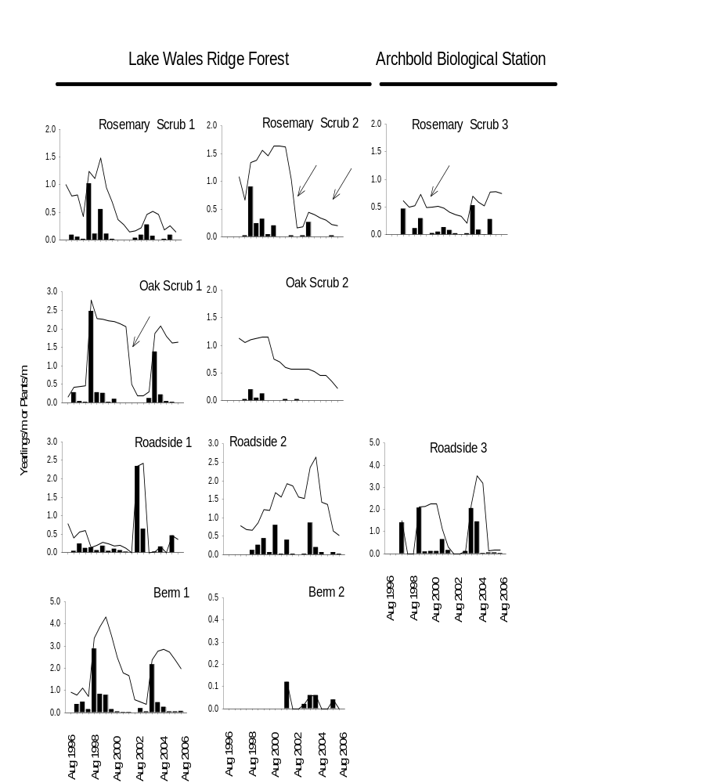Figure 1.

Lake Wales Ridge State Forest

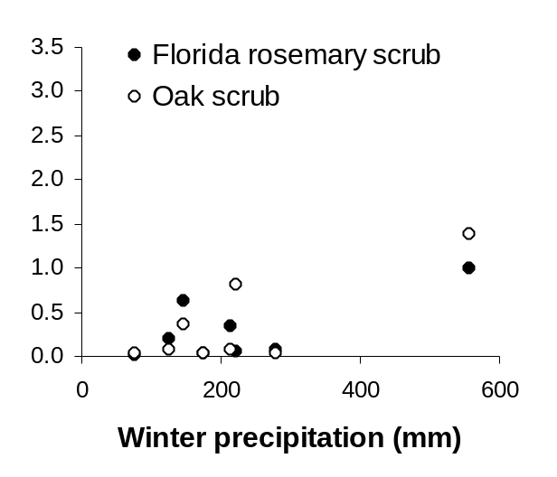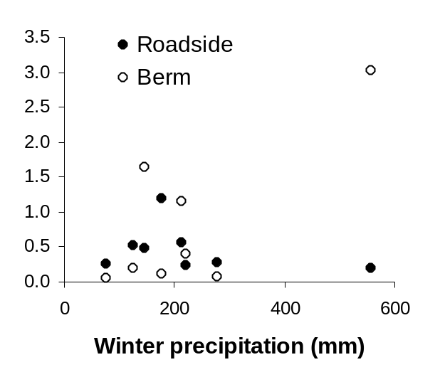
Seedlings/ m²

Archbold Biological Station

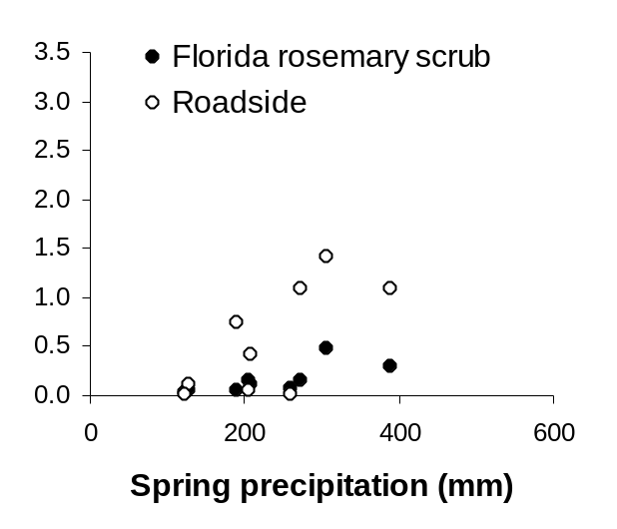
Seedlings/ m²

Fig. 2
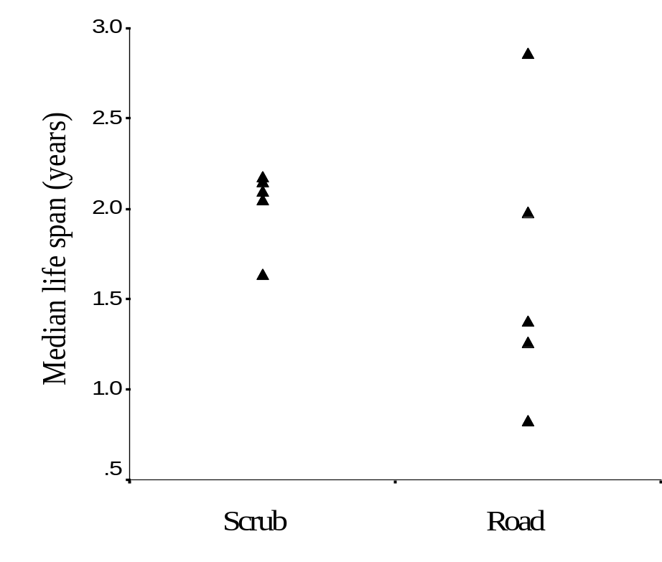

Figure 3.
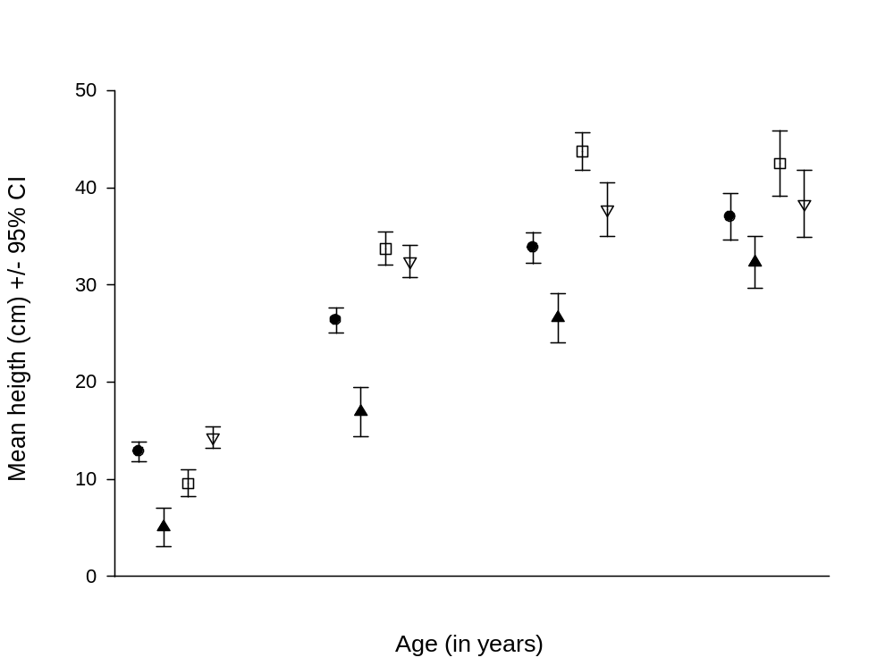
1 2 3 4
Florida Rosemary scrub
Oak scrub
Berm
Roadside
Figure 4.

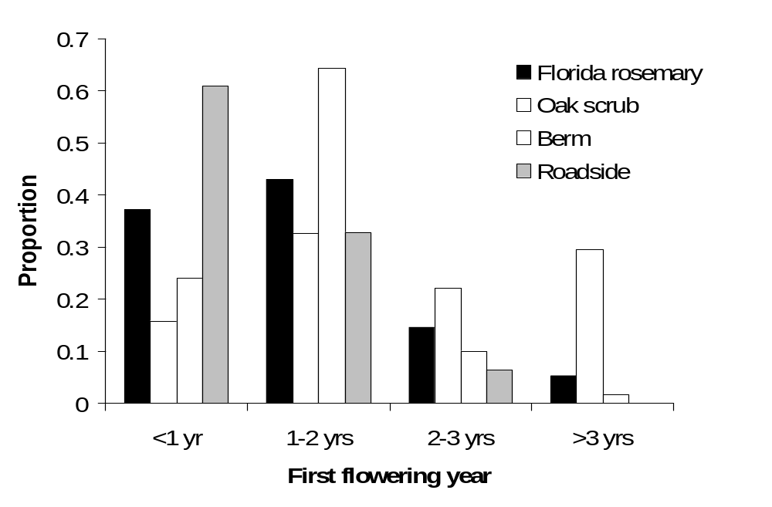

Figure 5

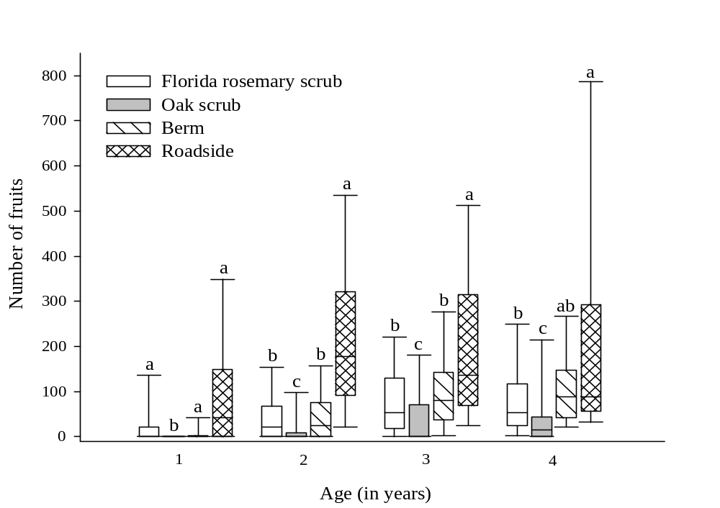

Figure 6

