Ecological Studies of Willow (Salix caroliniana):
Final Report – Year 2

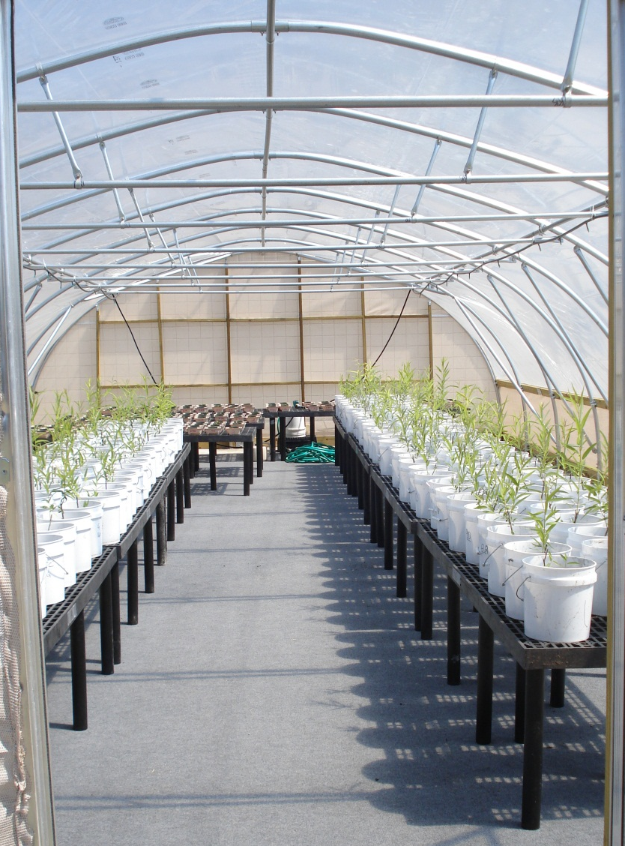

Drs. Pedro Quintana-Ascencio & John E. Fauth
with contributions from Luz M. Castro-Morales & Lisa McCauley

Department of Biology, University of Central Florida,
4000 Central Florida Boulevard, Orlando, Florida 32816


28 December 2010
Table of Contents

Acknowledgments | 3
List of Tables | 4
List of Figures | 5
List of Abbreviations | 7
Introduction | 8
Task 2.1 – Germination and early survival and growth experiments | 9
Germination experiments | 9
Early survival and growth experiments with willow seedlings and cuttings | 13
Task 2.2 – Willow transplantation | 41
Interspecific competition | 41
Hydrology  Additional hydrology experiment | 43  49
Task 2.3 – Fire response | 51
Task 2.4 – Willow life history | 53
Task 2.5 – Spatial analysis of willow distribution | 56
Task 2.6 – Demographic modeling | 57
Task 3.1-3.3 – Data analysis and final report | 58
Literature cited | 60

Acknowledgments

This project continued to benefit from contributions by many thoughtful and hard-working individuals. Dianne Hall, Kimberli Ponzio and Ken Snyder from the St. Johns River Water Management District provided access to sites, valuable advice about experiments, and many ideas about the willow invasion. We particularly thank the graduate students of Dr. Quintana-Ascencio’s Restoration Ecology class for their efforts: Ashley Bies, Brittany Billak, Maria Lina Sanchez Clavijo, Kathryn Elizabeth Brown, Jason Cade, and Danny Chen. Sarah Green, Jennifer Navarra, Hayley Smith and Elizabeth Stephens contributed with field and greenhouse work.

List of Tables

Table 1. Analysis of variance of proportion of willow seeds germinating | 10
Table 2. Nutrient concentrations for selected sites and multipliers used to determine nutrient addition concentrations in the greenhouse experiments | 16
Table 3. Seedlings per treatment that survived the entire greenhouse experiment | 19
Table 4. ANCOVA of growth in willow seedling height and contrasts among soil, nutrient, and watering regime treatments, and their interactions | 20
Table 5. ANCOVA of growth in willow seedling crown diameter and contrasts among soil, nutrients, and watering regime treatments, and their interactions | 24
Table 6. ANCOVA of change in number of leaves and contrasts among nutrient and watering regime treatments for seedlings | 27
Table 7. Cuttings per treatment combination that survived the experiment | 30
Table 8. ANCOVA of growth in stem length and contrasts among soil, nutrient, and watering regime treatments for willow cuttings | 31
Table 9. ANCOVA of growth in cutting stem diameter and contrasts among soil, nutrient, and watering regime treatments for willow cuttings | 33
Table 10. ANCOVA of change in number of leaves and contrasts among soil, nutrient, and watering regime treatments for willow cuttings  Table 11. Summary of responses to treatments in the two greenhouse experiments.  Table 12. Results of the field competition experiment | 35  40  42
Table 13. Analysis of variance of the percentage change in number of willow leaves in the island experiment | 47

List of Figures

Figure 1 – Demographic model of willow | 8
Figure 2 – Germination as a function of temperature regime and days until watering | 11
Figure 3 – Germination as a function of collection time and days until watering | 12
Figure 4 – Germination as a function of seed source and days until watering | 13
Figure 5 – Design of the cross-over experiment | 14
Figure 6 – Soil collection sites within the upper St. Johns River basin | 15
Figure 7 and cover photo – Willow cuttings (foreground) and seedlings (background) in greenhouse erected on the UCF campus  Figure 8 – Growth in seedling height as a function of soil treatment  Figure 9 – Growth in willow height as a function of initial seedling size and nutrient treatments  Figure 10 – Growth in willow seedling height as a function of initial seedling size and watering treatments  Figure 11 – Growth in willow crown diameter as a function of initial size and soil treatment  Figure 12 – Growth in willow crown diameter as a function of initial seedling size and watering treatments  Figure 13 – Growth in willow leaf number as a function of initial seedling size and soil treatments  Figure 14 – Growth in willow leaf number as a function of initial seedling size and watering treatments  Figure 15 – Growth in willow cutting height (= stem length) by soil treatment  Figure 16 – Growth in willow cutting stem diameter by soil treatment  Figure 17 – Growth in willow leaf number as a function of initial cutting size and soil treatments  Figure 18 – Growth in willow leaf number as a function of initial cutting size and watering treatments  Figure 19 – Growth in willow leaf number as a function of initial cutting size and nutrient treatments  Figure 20 – Locations of the northern, central, and southern blocks of the willow competition experiment  Figure 21 – Constructing experimental islands  Figure 22 – One of the four replicate willow islands  Figure 23 – Survival of willow seedlings as a function of elevation above initial marsh height  Figure 24 – Height of willow seedlings as a function of elevation above the initial marsh level  Figure 25 – Number of leaves on willow cuttings planted on four replicate islands at four different elevations above marsh level  Figure 26 – Design of the combined experiments on flooding and competition  Figure 27 – Arrangement of plants in the competition experiment  Figure 28 – Fire burned sawgrass but did not burn willow  Figure 29 – Small willow lit but did not burn  Figure 30 – Locations and habitats of willows sampled for demography data  Figure 31 – Removing a willow disk for dendrochronology analysis  Figure 32 – Predicted distribution of willow based on soil type  Figure 33 – Status of data sets | 17  21  22  23  23  25  26  28  29  32  34  36  37  38  42  43  44  45  46  48  49  50  51  52  54  55  56  57

List of Abbreviations

α | Type I error rate
ANCOVA | Analysis of covariance
BCMCA | Blue Cypress Marsh Conservation Area
df | degrees of freedom
diff | difference
F | F-ratio
FL | Florida
GIS | Geographic Information Systems
HSD | Honestly significant difference (Tukey’s method)
MS | mean square
P | statistical significance level
p_{adj} | adjusted p value
RLCA | River Lakes Conservation Area
SE | standard error
SD | standard deviation
SJMCA | St. Johns Marsh Conservation Area
SJRWMD | St. Johns River Water Management District
SS | sums of squares
SRWMA | Seminole Ranch Wildlife Management Area
UCF | University of Central Florida
Ecological Studies of Willow (Salix caroliniana): Final Report – Year 2

INTRODUCTION
The headwater region of the Upper St. Johns River has extensive wetlands dominated by herbaceous marshes, willow swamps, wet prairies, sloughs, shrub swamps and forested swamps. Over the past 40 years, woody shrubs – primarily Carolina willow (Salix caroliniana Michx.) – have encroached into areas that were historically herbaceous marsh. Woody shrub encroachment has been attributed to hydroperiod reductions, reduced fire frequency, and disturbance caused by construction of roads, levees, and canals. However, before we began our project in 2008, little information was available about the ecology of willow invasion in this watershed. The objectives of our project are to determine how:

- environmental factors such as soil type (peat, sand, clay), hydrology (saturated, flooded, dry), and nutrients (phosphorus, nitrogen, micronutrients) affect willow seed germination, growth, and survival; and
- fire, hydrology, and interspecific competition control the distribution of willow in marsh habitats.

We view the willow invasion as a multi-phase (Introduction → Colonization → Naturalization) and multi-scale process (individual, population, and region). We are addressing each phase using experiments and field observations, and will integrate the results into a predictive, demographic model (Fig. 1) to inform management decisions.

We will parameterize the model with probabilistic estimates of vital rates that reflect the performance of willow in contrasting environments, evaluate its relative success across regional ecosystems and map expected invasion fronts using geographic information systems (GIS). The goal is to identify areas susceptible to colonization and expansion of willow, identify practical management techniques, and prioritize management on areas critical for halting and eventually reversing the current invasion of herbaceous wetlands.

This report describes the major project elements completed in 2009-2010 and those that are still underway, and explains how they relate to overall objectives. Project elements are presented herein as tasks, with numbers corresponding to those in the Scope of Work.

Extensive documentation of this project, including photographs, raw data, spreadsheets and preliminary analyses are available on-line. The report from Year 1 of our work also is available at the same web site: http://biology.ucf.edu/~pascencio/willow%20research.html

Task 2.1 – Germination and early survival and growth experiments

Germination experiments – In Year 1, we conducted two germination experiments, which demonstrated that only green seeds were viable and that successful germination was strongly influenced by water availability. In Year 2, we conducted another growth chamber experiment to determine how long willow seeds remain viable. This information is vital to parameterize the life history model (Fig. 1) and for reducing willow invasion into marshes.

The experiment was performed at two temperature regimes representative of the Upper St. Johns River Basin: one similar to that of the northern region (State Route 50) and the other of the southern region (State Route 60). We collected willow seeds between March 5, 2010 and April 22, 2010. Seeds were held for different time periods and then germinated at each temperature regime. The entire design was repeated three times, with seeds collected early (SR 60, March 5; SR 50, March 21), middle (SR 60, March 19; SR 50, April 8) or late (SR 60, April 8; SR 50, April 22) in the flowering season. We collected viable (green) seeds from three different individuals per region, and organized seeds into groups of thirty, which were placed onto filter paper within a Petri dish. We then randomly selected and applied one of six different treatments: start watering on the same day seeds were collected or 2, 4, 6, 8 or 10 d later. During this time, seeds were maintained in a CMP 4030 (CONVIRON, Canada) growth chamber that reproduced spring temperature regimes for either Titusville, FL (north) or Lake Placid, FL (south). Thus, the experiment had all possible combinations of four main factors: season and location of seed collection, the number of days seeds were held before watering, and temperature regime in the growth chamber (Table 1).

Analysis of variance revealed that all four main effects were statistically significant, as well as three 2-way interactions and two 3-way interactions (Table 1). By far the single most important factor was the number of days before watering. Few willow seeds germinated when they were held 10 d without watering (Fig. 2-4) and seeds collected in mid-season remained viable the longest (Fig. 3). Temperature regime also was statistically significant, with seeds germinated under the cooler, northern temperature regime remaining viable slightly longer than those germinated under the warmer, southern temperature (Fig. 2). This result was independent of the number of days to watering (Table 1, non-significant D x T interaction). Similarly, seeds collected in the north location remained viable longer than those collected in the south, particularly toward the end of the 10-day holding period (Fig. 4).

Table 1. Analysis of variance of proportion of willow seeds germinating. Data angularly transformed to meet analysis assumptions. Adjusted R² = 0.94.

Source of variation | df | SS | MS | F | P
Days to watering (D) | 5 | 42.84 | 8.57 | 623.04 | <0.0001
Location of seed collection (L) | 1 | 0.07 | 0.07 | 5.13 | 0.025
Temperature regime (T) | 1 | 0.06 | 0.06 | 4.63 | 0.033
Seasonal timing of seed collection (S) | 2 | 0.70 | 0.35 | 25.41 | <0.0001
D x L | 5 | 0.52 | 0.10 | 7.53 | <0.0001
D x T | 5 | 0.07 | 0.02 | 1.08 | 0.374
L x T | 1 | 0.00 | 0.00 | 0.05 | 0.827
D x S | 10 | 1.20 | 0.12 | 8.72 | <0.0001
L x S | 2 | 0.69 | 0.35 | 25.08 | <0.0001
T x S | 2 | 0.04 | 0.02 | 1.33 | 0.267
D x L x T | 5 | 0.03 | 0.01 | 0.41 | 0.843
D x L x S | 10 | 0.38 | 0.04 | 2.78 | 0.003
D x T x S | 10 | 0.08 | 0.01 | 0.55 | 0.853
L x T x S | 2 | 0.09 | 0.05 | 3.40 | 0.036
D x L x T x S | 10 | 0.05 | 0.01 | 0.35 | 0.964
Residuals | 144 | 1.98 | 0.01
Total | 215 | 48.8

Combined, these results indicate that willow seeds are viable for only a short time (ca. 8-10 d) but that seed dispersal times and germination success varies between locations along the north-south gradient. Thus, willow seeds can be prevented from germinating if favorable microhabitats (such as open areas of disturbed, moist soil) do not become available until about two weeks after adult willows cease producing viable, green seeds. The exact date this occurs will vary from location to location and among years, and may be determined by monitoring specific areas of interest.

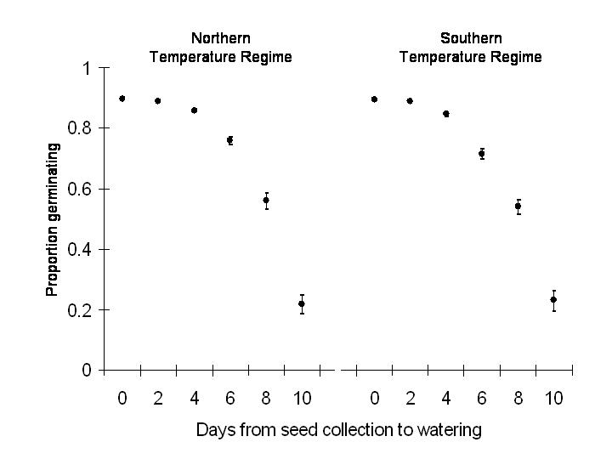
Arcsine(proportion)
Fig. 2. Mean and 95% CI of willow germination as a function of temperature regime and days until watering. Confidence intervals are asymmetrical because they were back-calculated from the angularly-transformed data used for hypothesis testing. The northern temperature regime was based on Titusville, FL and the southern regime on Lake Placid, FL.

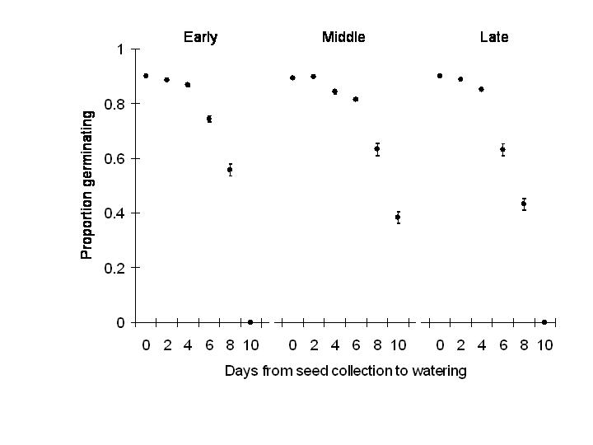Fig. 3. Mean and 95% CI of willow germination as a function of collection time (early, middle, and late in flowering season) and days until watering. Confidence intervals are asymmetrical because they were back-calculated from the angularly-transformed data used for hypothesis testing.
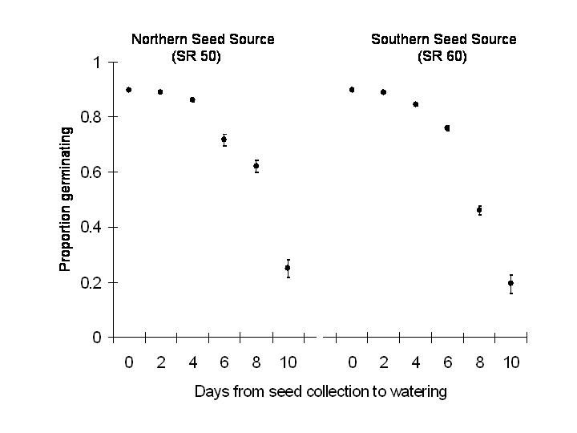
Fig. 4. Mean and 95% CI of willow germination as a function of seed source and days until watering. Confidence intervals are asymmetrical because they were back-calculated from the angularly-transformed data used for hypothesis testing.

Early survival and growth experiments with willow seedlings and cuttings – We completed two greenhouse experiments to assess germination and early survival of Carolina willow seedlings and cuttings under different soil types, nutrient levels, and moisture regimes. Both experiments used a similar randomized complete block design with six different soil types crossed with four levels of moisture, and maintained at one of six nutrient levels (Fig. 5). Each treatment combination was replicated 4-8 times, with the goal of maintaining a completely balanced design.

We created six soil treatments using pure soils and 50:50 mixtures (by volume) of three soil types. The resulting six treatments spanned a range of wetland soils typical of sites that are susceptible or resistant to willow invasion. We collected inorganic soil (Floridana sand) from a site within St. Johns Marsh Conservation Area (SJMCA) near Sawgrass Lake. Willow was absent from this site, which was dominated by grasses and cabbage palm (Sabal palmetto). We collected organic soil with high nitrogen and phosphorus from the River Lakes Conservation Area (RLCA), within an area where invading willows were removed using intensive mechanical treatments. We collected organic soil with lower phosphorus levels from Blue Cypress Marsh Conservation Area (BCMCA) in an interior location where willows were small and more sparsely distributed within a sawgrass (Cladium jamacensis) marsh (Fig. 6).

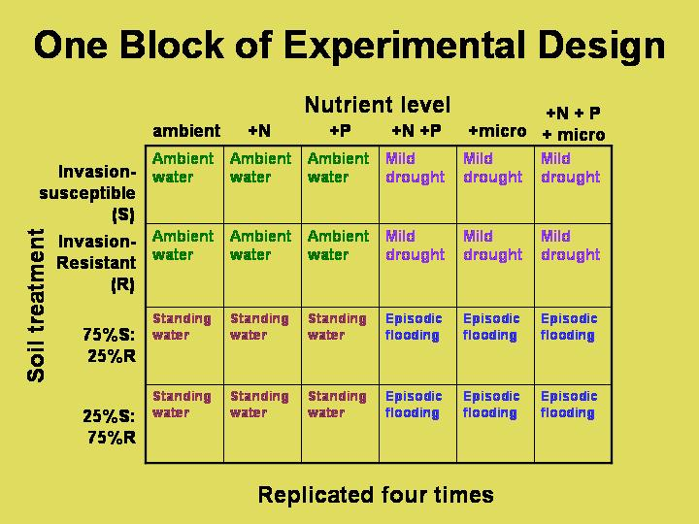

Fig. 5. One-quarter of the cross-over experiment. Each nutrient treatment was delivered to an individual pot in sequence; thus, the treatments “cross-over” and responses to every treatment are recorded for each individual pot. This can be visualized as a rotation of the watering treatments (colored text) in the diagram above.

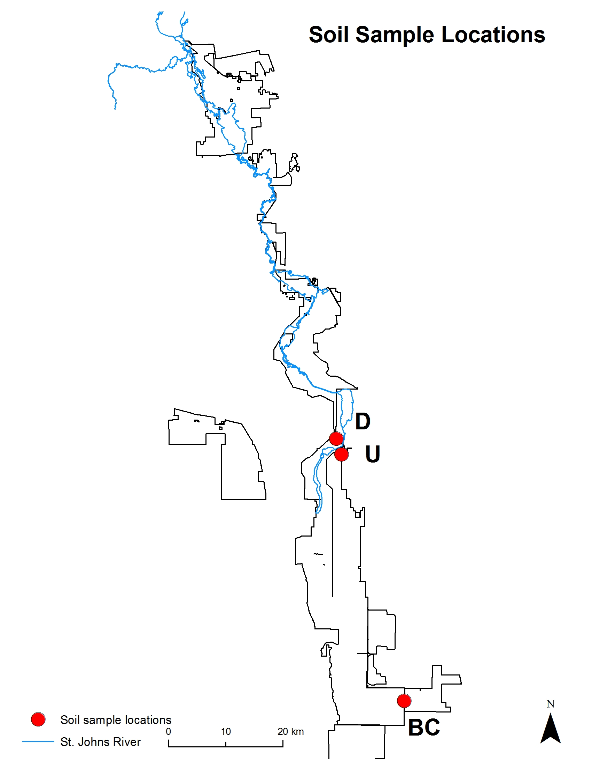
RL
SJ

Fig. 6. Location of soil collection sites within the upper St. Johns River basin. RL (organic soil with high nitrogen); SJ = sandy soil; BC = Blue Cypress (organic soil with high phosphorus).
We established six nutrient treatments using fertilizers to produce:

1) ambient nutrients (i.e., those in tap water)
2) enhanced NH₄ (ambient + 0.375 mg/l)
3) enhanced PO₄ (ambient + 0.25 mg/l)
4) enhanced NH₄ & PO₄
5) enhanced micronutrients: K = ambient + 8 mg/l , Cu = ambient + 5 µg/l , Mg = ambient + 14 mg/l , Fe = ambient + 600 µg/l, and
6) enhanced NH₄, PO₄ & micronutrients.

Nutrient additions were determined from maximal concentrations found in water samples collected in impacted or higher-nutrient areas within SJMCA multiplied by a correction factor supplied by District staff (Table 2).

Table 2. Nutrient concentrations for selected sites and multipliers used to determine nutrient addition concentrations in the greenhouse experiments. Data are five-year averages (2002-2007) provided by the District.

Marsh System | TP (mg/L) | TN (mg/L) | PO4 (mg/L) | NH4 (mg/L) | NOx (mg/L) | K (mg/L) | Cu (μg/L) | Mg (mg/L) | Fe (μg/L)
Fort Drum | 0.09 | 1.5 | 0.044 | 0.05 | 0.012 | 3.8 | 1.33 | 4.3 | 258
BCWMA East | 0.013 | 1.8 | 0.002 | 0.051 | 0.014 | 5.3 | 0.55 | 6.5 | 138
BCWMA West | 0.102 | 2 | 0.056 | 0.077 | 0.008 | 8.5 | 1.22 | 9.7 | 57
BCMCA BCT | 0.04 | 2.9 | 0.003 | 0.057 | 0.018 | 2.1 | 1.19 | 3.8 | 320
BCMCE | 0.01 | 1.7 | 0.008 | 0.05 | 0.007 | 4.2 | 0.55 | 6.5 | 80
SJMCA BBM | 0.103 | 1.96 | 0.069 | 0.029 | 0.01 | 3.6 | 0.64 | 6.5 | 231
SJMCA MBM | 0.313 | 3.84 | 0.102 | 0.065 | 0.019 | 4.3 | 1.24 | 7.1 | 365
SJMCA SMME | 0.155 | 2.0 | 0.078 | 0.051 | 0.015 | 3.8 | 2.56 | 6.3 | 397
USH | 0.11 | 1.95 | 0.031 | 0.075 | 0.019 | 3.56 | 0.53 | 7.1 | 218
Max obs |  |  | 0.1 | 0.075 |  | 4 | 2.5 | 7 | 400
Multiplier |  |  | 2.5 | 5 |  | 2 | 2 | 2 | 1.5
Used Concentration |  |  | 0.25 | 0.375 |  | 8 | 5 | 14 | 600
Nutrients were delivered to the pots biweekly by watering at the same time pots were re-randomized to new positions within the greenhouse (Fig. 7).

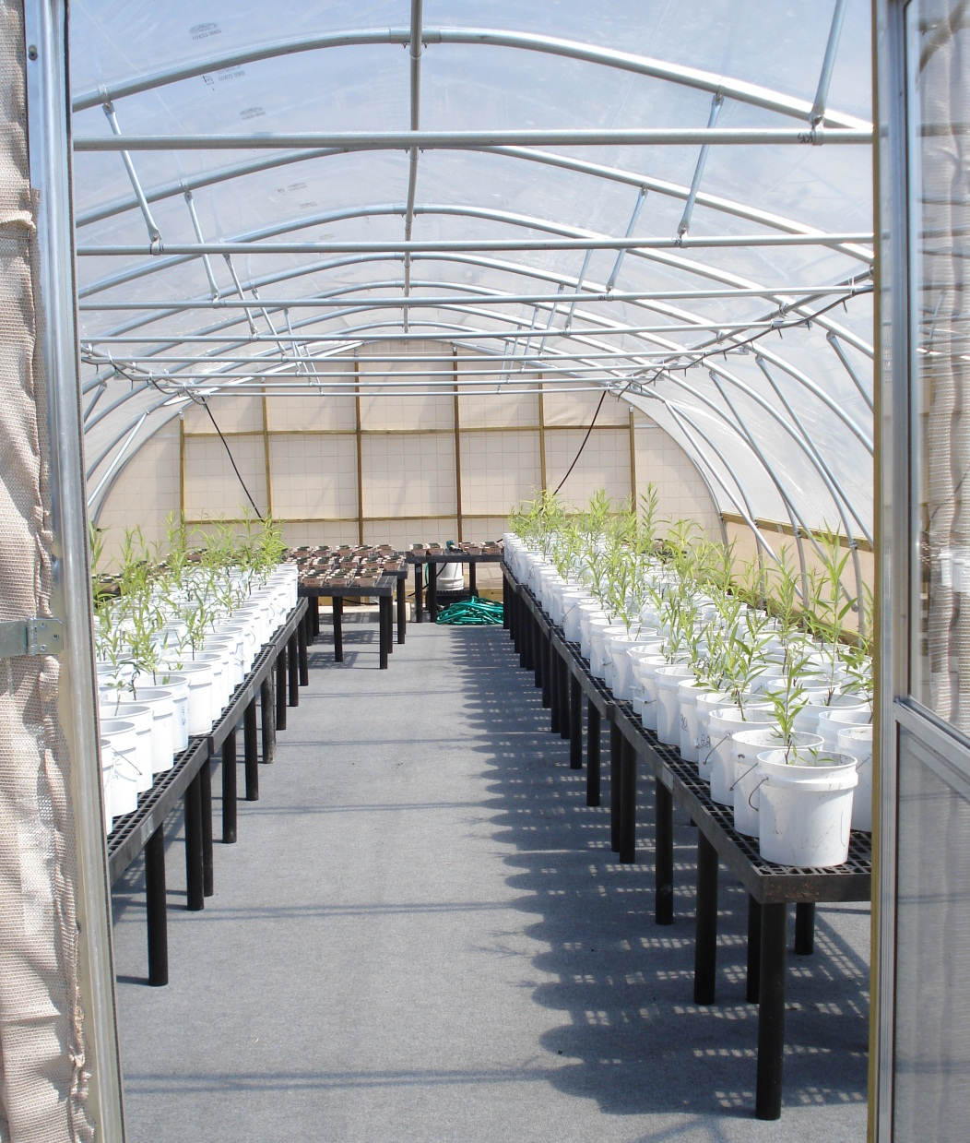

Fig. 7. Willow cuttings (foreground, in large white containers) and seedlings (background) in greenhouse erected for this project on the UCF campus.
The hydrologic regime followed one of four schedules (cf. Pezeshki et al. 1998):

1) Ambient Rainfall = watered from above every other day with 178 mL of tap water; total application of water equivalent to mean central Florida wet season rainfall, which is 76.9 cm (30.27”) When watering exceeded evapotranspiration, water sometimes accumulated 1-2 cm deep in the plastic bucket, allowing soil to wick water up.

2) Simulated Drought = watered from above every other day with tap water; total application of water equivalent to one-half the mean central Florida wet season rainfall (as estimated from past 20 years of precipitation data). Water never accumulated in the plastic bucket so soils were never saturated.

3) Constant Inundation = watered from above every other day with tap water, but with water levels maintained above the soil surface by ~ 1 cm. Soils were constantly saturated and the soil surface was flooded.

4) Fluctuating Water Level = This treatment simulated flashy (short-term) changes in hydrology. In this treatment, pots were watered from above every other day with tap water during Week 1, which was identical to the Ambient Rainfall condition. In weeks 2 & 3, we watered pots from above every other day with 178 mL of tap water, but with water levels maintained above the soil surface by ~ 1 cm. This was identical to the Constant Inundation condition. In the last week, we removed water from the buckets and again watered pots from above every other day with 178 mL of tap water (= Ambient Rainfall condition).

We superimposed soil moisture treatments to the 36 soil type/nutrient treatment combinations using a cross-over design (Fig. 5; also see Mead 1988). Soil moisture treatments were applied in sequence to each pot, the sequence being different for different pots. Soil moisture was rotated monthly, with each pot provided with each soil moisture treatment once during the experiment. This design was logistically feasible and also had very high statistical power.

One seedling or one rooted cutting was in each pot during the cross-over experiment. We collected seeds and cuttings from multiple willows at four locations within SJRWMD lands and pooled them into homogeneous groups. Thirty seeds were initially germinated per pot and then thinned to reach one established seedling per pot. Cuttings were rooted in pots with moist potting soil, then removed, washed, and transplanted to pots with the experimental soil types. Plants were acclimated to greenhouse conditions for at least 1 mo prior to the start of the experiment. When the experiment began on May 14, seedlings were almost 0.5 m shorter (mean = 45.34 mm ± 20.65 mm SD, N = 178) than cuttings (mean = 542.35 mm ± 241.80 mm SD, N = 166).

Analysis of the seedling experiment was challenging because of high mortality in certain watering treatments (Table 3). This led to an unbalanced design, which required a careful analysis; additional details are in the monthly reports and salient results are given here.

Table 3. Number of seedlings per treatment that survived the whole experiment. Soil types were Blue Cypress (BC), River Lakes (RL), St. Johns (SJ) and their 50:50 mixtures.

Nutrients | Soil type
 | BC | BC/RL | BC/SJ | RL | SJ | RL/SJ
Control | 3 | 2 | 4 | 0 | 2 | 1
micronutrients | 4 | 2 | 2 | 4 | 2 | 2
N | 3 | 4 | 3 | 1 | 3 | 0
N P | 4 | 3 | 3 | 1 | 3 | 0
N P micronutrients | 4 | 5 | 5 | 2 | 0 | 1
P | 4 | 1 | 3 | 4 | 3 | 2

Plants on substrate combinations that contained BC soil had at least one survivor per treatment combination (Table 3), so we analyzed a subset that included only those plants on BC soils and its combinations. We analyzed the variation in growth, height, and crown diameter:

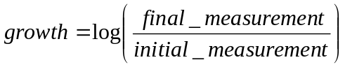

This transformation accounted for individual variation in size and reduced the temporal correlation between consecutive evaluations.

We controlled additional non-treatment variation by using size at the beginning of each interval as a covariate. This allometric function accounted for significant variation in all variables.

We analyzed variation in the change in number of leaves as:



Non-treatment variation was controlled by using number of leaves (or its logarithm) at the beginning of each interval as a covariate. This allometric function accounted for significant variation in the change in the number of leaves for both stages. The leaf count of one seedling was missed during one evaluation, so we analyzed data without this single plant. One seedling plant that lost all its leaves between treatments but did not die had exceptional decrease in crown diameters. We therefore analyzed the data with and without this outlier.

Growth in height of willow seedlings varied significantly with their initial height and all experimental factors (Table 4, top). Initial seedling height had the largest influence, followed by soil type and the initial height x soil type interaction. Seedlings established on pure BC soil increased the most in height compared to those in soil mixtures except at the very largest initial seedling sizes (Table 4, bottom; Fig. 8).

Table 4. (Top) Analysis of covariance of growth in willow seedling height as a function of soil, nutrients, watering regime, and their interactions. Log of initial size was used as a covariate. All plants on BC soil or its combinations were included (r²=0.748). Table entries are sources of variation, degrees of freedom (df), sums of squares (SS), mean squares (MS), F-ratios (F) and their associated probabilities (P).

Source of variation | df | SS | MS | F | P
log(initial) | 1 | 18.1312 | 18.1312 | 718.346 | <0.0001
Soil | 2 | 0.7215 | 0.3608 | 14.2936 | <0.0001
Nutrients | 5 | 0.4268 | 0.0854 | 3.3818 | 0.006
Watering regime | 3 | 0.2098 | 0.0699 | 2.7703 | 0.042
log(initial) x Soil | 2 | 0.6441 | 0.3221 | 12.7603 | <0.0001
log(initial) x Nutrients | 5 | 0.5595 | 0.1119 | 4.4336 | <0.0007
Residuals | 276 | 6.9663 | 0.0252

(Bottom) Simple contrasts among treatment levels for this ANOVA. Reference treatments (BC for soils, ambient nutrient levels, and ambient rainfall) do not appear in the list. Because contrasts were not independent we used the Bonferroni adjustment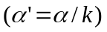to obtain an experimentwise error rate of 0.017 for nutrient comparisons and 0.01 for watering treatments and soils. Statistically significant contrasts with reference treatments are in bold.

Coefficients | Estimate | Std.Error | t | Pr(>|t|)
(Intercept) | 2.381 | 0.187 | 12.728 | <0.0001
log(initial) | -0.386 | 0.037 | -10.418 | <0.0001
Soil BCRL | -0.539 | 0.180 | -2.994 | 0.003
Soil BCSJ | -0.678 | 0.147 | -4.605 | <0.0001
Nutrients micro | 0.190 | 0.254 | 0.747 | 0.456
Nutrients N | -0.573 | 0.225 | -2.550 | 0.011
Nutrients NP | 0.203 | 0.226 | 0.896 | 0.371
Nutrients NPmic | 0.368 | 0.225 | 1.634 | 0.103
Nutrients P | -0.050 | 0.235 | -0.212 | 0.832
Fluctuating water level | 0.020 | 0.026 | 0.760 | 0.448
Simulated drought | -0.053 | 0.026 | -2.052 | 0.041
Constant inundation | -0.024 | 0.026 | -0.922 | 0.357
log(initial) x SoilBCRL | 0.091 | 0.035 | 2.578 | 0.010
log(initial) x SoilBCSJ | 0.117 | 0.029 | 4.028 | <0.0001
log(initial) x Nutrientsmicro | -0.027 | 0.049 | -0.553 | 0.581
log(initial) x NutrientsN | 0.108 | 0.045 | 2.404 | 0.017
log(initial) x NutrientsNP | -0.034 | 0.045 | -0.763 | 0.446
log(initial) x NutrientsNPmic | -0.065 | 0.044 | -1.472 | 0.142
log(initial) x NutrientsP | 0.017 | 0.047 | 0.372 | 0.710

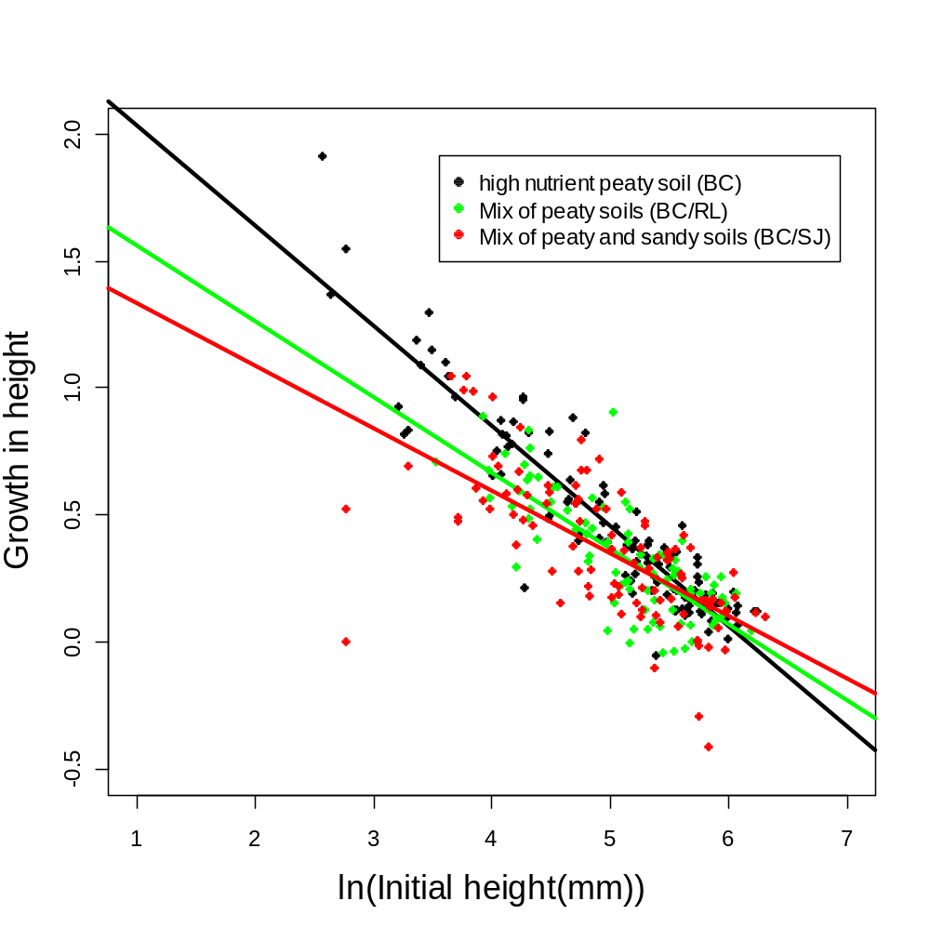
Fig. 8. Growth in willow seedling height as a function of the natural logarithm of initial size and soil treatment. Small seedlings grew significantly faster on pure BC soil (black symbols) than on mixtures but the difference was smaller for large seedlings.

The most striking result was lower mean growth in seedling height in the nitrogen-addition treatments relative to the controls, except for the very largest seedlings (Table 4, Fig. 9). This result can arise if nitrogen addition promotes growth of microbes (soil algae, bacteria and fungi) that interfere or compete with willow seedlings, especially those that initially are small.

Compared to the control, only the simulated drought treatment influenced willow growth in height but this contrast was not statistically significant (Table 4, Fig. 10). Seedlings in the simulated drought treatment grew slowly, if they survived. These results are consistent with the field competition and island experiments, where seedlings died during the dry season and at the highest elevations above marsh level, and did not survive when submerged.
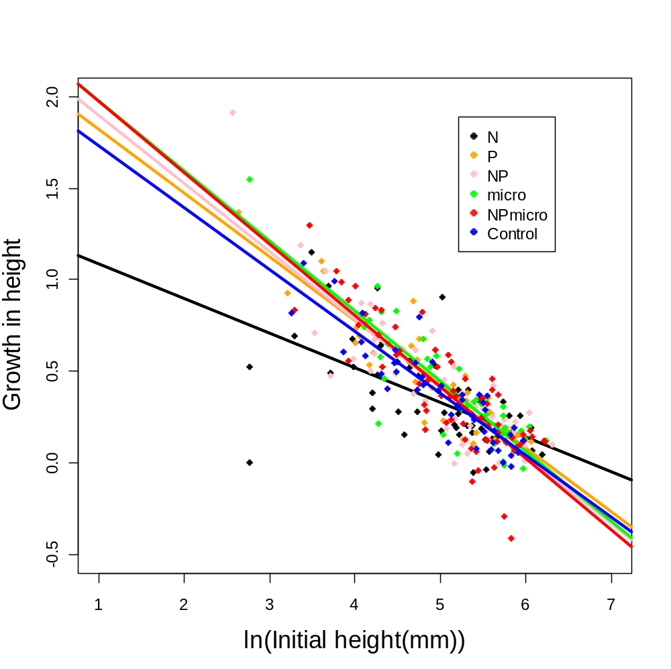

Fig. 9. Growth in willow seedling height as a function of the natural logarithm of initial seedling size and nutrient treatments. Notice the lower growth of seedlings in the nitrogen-addition treatment (black symbols) compared to all others, except for the very largest seedlings, where the difference disappears.

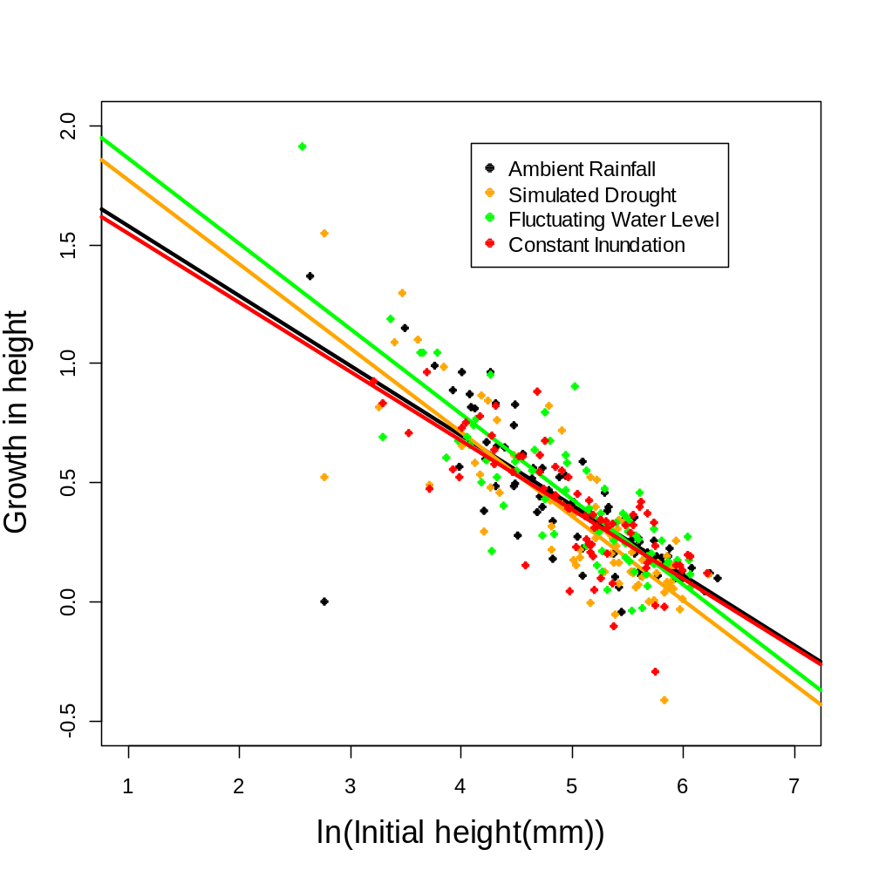
Fig. 10. Growth in willow height as a function of initial seedling size and watering treatments.
Crown diameter varied significantly among soil and watering treatments (Table 5). Seedlings established on pure BC soil increased the most in crown diameter compared to those in soil mixtures, especially the sandy BCSJ mixture (Table 5, bottom; Fig. 11). Crown growth also was significantly higher in the ambient watering treatment than in either simulated drought or constant inundation (Table 5, bottom; Fig. 12).

Table 5. (Top) Analysis of covariance of growth in willow seedling crown diameter as a function of soil, nutrients and watering regime. Log of initial size was used as covariate. All plants on BC soil or its combinations were included (r²=0.44). Entries are as in Table 4.
 | df | SS | MS | F | P
log(initial) | 1 | 13.3638 | 13.3638 | 165.4458 | <0.0001
Soil | 2 | 2.6211 | 1.3105 | 16.2245 | <0.0001
Nutrients | 5 | 0.437 | 0.0874 | 1.082 | 0.370
Watering | 3 | 0.8845 | 0.2948 | 3.6501 | 0.013
log(initial) x Soil | 2 | 0.2792 | 0.1396 | 1.7282 | 0.179
Residuals | 281 | 22.6977 | 0.0808

(Bottom) Simple contrasts among treatments levels for growth in crown diameter. Statistically significant contrasts are in bold and use the same Bonferroni adjustment as in Table 4.

Coefficients:
 | Estimate | Std.Error | t | Pr(>|t|)
(Intercept) | 2.849 | 0.222 | 12.822 | <0.0001
log(initial) | -0.665 | 0.056 | -11.970 | <0.0001
Soil Treatments  SoilBCRL | -0.793 | 0.358 | -2.216 | 0.028
SoilBCSJ | -0.807 | 0.322 | -2.509 | 0.013
Watering Treatments  Fluctuating water level | -0.056 | 0.040 | -1.402 | 0.162
Simulated drought | -0.123 | 0.040 | -3.075 | 0.002
Constant inundation | -0.100 | 0.040 | -2.499 | 0.013

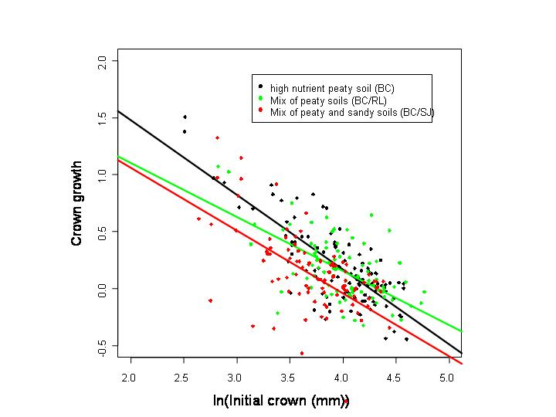

Fig. 11. Growth in willow crown diameter as a function of initial size and soil treatment. Crown growth was significantly higher on pure BC soil (black symbols) than on the BCSJ mixture (red symbols).

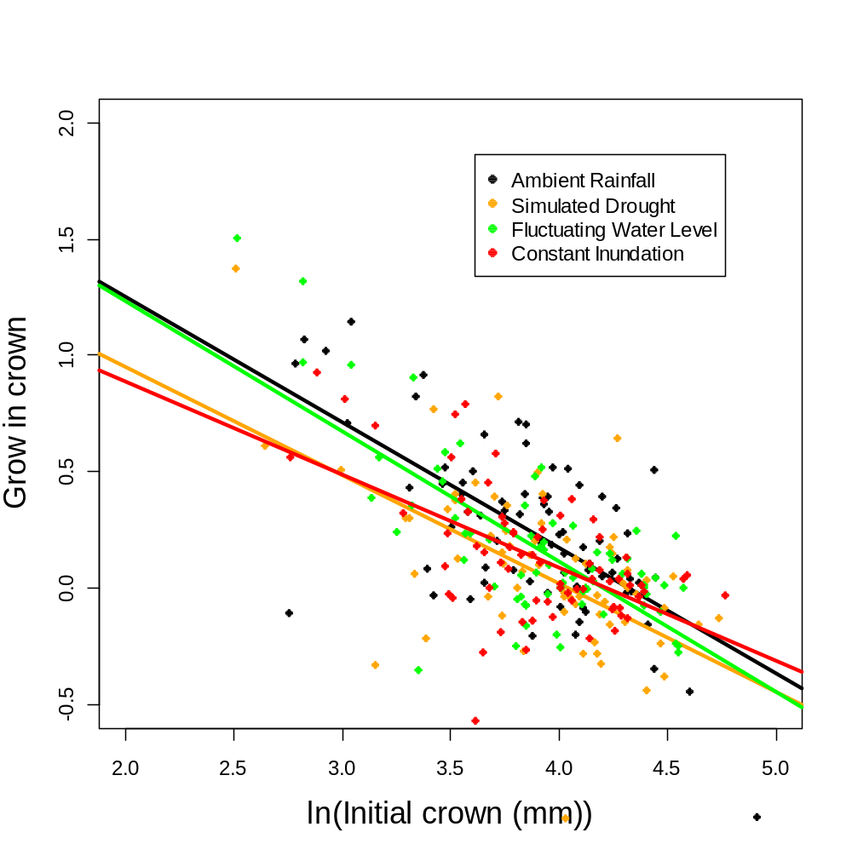
Fig. 12. Growth in willow crown diameter as a function of initial seedling size and watering treatments. Notice the significantly lower crown growth of seedlings in the simulated drought (orange symbols) and constant inundation (red symbols) treatments compared to the ambient rainfall control (black symbols)

Growth in the number of leaves varied significantly with initial number of leaves, soil type, and watering regime (Table 6, top). Willow seedlings established on the 50% Blue Cypress:50% St. Johns soil mixture or in the simulated drought treatment grew significantly fewer leaves than the control treatments (Table 6, bottom; Figs. 13 & 14). Nutrient treatment had no significant effect on the number of leaves grown by seedlings (Table 6).

Table 6. (Top) Analysis of covariance of change in number of leaves as a function of soil, nutrients and watering regime for seedlings. All plants on BC soil or its combinations were included except one plant without data in one evaluation. Log of initial number of leaves was used as a covariate (r²=0.34). Entries are the same as in Table 4.

Source of variation | Seedlings
 | df | SS | MS | F | P
log(initial) | 1 | 25.035 | 25.035 | 130.986 | <0.0001
Soil | 2 | 2.615 | 1.308 | 6.842 | <0.0001
Nutrients | 5 | 0.414 | 0.083 | 0.433 | 0.826
Watering | 3 | 2.026 | 0.675 | 3.533 | 0.015
log(initial):Soil | 2 | 0.55 | 0.275 | 1.439 | 0.239
log(initial):Nutrients | 5 | 0.871 | 0.174 | 0.912 | 0.474
Residuals | 271 | 51.795 | 0.191

(Bottom) Simple contrasts among treatments for change in the number of leaves in seedlings. The reference treatment (Simulated draught) does not appear in the list. Significant contrasts are in bold and use the same Bonferroni adjustment as in Table 4. Nutrient treatment and interactions did not explain significant variation and therefore are not included in the contrasts.

Coefficients:
 | Estimate | Std.Error | t | Pr(>|t|)
(Intercept) | 1.785 | 0.137 | 13.07 | <0.0001
log(initial) | -0.463 | 0.040 | -11.72 | <0.0001
Soil Treatments  Soil BCRL | -0.013 | 0.064 | -0.20 | 0.842
Soil BCSJ | -0.204 | 0.061 | -3.35 | 0.001
Watering Treatments  Simulated drought | -0.218 | 0.073 | -3.00 | 0.003
Ambient | -0.035 | 0.072 | -0.48 | 0.631
Submerged | -0.048 | 0.073 | -0.65 | 0.516

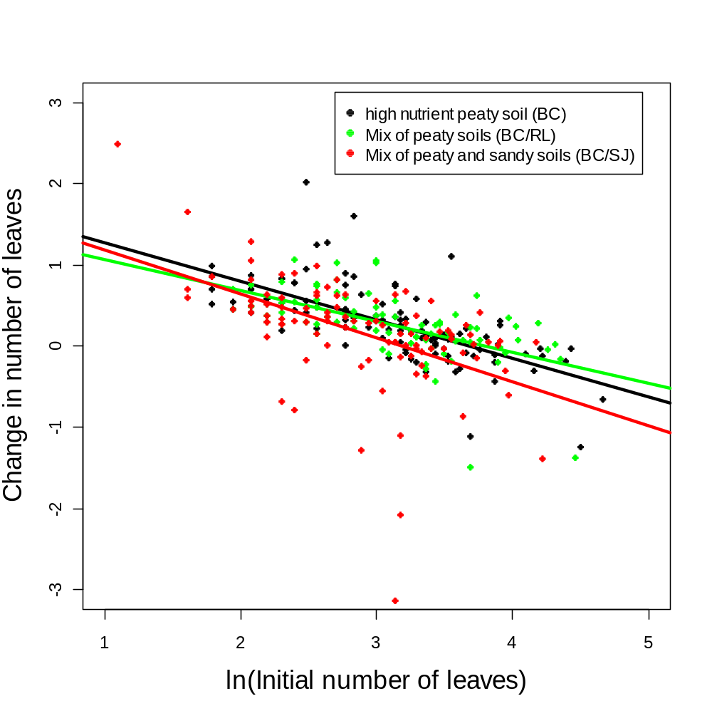
Fig. 13. Growth in number of leaves as a function of initial seedling size and soil treatments. Seedlings grew significantly fewer leaves when potted in the BCSJ soil mixture (red symbols) than in pure BC soil (black symbols).

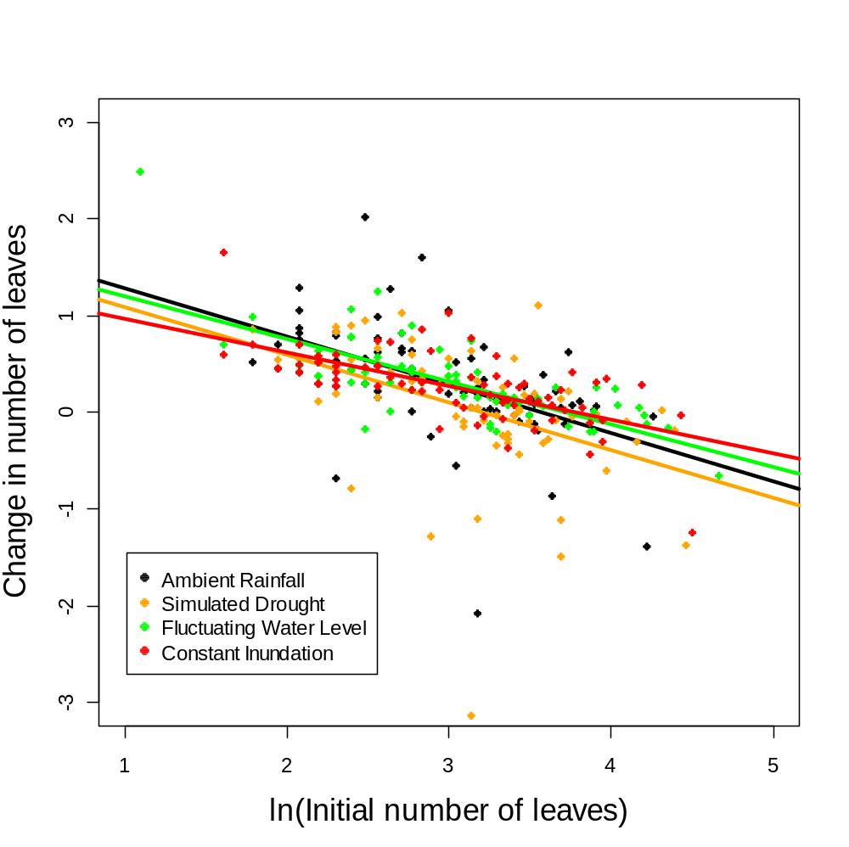
Fig. 14. Growth in number of leaves as a function of initial seedling size and watering treatments. Seedlings grew significantly fewer leaves during simulated drought (orange symbols) compared to ambient rainfall (black symbols).

High survival of willow cuttings allowed us to analyze data on stem diameter and stem length variation using the original design (Table 7). We controlled additional non-treatment variation using size at the beginning of each interval as a covariate. This allometric function accounted for significant variation in stem diameter, but not stem length.

Table 7. Number of cuttings per treatment combination that survived the whole experiment. Soil types are Blue Cypress (BC), River Lakes (RL), St. Johns (SJ) and their 50:50 mixtures.

Nutrients | Soil type
 | BC | BC/RL | BC/SJ | RL | SJ | RL/SJ
Control | 4 | 3 | 5 | 4 | 4 | 4
micronutrients | 5 | 5 | 4 | 4 | 4 | 5
N | 5 | 5 | 4 | 5 | 4 | 5
N P | 5 | 5 | 5 | 3 | 6 | 4
N P micronutrients | 4 | 5 | 5 | 3 | 5 | 5
P | 5 | 5 | 4 | 4 | 6 | 4

Nutrients and watering regime had no detectable effect on stem growth (Table 8, top). The high statistical power of this experiment makes it unlikely that this occurred due to a Type II error and the low F-ratios indicate that these factors explained little variation.

Growth in height (= stem length) varied significantly with the initial diameter x soil interaction (Table, top). Small plants grown in sandy, SJ soils barely increased in height while larger cuttings in the same soil treatment displayed the largest increases in diameter (Table 8, bottom; Fig. 15).

Growth in stem diameter did vary significantly among soils and with the initial diameter x soil interaction. Cuttings with small initial sizes grew more slowly than those with large initial diameters, especially in BC or BC/RL soil. However, cuttings with large initial sizes and potted in BC /RL soil grew the fastest, hence the large initial size x soil interaction term (Table 9, bottom; Fig. 16).

Table 8. (Top) Analysis of covariance of growth in stem length as a function of soil, nutrients and watering regime. Initial length was used as covariate (r²=0.042, P=0.003). Entries are the same as in Table 4.

Response: | Stem length growth
 | df | SS | MS | F | P
Initial | 1 | 0.164 | 0.164 | 1.5687 | 0.21086
Soil | 5 | 0.434 | 0.087 | 0.8302 | 0.52842
Nutrients | 5 | 1.016 | 0.203 | 1.9444 | 0.08513
Watering regime | 3 | 0.329 | 0.110 | 1.0489 | 0.37036
Initial x Soil | 5 | 2.19 | 0.438 | 4.1926 | 0.00093
Residuals | 628 | 65.613 | 0.104

(Bottom) Simple contrasts among the levels of treatments for growth in stem length. The reference treatment (BC soil) does not appear in the list. Statistically significant contrasts in bold.

Coefficients:
 | Estimate | Std.Error | t | Pr(>|t|)
Intercept | 0.2114 | 0.0832 | 2.543 | 0.01124
initial | 0.0000 | 0.0001 | -0.32 | 0.74932
Soil Treatments  SoilRL | 0.0732 | 0.1315 | 0.556 | 0.57822
SoilRLBC | -0.1729 | 0.1364 | -1.268 | 0.20523
SoilSJ | -0.3667 | 0.1190 | -3.08 | 0.00216
SoilSJBC | -0.2662 | 0.1300 | -2.048 | 0.04092
SoilSJRL | 0.0947 | 0.1242 | 0.762 | 0.44621
Interactions  initial:SoilRL | 0.0000 | 0.0001 | -0.419 | 0.67555
initial:SoilRLBC | 0.0001 | 0.0001 | 0.951 | 0.34215
initial:SoilSJ | 0.0004 | 0.0001 | 3.304 | 0.00101
initial:SoilSJBC | 0.0002 | 0.0001 | 1.659 | 0.09754
initial:SoilSJRL | -0.0001 | 0.0001 | -0.654 | 0.51344

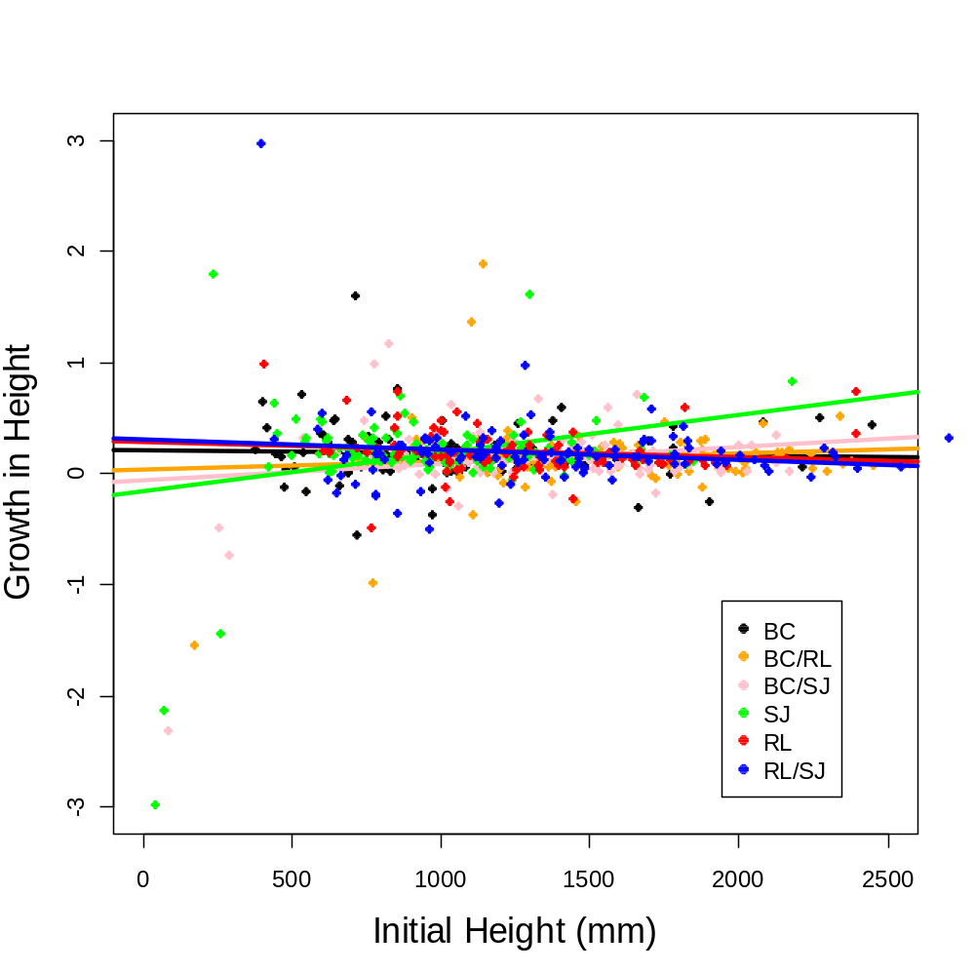
Fig. 15. Growth in willow height (= stem length) as a function of initial cutting height and soil treatment. Soils that supported the most growth at small initial cutting heights (RLSJ, blue symbols; RL, red symbols; BC, black symbols) supported the least growth when cuttings initially were large.
Table 9. (Top) Analysis of covariance of growth in cutting stem diameter as a function of soil, nutrients, and watering regime. Initial diameter was used as a covariate (r²=0.338). Entries are the same as in Table 4.

Response: | Stem diameter
Source of variation | df | SS | MS | F | P
Initial | 1 | 5.114 | 5.114 | 268.263 | <0.0001
Soil | 5 | 0.365 | 0.073 | 3.825 | 0.00202
Nutrients | 5 | 0.119 | 0.024 | 1.245 | 0.28655
Watering regime | 3 | 0.058 | 0.019 | 1.006 | 0.38980
Initial x Soil | 5 | 0.464 | 0.093 | 4.870 | 0.00022
Residuals | 628 | 11.972 | 0.019

(Bottom) Simple contrasts among the treatment levels for growth in diameter. The reference treatment (BC soil) does not appear in the list. Statistically significant contrasts in bold.

Coefficients:
 | Estimate | Std.Error | t | Pr(>|t|)
(Intercept) | 0.388381 | 0.06263 | 6.201 | <0.0001
initial | -0.03306 | 0.006907 | -4.787 | <0.0001
Soil Treatments
SoilRL | 0.251601 | 0.087987 | 2.86 | 0.0044
SoilRLBC | -0.08708 | 0.091406 | -0.953 | 0.3411
SoilSJ | 0.192937 | 0.085274 | 2.263 | 0.0240
SoilSJBC | 0.207531 | 0.086585 | 2.397 | 0.0168
SoilSJRL | 0.152724 | 0.085184 | 1.793 | 0.0735
Interactions  initial:SoilRL | -0.02124 | 0.009272 | -2.291 | 0.0223
initial:SoilRLBC | 0.014414 | 0.009269 | 1.555 | 0.1204
initial:SoilSJ | -0.01661 | 0.009192 | -1.806 | 0.0713
initial:SoilSJBC | -0.01681 | 0.009099 | -1.848 | 0.0651
initial:SoilSJRL | -0.01098 | 0.008924 | -1.231 | 0.2189

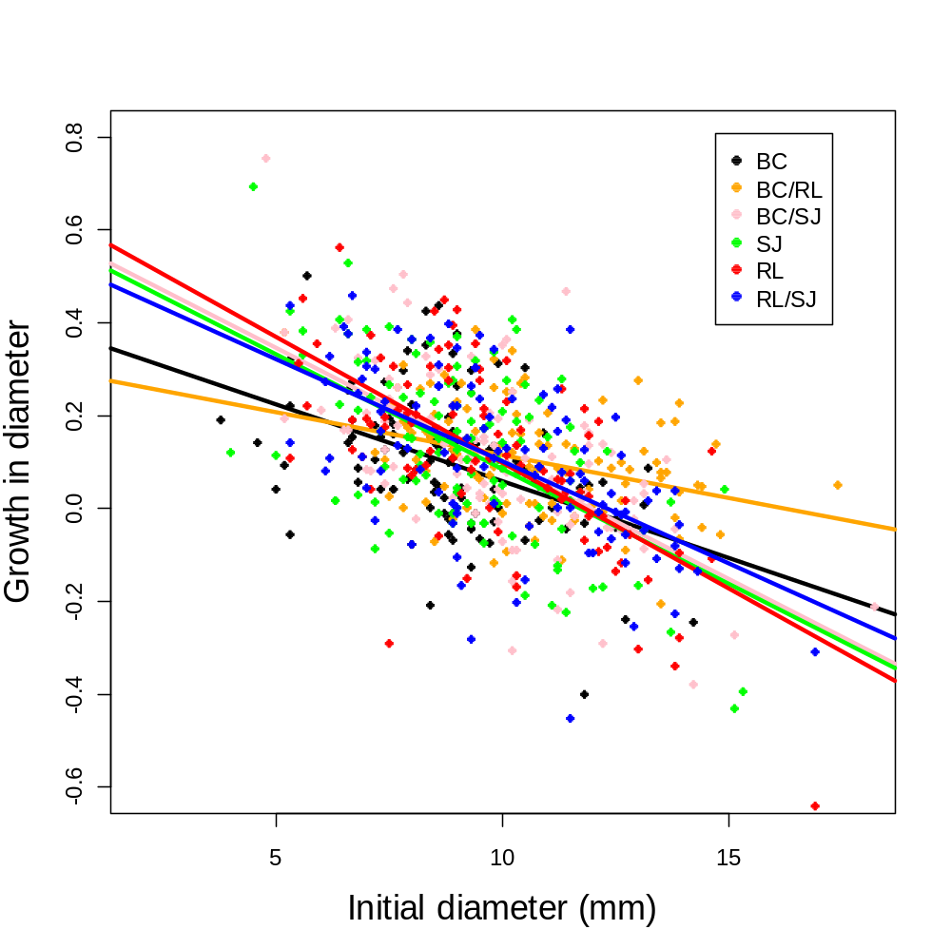
Fig. 16. Growth in stem diameter of willow cuttings as a function of initial diameter and soil treatment. Notice the lower growth of cuttings in BC (black symbols) and BCRL (orange symbols) compared to all other soils.
Just as in seedlings, changes in leaf number by willow cuttings varied significantly among both soil types and watering treatments (Table 10, top). Willow cuttings tended to grow the most leaves in the BC/RL soil, compared to the control (BC) (Table 10, bottom; Fig. 17). Growth in leaf number of cuttings tended to be lower in the simulated drought treatment than in the control, but the difference was not statistically significant once the Bonferonni correction was applied (Table 10, Fig. 18). Growth in leaf number by cuttings varied significantly among nutrient treatments in a size-dependent manner (Table 10, bottom). At small initial sizes, willow cuttings grew the most leaves when fertilized with both nitrogen and phosphorus, NP plus micronutrients, or micronutrients alone; but at large initial sizes the ranking was reversed and cuttings grew the most leaves when supplied with just ambient nutrients (Fig. 19).

An interesting pattern emerged when willow responses were summarized by life-history stages and growth parameters (Table 11). In both seedlings and cuttings, all growth parameters varied significantly with the initial size covariate. This result was expected because willows tended not to shrink in diameter or height, or to lose leaves. All growth parameters also responded to soil type, which remained the same for each plant throughout the experiment. Nutrients also remained the same for each plant throughout the experiment, but only affected seedling height. Willow cuttings responded to nutrient treatments in a size-dependent manner, with small plants growing more leaves when supplied with added nitrogen, phosphorus, micronutrients and their combinations. However, large plants added the most leaves in the ambient-nutrient control treatments.

In the cross-over design (Fig. 5), watering treatments varied from interval to interval, just as rainfall often does during the year. All three growth parameters of willow seedlings were affected by watering treatments. In contrast, willow cuttings only responded with increases in leaf growth (Table 11).

Interactions between the initial covariate and experimental treatments were important for particular growth parameters. In seedlings, growth in height was influenced by interactions between initial height and the soil and nutrient treatments. In cuttings, growth in stem diameter was influenced by the interaction between initial height and the soil treatments, while growth in leaf number was influenced by the initial leaf number x nutrient interaction (Table 11).

For both seedlings and cuttings, the most informative model of change in number of leaves included the main effect of soil and watering treatments, with initial number of leaves as a covariable. Residuals of the best models were randomly distributed, normal and independent, illustrating the effectiveness of the allometric covariate. For both seedlings and cuttings, growth in number of leaves varied with initial number of leaves entering the treatment period in the crossover design. Seedlings and cuttings with large numbers of leaves entering a treatment period tended to have more leaves at the end of the period than did plants with few leaves.

Overall, results of the greenhouse experiments conform well to field observations. Willow seedlings were more sensitive to environmental conditions than larger plants (cuttings) and soils tremendously influenced growth at both willow stages. Seedlings were especially responsive to water treatments, while cuttings were largely unaffected by any treatment except simulated drought. Nutrients had less effect on willow growth and the responses sometimes varied with initial plant size (Table 11).
Table 10. (Top) Analysis of covariance of change in number of leaves with soil, nutrients, and watering regime for cuttings. All surviving plants were included. Initial number of leaves was used as covariate (r²=0.21). Table entries are the same as in Table 4.
Response: | Cuttings
 | df | SS | MS | F | P
log(initial) | 1 | 13.982 | 13.982 | 140.509 | <0.0001
Soil | 5 | 3.357 | 0.671 | 6.747 | <0.0001
Nutrients | 5 | 0.708 | 0.142 | 1.422 | 0.2142
Watering | 3 | 0.896 | 0.299 | 3.001 | 0.0300
log(initial):Soil | 5 | 0.426 | 0.085 | 0.857 | 0.5097
log(initial):Nutrients | 5 | 1.463 | 0.293 | 2.940 | 0.0124
Residuals | 623 | 61.993 | 0.100

(Bottom) Simple contrasts among treatments for change in the number of leaves in cuttings. The reference treatment does not appear in the list. Significant contrasts in bold. Because contrasts were not independent we used Bonferroni to obtain an experimentwise error rate of 0.01 for watering treatments and soils.
Coefficients:
 | Estimate | Std.Error | t | Pr(>|t|)
(Intercept) | 0.2816 | 0.1118 | 2.5190 | 0.0120
initial | -0.0023 | 0.0011 | -2.1190 | 0.0345
Soil Treatments  Soil RL | 0.1228 | 0.1182 | 1.0390 | 0.2994
Soil RLBC | 0.2212 | 0.1150 | 1.9230 | 0.0549
Soil SJ | 0.0333 | 0.1120 | 0.2970 | 0.7664
Soil SJBC | 0.0890 | 0.1238 | 0.7190 | 0.4725
Soil SJRL | 0.1770 | 0.1177 | 1.5040 | 0.1331
Watering Treatments
Simulated drought | -0.0571 | 0.0352 | -1.6230 | 0.1051
Ambient | 0.0088 | 0.0352 | 0.2500 | 0.8028
Constant Inundation | -0.0697 | 0.0353 | -1.9750 | 0.0487
Interactions  initial:Soil RL | 0.0003 | 0.0011 | 0.3040 | 0.7610
initial:Soil RLBC | -0.0001 | 0.0011 | -0.0510 | 0.9591
initial:Soil SJ | -0.0003 | 0.0013 | -0.2290 | 0.8190
initial:Soil SJBC | 0.0002 | 0.0012 | 0.1900 | 0.8496
initial:Soil SJRL | -0.0004 | 0.0011 | -0.3600 | 0.7191
initial:Nutrients micro | -0.0020 | 0.0010 | -2.0260 | 0.0432
initial:Nutrients N | -0.0005 | 0.0009 | -0.5350 | 0.5930
initial:Nutrients NP | -0.0029 | 0.0009 | -3.1690 | 0.0016
initial:Nutrients NPmicro | -0.0024 | 0.0009 | -2.6260 | 0.0089
initial:Nutrients P | -0.0012 | 0.0008 | -1.4110 | 0.1589

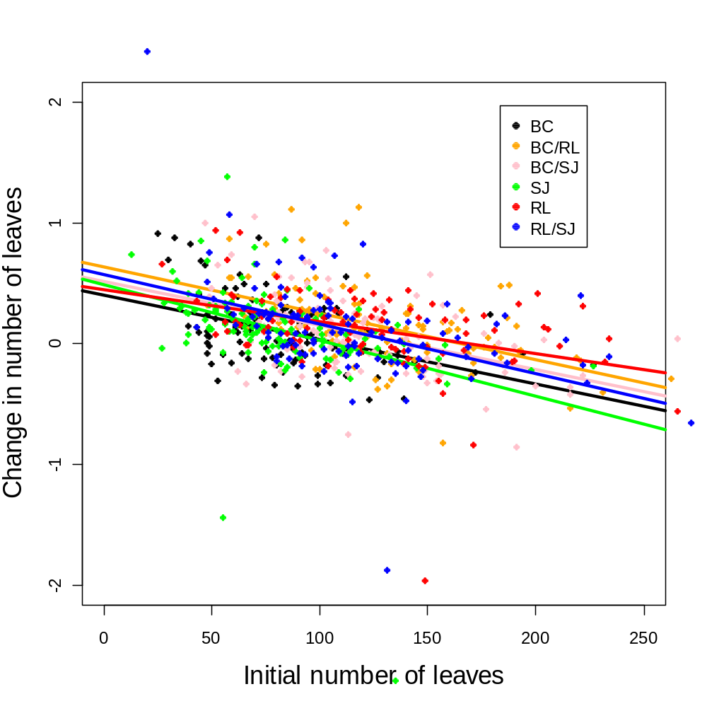
Fig. 17. Growth in number of willow leaves as a function of initial leaf number and soil treatment.

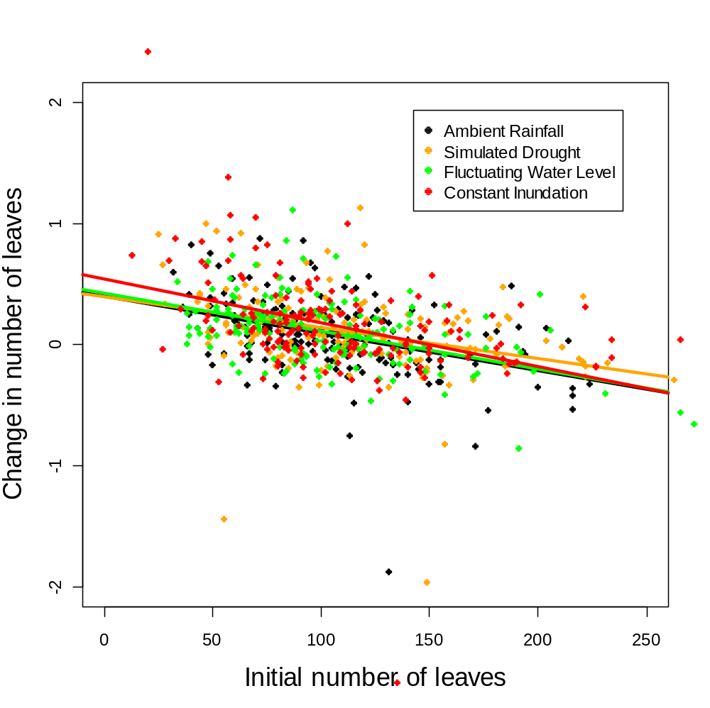
Fig. 18. Growth in number of leaves as a function of initial leaf number and watering treatment.
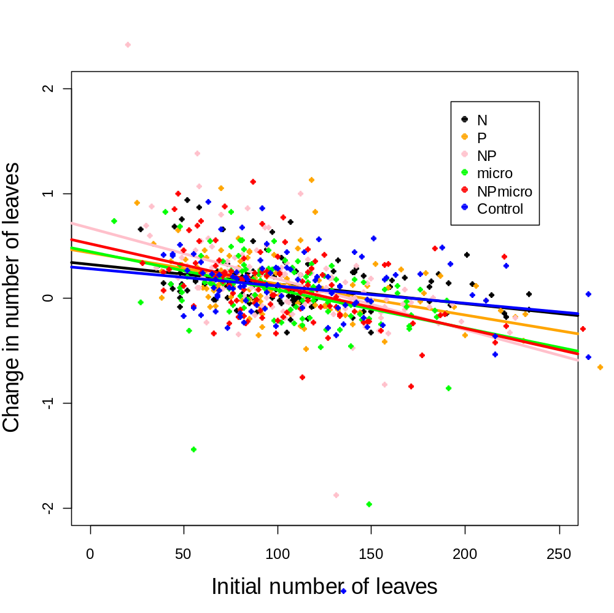
Fig. 18. Growth in number of leaves as a function of initial leaf number and nutrient treatments.

Table 11. Summary of statistically significant willow responses to treatments in the two greenhouse experiments.

 | Seedlings | Cuttings
Height | Initial  Soil  Nutrients  Watering  Initial x Soil  Initial x Nutrients | Initial  Soil  Nutrients
Diameter* | Initial  Soil  Watering | Initial  Soil  Initial x Soil
Number of leaves | Initial  Soil  Watering | Initial  Soil  Watering  Initial x Nutrients
*Crown diameter of seedlings and stem diameter of cuttings.
Task 2.2 – Willow Transplantation
We conducted two manipulative field experiments (sensu Diamond 1986) in the northern, central, and southern regions of the Upper St. Johns River Basin. Each experiment tested a major factor that was thought to influence willow invasion: interspecific competition and hydrology. For each experiment, we collected seeds and cuttings from multiple willows at >20 locations within SJRWMD lands and pooled seeds and cuttings (independently) into homogeneous groups, as described in the previous section. Seeds were germinated in pots, while cuttings were planted into small (4” diameter) pots with commercial potting soil to force rooting into the native soil after transplanting. We transplanted 1-10 seedlings (initial number was used as covariate) or one rooted cutting per plot and randomly assigned each group to one of the experimental treatments, described below.

Interspecific Competition - We examined competitive interactions between willow seedlings and cuttings and the native plants in areas with different soils and different hydrology. We established three transects in areas chosen to represent the range of available soil types and hydrological gradients (Fig. 20). Transects spanned the floodplain from the St. Johns River or a nearby canal to a shrub- or tree-dominated hammock or marsh-upland transition zone. We quantified competitive interactions between willow seedlings and the dominant clonal grasses and shrubs under open (e.g., herbaceous wetland) and shaded (e.g., wetland/upland ecotone) conditions.
Treatments were willow seedlings or a cutting planted:

(1) without neighbors in a 30 cm radius within a gap > 1 m²
(2) within a circular plot with grass cover >50% and no shrubs closer than 50 cm
(3) within a circular plot with at least one non-willow shrub or tree closer than 40 cm

We recorded willow survival and growth monthly as a function of grass and forb cover and tree presence. Almost all willows in the northern region perished within a month of transplanting due to a prolonged dry spring and the sandy native soil. One remaining individual died a few months later, after being inundated by rising water levels from Tropical Storm Fay. Similarly, most individuals in the central block succumbed during the dry conditions in April and the few remaining transplants died after prolonged inundation with water, as marsh levels rose during the summer rainy season.

Willow survival varied significantly among regions and between life-history stages (Table 12). Willows only survived to the end of the experiment (approx. 1 y) in the southern region and only cuttings survived; all seedlings died in all three regions (Table 12). These results are consistent with those of the greenhouse experiment, which showed that willow cuttings were less susceptible to drought and flooding than seedlings.

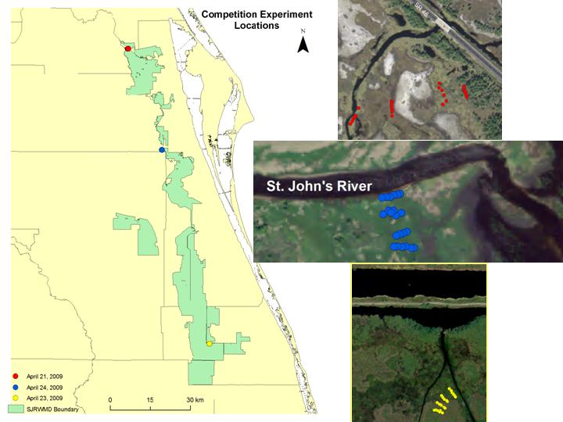
Figure 20. Locations of the northern (red), central (blue) and southern (yellow) blocks of the willow competition experiment. Seedlings and cuttings were planted in four locations along the river-to-upland gradient: along a river, stream or airboat trail; at the wetland/upland transition zone; and at two intermediate locations between these two extremes. Within a block, willow cuttings and seedlings were planted in an open area; near a grass or forb; or near a non-willow shrub. Planting dates are given in the legend. Each circle on the map identifies one of these six treatments, which are repeated four times along the gradient (the four parallel lines of circles).
Table 12. Results of the field competition experiment. Analysis is of survival. Table entries are sources of variation, degrees of freedom (df), Chi square (Chisq), and their corresponding significance levels.

Source of variation | df | Chisq | P
Region (R) | 2 | 40.27 | >0.0001
Location along gradient (L) | 3 | 0.29 | 0.96
Competitor (C) | 2 | 0.03 | 0.99
Willow stage (W) | 1 | 21.34 | >0.0001
Hydrology - District personnel helped us create four islands for this hydrology experiment (Fig. 21), which began on April 11, 2009. Briefly, both seedlings and cuttings were transplanted onto islands at four different heights: at marsh level and 16.7, 33.5 and 50 cm above it (marsh level recorded as 0.75 ft [20 cm] at nearby District staff gage). Each of these treatments was repeated on the north, east, south, and west sides of each island (Fig. 22).
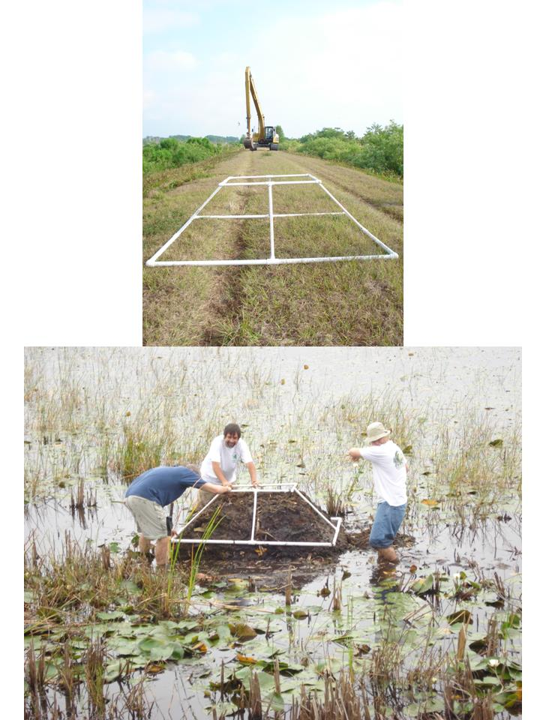

Figure 21. (Top) District personnel used heavy equipment to pile submerged marsh soil into artificial islands, which were shaped using the white frame (foreground). (Bottom) Dr. Quintana-Ascencio and two members of the Biology Graduate Student Association shaping willow islands.
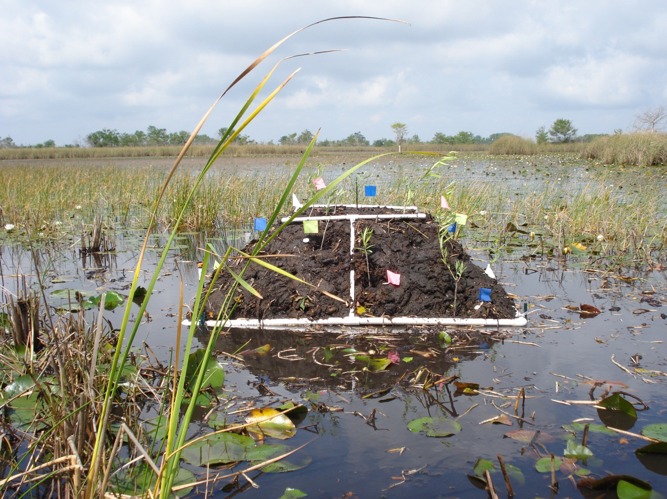
Figure 22. One of the four replicate willow islands to test hydrologic effects on willow seedling and cutting growth. Colored flags mark seedlings and cuttings from different populations.

We monitored plants monthly during this experiment and terminated it when willows began flowering in February, 2010. We measured basal diameter and height of willow plants and counted the number of branches, leaves, and flowers. Only a small fraction of transplanted cuttings flowered and none set fruit. No seedlings flowered. Other, non-experimental plants that colonized the islands were identified.

We then clipped willow seedlings and cuttings into small sections, placed them into labeled paper bags and returned them to the laboratory. We dried plants at 60 ^{O}C for >24 h and then weighed them to estimate dry biomass.

Only 15% of willow seedlings planted onto the experimental islands survived to the end of the experiment. Survivors were clustered in 16 of the 64 locations. We used nominal logistic regression to evaluate the effects of island, elevation above marsh level, and orientation (north, east, west and south face), plus all their two-way interactions, on seedling and cutting survival. The model fit well (X² = 60.89, 36 df, P < 0.006, R² = 0.85) but parameter estimates were unstable. We therefore used individual likelihood-ratio tests to evaluate the main effects. Variation due to island and orientation were not statistically significant (both X² < 4.55, 3 df, P > 0.22) but survival differed significantly among elevations (X² = 18.12, P < 0.0004, R² = 0.25). Survival was highest at the intermediate elevation of 0.35 m above initial marsh height (Fig. 23). No seedlings survived at the lowest elevation, very few at 0.175 m above initial marsh depth and just 22% at the highest elevation (Fig. 23). However, mean height of willow seedlings tended to decrease with increasing elevation above the initial marsh level (Fig. 24).

0
0.1
0.2
0.3
0.4
Mean survival
0
12.5
25
37.5
50
Elevation (cm) (cm)
Fig. 23. Mean survival of willow seedlings as a function of elevation above initial marsh height, which was 20 cm at the nearest District staff gage. The curve is a spline fit with lambda = 100.

Mean seedling height (cm)
30
35
40
45
50
55
10
20
30
40
50
60
Elevation (cm) (cm) (cm)

Fig. 24. Mean height of willow seedlings as a function of elevation above the initial marsh level, which was 20 cm at the nearest District staff gage. The regression line explains substantial variation (R² = 0.95, F_{1,1} = 17.49) but is not statistically significant at α = 0.05.

All but six cuttings survived until the end of the experiment, illustrating willow’s tolerance for different conditions once it grows beyond the seedling stage. Three-way factorial ANOVA revealed no significant variation in final cutting height or the percentage change in basal diameter among islands, height above the marsh, or directions (all F < 3.14, P > 0.096). Thus, overall plant morphology of cuttings was similar despite the variation in environmental conditions that greatly affected seedlings. However, the percentage change in the number of leaves varied significantly among islands, heights, directions, and with the island x height and island x direction interactions (Table 13). The full model accounted for almost all of the variation in this parameter (R² = 0.97). On average, willow cuttings on Island 3 gained leaves (3%) while cuttings on the other islands lost 0.1-1%. Willow cuttings planted 35 cm above the initial marsh waterline also gained a greater percentage of leaves (1%) than those planted 17.5 cm above the waterline, which lost 0.25% of theirs. And on average, willow cuttings planted on the south sides of islands gained a greater percentage of leaves (1.4%) than those planted on the north side, which lost 0.6% of theirs. Of the two statistically-significant two-way interactions, the island by height is the more interesting (Table 13). Willow cuttings on Island 3 and initial height 35 cm grew more leaves than cuttings at almost every other island and height combination (Fig. 25). The small net loss of leaves elsewhere reflects cuttings that shed leaves at the beginning of their reproductive season. Several of these plants were already producing flowers but had not yet set seed when we terminated the experiment.

Table 13. Analysis of variance of the percentage change in number of willow leaves in the island experiment.
Source of variation | df | SS | MS | F | P
Island (I) | 3 | 42.31 | 14.10 | 27.1 | 0.0003
Height above marsh (H) | 3 | 7.42 | 2.47 | 4.75 | 0.0412
Direction (D) | 3 | 11.59 | 3.86 | 7.42 | 0.0141
I x H | 9 | 20.78 | 2.31 | 4.44 | 0.0311
I x D | 9 | 22.84 | 2.54 | 4.87 | 0.0243
H x D | 9 | 11.21 | 1.25 | 2.39 | 0.1315
Residuals | 7 | 3.64
Total | 43 | 137.18

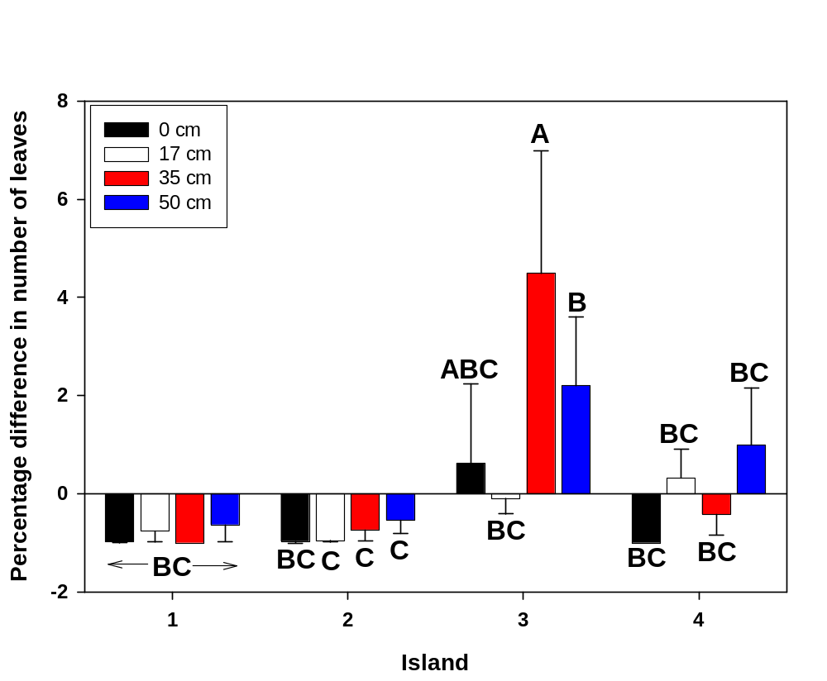
Figure 25. Mean (+ 1 SE) percentage difference in the number of leaves on willow cuttings planted on four replicate islands and at four different heights above the initial marsh water level.

Additional hydrology experiment - We took advantage of the UCF experimental ponds to begin a replicated flooding experiment. Our design (Figure 26) overlapped this experiment with another, new experiment, which investigated competition between willow and sawgrass (Cladium jamaicensis).

In the flooding experiment, we planted three types of willow (seedlings, and short [15 cm] or tall [30 cm] cuttings) at each of four heights above the pond waterline: 0, 18, 35 and 50 cm. Each treatment was replicated twice within each of six experimental blocks, which were located on the east and west sides of three separate ponds.

In the competition experiment, we planted each willow type surrounded either by none, three or six plugs of sawgrass, which we obtained from a commercial supplier (Aquatic Plants of FL, Inc). Sawgrass plugs were spaced equidistant from each other and 15 cm from the central willow plant (Fig. 27). We placed this design only at the 0.18 and 0.35 m heights above the waterline, because we expected the sawgrass would die at the two extreme heights. We replicated the sawgrass competitor treatments once within each block.
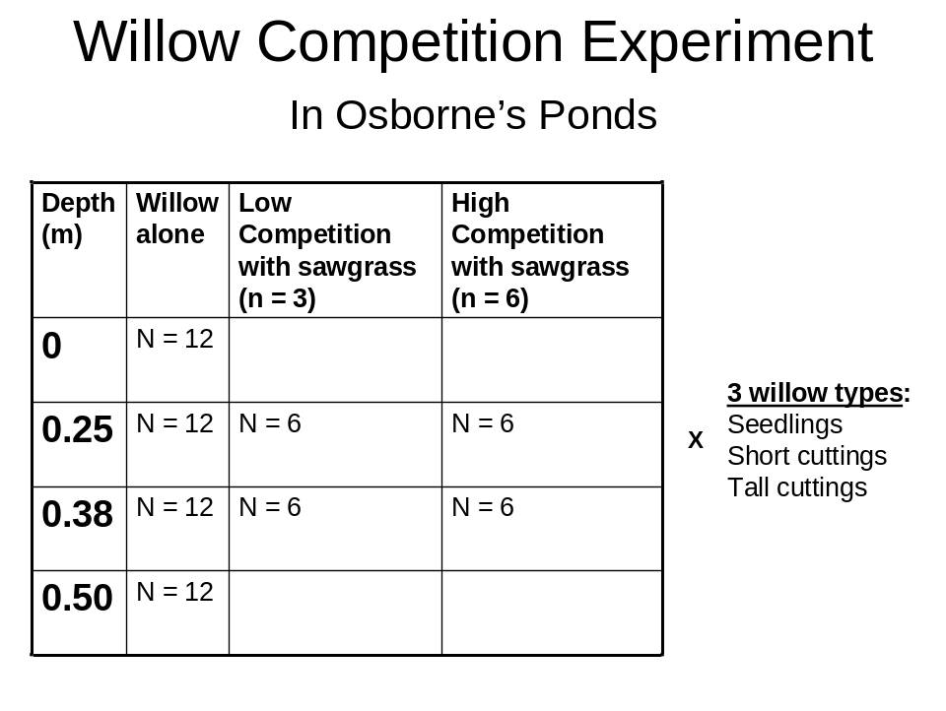
Fig. 26. Design of the combined experiments on flooding and competition. The flooding design is in the second column from the left and the competition experiment is in the middle two rows. The experiments overlap, sharing the treatments of willows grown alone at 0.18 and 0.35 m heights above the pond level. The number of replicates is provided within each cell.

We watered the plants as necessary until they become established, and then gradually raised the water level until plants at the highest level were at the waterline. At this point, the other plants were 0.12, 0.25 or 0.5 m underwater. We monitored the plants monthly through November, 2010, recording survival, growth, and the competitive effect of sawgrasses on willows. Willows with no sawgrass planted around them served as the no-competition control and also were part of the flooding experiment (Fig. 22).

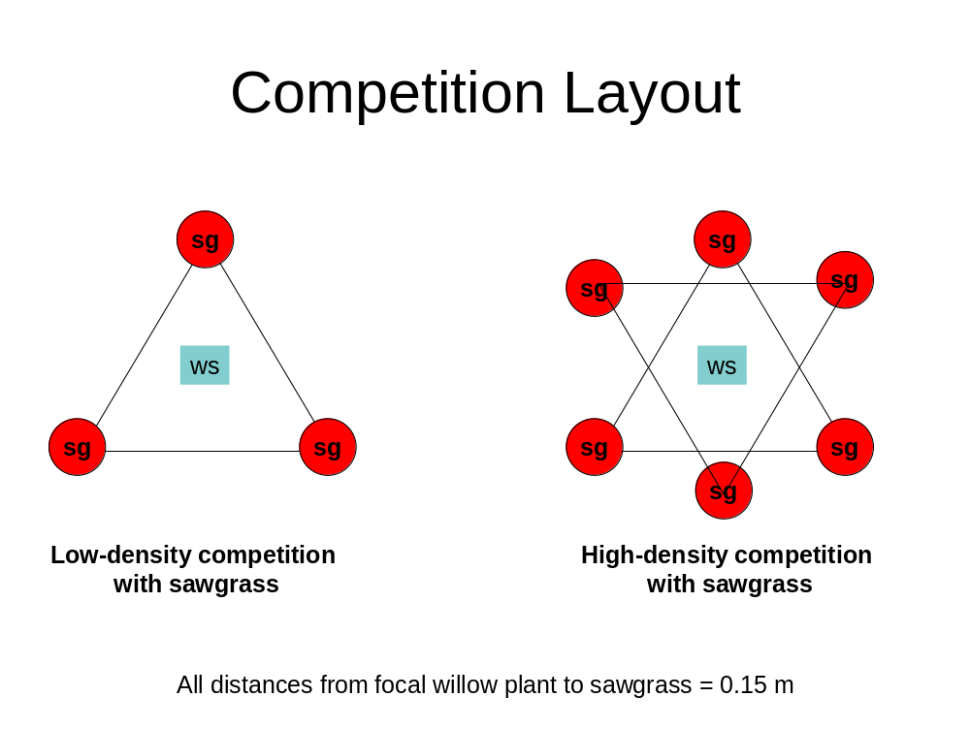
Fig. 27. Arrangement of willow (ws, blue squares) and sawgrass (sg, red circles) in the low- and high-density treatments of the competition experiment.

Task 2.3 – Fire Response
Together with District Personnel, we initiated the fire experiment on July 1, 2010. Despite low water and meteorological conditions favorable for a prescribed burn, we were unable to burn the willow plots. Burns in surrounding sawgrass (Cladium jamaicensis) did not carry into willow stands due to lack of fuel, both directly under the willows and in the buttonbush (Cephalanthus occidentalis) surrounding them (Fig. 28). We even lit one willow directly and the fire was extinguished with little damage to the shrub itself (Fig. 29).

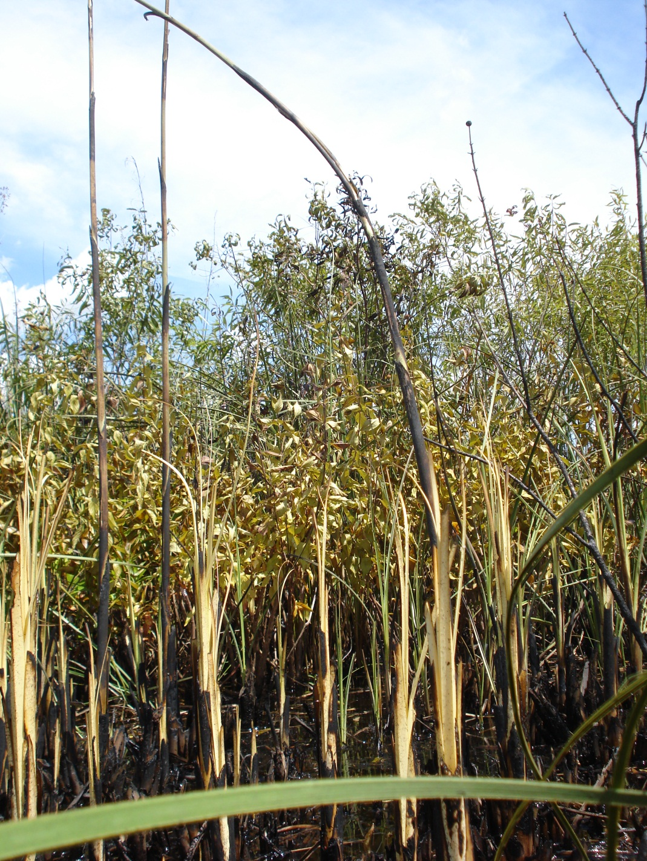
Fig. 28. Fire burned sawgrass (foreground) but stalled in buttonbush (middle), leaving the willow stands largely unscathed (background).

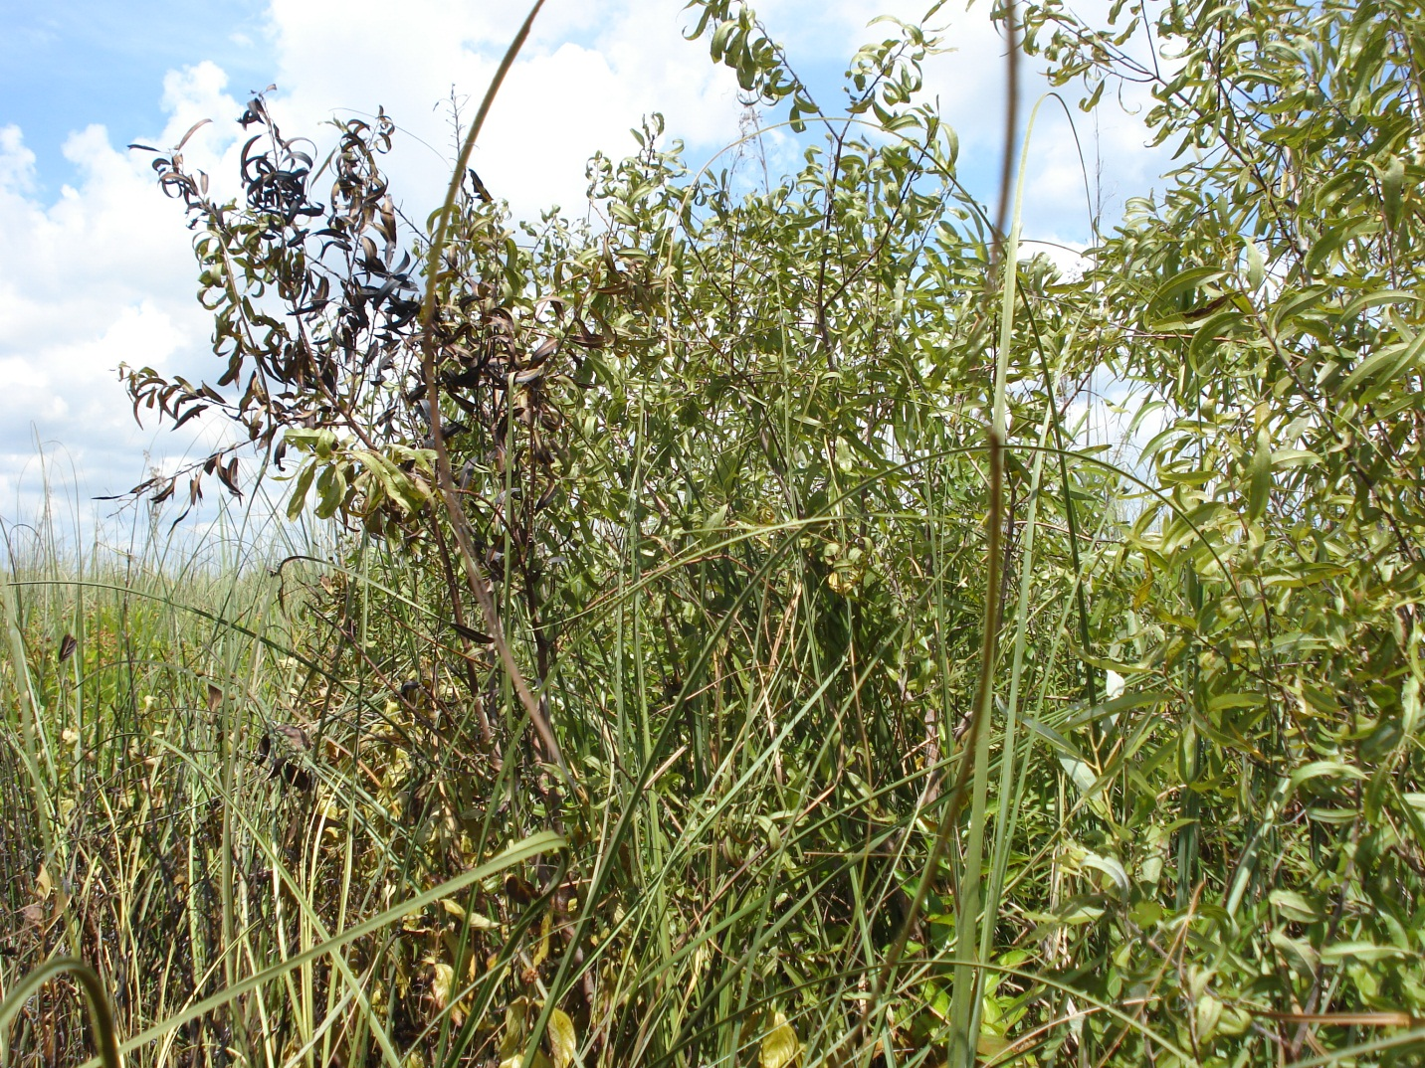
Fig. 29. District personnel directly lit this small willow but the fire went out, leaving most of the plant unharmed.

After failing to ignite willows inside 3 of the 10 designated burn plots, we halted this experiment. It was clear to both the UCF team and District personnel that there was insufficient fuel beneath willows to carry a fire. Buttonbush encircling the willows also did not carry the fire, making the small, isolated willow stands even more resistant. We noticed during our demography work that disks of willow removed for dendrochronology analysis were very heavy and wet, suggested that the plant has a high moisture content that makes burning difficult. Using controlled burns to remove willows will be very difficult once the plants have reached shrub size and produced an open understory with little fuel beneath it.

Task 2.4 – Willow Life History
We used standard dendrochronology and allometric techniques to determine whether growth rings, basal diameter, number of nodes or some other measure reflects differences in age structure and growth rates among different willow populations.

We sampled willows in the northern, central, and southern regions of the Upper St. Johns River Basin, and within each region, chose sites with willows 1) along rivers or canals; 2) along roads or levees; 3) in isolated willow swamps or thickets; and 4) in areas where willow is invading open, herbaceous marsh (Figure 30). At each of these twelve sites, we sampled five focal willows, for a total sample size of 60 individuals. At each site, we recorded key demographic parameters of five individual willows of varying sizes and any additional willows within a 1 m radius. We took trunk samples or cores from each focal willow for dendrochronology, and marked one individual per site for re-assessment of growth rings next year, to verify that growth rings represent annual growth increments. We have collected ~50 of such samples (Fig. 31), which are currently being sanded and stained for growth ring analysis. Combined with demographic plots sampled last year, we have completed >90% of our life history sampling, and expect to finish it on October 1, 2010.

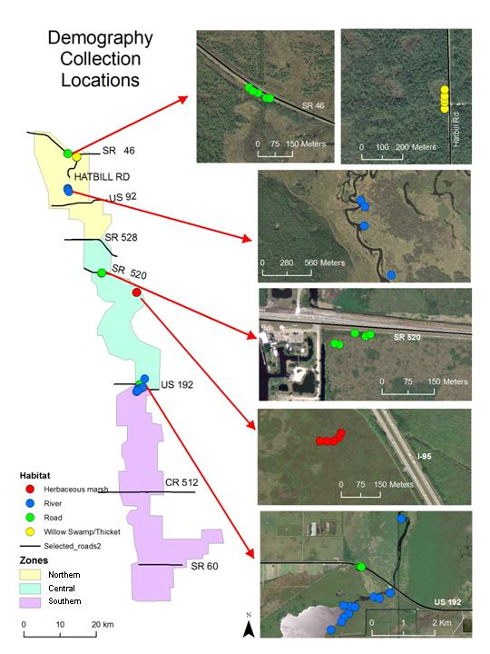
Fig. 30. Locations and habitats of willows sampled for demography data. At least five willows were sampled at each site, including individuals cored or sectioned for dendrochronology.

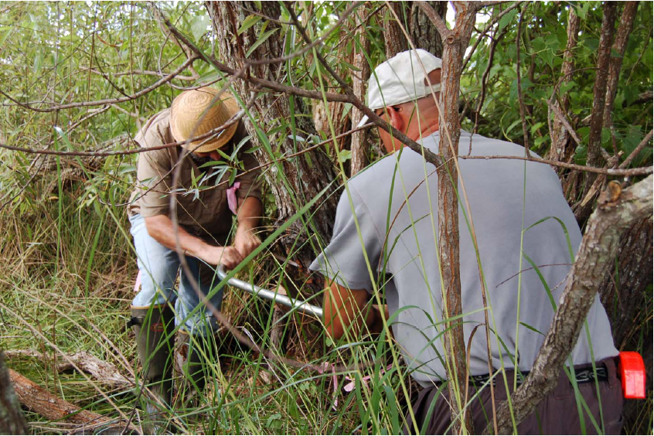
Figure 31. Drs. Pedro Quintana-Ascencio (left) and John Fauth (right) removing a willow disk for dendrochronology analysis.
Task 2.5 – Spatial Analysis of Willow Distribution
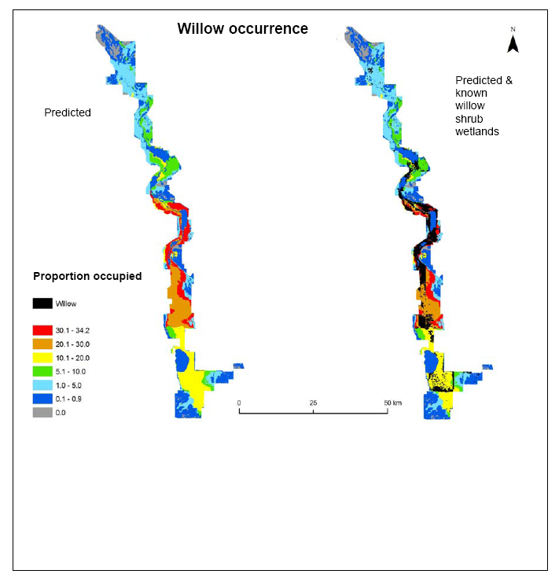
Previously, we developed a spatial model (Fig. 32) that predicts the distribution of willow based only on soils. We are modifying this model to include proximity to willow invasion sites and the susceptibility of wetland habitats to willow invasion.

Fig. 32. (LEFT) Predicted distribution of willow shrub wetlands based on soil type. Red and orange shading indicates regions with a high probability of having willow shrub wetlands, blue and gray depict regions with low probability. (RIGHT) Actual distribution of willow shrub wetlands (black), as mapped by the District.

Task 2.6 - Demographic Modeling
Information on germination, vegetative reproduction, survival, and mortality will be compared to estimates obtained from the long-term demographic and dendrochronology studies to develop a demographic model. We will integrate the estimates of vital rates across different environmental conditions in demographic models (Fig. 1) to estimate vital rate elasticities (relative population growth change with vital rate change) and population trends. Raw data and spreadsheets are available at http://biology.ucf.edu/~pascencio/willow%20research.html

Task 3.1-3.3. Data Analysis and Final Report
This report includes information from field observations, demography, and experiments in growth chambers, the greenhouse, and in the field (Fig. 33). Combined with results of GIS modeling, we can begin to understand the demography and distribution of willow.

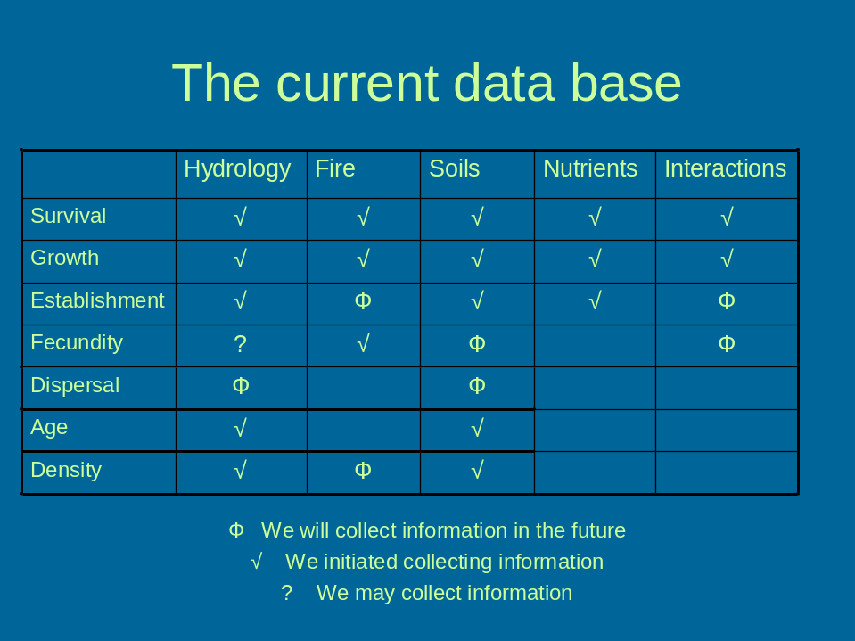
Figure 33. Checklist of the current database on willow life history and demography, showing data already collected, and planned for Year 3.

Previously, we showed that willows produce tremendous numbers of wind-dispersed seeds for 2-4 weeks, beginning in late February and lasting until late March. Early seed production gives willow the advantage of colonizing open habitats. Only green seeds are alive and for all practical purposes viviparous; willow seeds have no tangible dormant stage (Lee 1994, Hanselman et al. 2005, Lee et al., pers. comm.) and remain viable for <10 d. Lack of dormancy and absence of a seed bank (Lee 1994, Hanselman et al. 2005, Lee et al., pers. comm.) provide an opportunity to prevent Carolina willow from invading areas undergoing construction and other disturbances. Timing activities to avoid peak seed dispersal will reduce opportunities for willow to invade.

Willow seedlings depend on consistently moist conditions for survival and growth. Experiments in a germination chamber, the greenhouse, and field experiments show high seedling survival in well-watered, but not flooded conditions and very low survival under dry conditions. In the greenhouse, willow seedlings fared poorly under reduced water treatments that simulated drought, while in the field competition experiment, seedlings died quickly in two floodplain areas that remained dry in spring. In addition, very few willow seedlings survived atop the willow islands, which – despite being composed of peaty soil – dried to the point of cracking in late spring. Four independent lines of evidence show that willow seedlings are very susceptible to dry conditions on any soil type.

While more tolerant of dry conditions, willow cuttings also grow best when soil is continually saturated with water. However, prolonged inundation can kill both willow seedlings and cuttings. All willows still alive in the field competition experiment died when flooded (overtopped) by >0.5 m of water for several weeks. A similar pattern was evident in the willow island experiment, where both seedlings and cuttings had reduced survival at the lowest elevation, which was underwater for several months. Seedlings were especially susceptible to mortality from flooding. Submerged willows often become fouled with algae and bladderwort (Utricularia sp.) or overtopped by water hyacinth (Eichhornia sp.), which may increase the rate of mortality.

Successful establishment of willow clearly depends on a specific set of hydrologic conditions in the weeks following seed dispersal. Dry conditions decrease survival while flooding kills both seedlings and larger cuttings. Results of the greenhouse cross-over experiment demonstrate that hydrologic regime and soil type usually are much more important that nutrient levels in controlling willow germination, survival, and growth. Soil type is a good predictor of willow distributions in the upper St. Johns River basin (Fig. 32) but had little influence on willow germination in our experiment. Instead, the water-holding capacity of soils may control willow survival and growth in the seedling stage. Results of the competition experiment support this hypothesis; almost all willow seedlings in the northern and central blocks died within the first month, when little rain fell and the soil was dry. At the same time, seedlings persisted in the southern block, which had moist organic soil. The greenhouse experiments provide additional evidence of a positive effect of consistently moist, peaty soil on willow germination, survival, and growth.

Nutrients had little influence on survival and growth of willow seedlings and cuttings. The only statistically significant response was lower mean growth in seedling height in the nitrogen-addition treatments relative to the controls, and which may have been due to excessive algal growth.

Low survival in the field competition experiment precludes interpreting the effects of grasses, forbs, non-willow shrubs and trees on Carolina willow seedlings and cuttings. However, diverse wetland plants recruited onto the willow islands, where they could compete with the willow seedlings and cuttings that we planted. We plan to investigate this hypothesis analytically in Year 3.

We continued to gather data for our demographic model. To date, we have established statistical relationships between maximum branch diameter, rooted branch basal diameter, and number of inflorescences. We also have cored a total of >50 willows from eleven populations, and all stems have obvious growth rings.

YEAR 3
We will extend data collection on the willow competition and hydrology experiment conducted in UCF experimental ponds into Year 3 to assess responses over a 6-month period. We also will conduct additional experiments based on results and hypotheses generated in Years 1 & 2, in consultation with District staff. One issue that remains unaddressed is the effect of cattle grazing on willow recruitment and survival. Willows are uncommon where cattle graze in the northern and central regions of the upper St. Johns River basin. This pattern could be caused by cattle grazing on or trampling willow, or it could be coincidental; a cattle-exclusion experiment can discriminate between the two possibilities. Because excluding cattle is problematic along the St. Johns River floodplain due to boat traffic, we propose conducting an experiment within isolated ephemeral wetlands in Seminole Ranch Wildlife Management Area (SRWMA). The area is grazed but the wetlands are inaccessible to boaters because they are embedded within pastures. We can easily plant willow seedlings and cuttings into moist soils, and either prevent cattle access by fencing or allow access using unfenced plots. We envision the experiment as a randomized complete block design for analysis of variance, with willow responses quantified as in our previous field experiments.

In addition, the major focus of Year 3 will be completing the demographic analysis and dendrochronology, and developing the predictive demographic model (Fig. 1). Completing the model is a large component of Dr. Quintana-Ascencio’s planned sabbatical during the 2011-2012 academic year and will be performed in conjunction with researchers at the School of Botany, University of Melbourne, Australia. They have developed an algorithm that simulates management strategies to control the invasion of S. cinerea (Moore and Runge 2010). Their model evaluates relative costs and efficiencies of the different management strategies. Our combined data and expertise will be used to model willow population spreading out in our study areas, and the feasibility of possible management actions.

LITERATURE CITED
Armas, C., R. Ordiales, and F. I. Pugnaire. 2004. Measuring plant interactions: A new comparative index. Ecology 85:2682-2686.

Cook, E., and L. Kairiūkštis. 1990. Methods of Dendrochronology: Applications in the Environmental Sciences. Springer.

Diamond, J. 1986. Overview: Laboratory experiments, field experiments, and naturalexperiments. Pages 3-22 in J. Diamond and T. J. Case, editors. Community Ecology. Harper and Row, New York, New York, USA.

Hanselman, J. A., M. Bush and M. A. Lee. 2005. Seed content and percent organic matter in surface sediments as indicators of wetland plant communities, Blue Cypress Marsh, Florida. Florida Scientist 68:250-260.

Lee, M. A. 1994. Seed banks of marsh and restoration sites - Upper St. Johns River Basin. St. Johns River Water Management District, Technical Memorandum No. 4.

Lee, M.A., K. J. Ponzio and S. J. Miller. 2005a. Response of willow (Salix caroliniana Michx.) in a floodplain marsh to a growing season prescribed fire. Natural Areas Journal 25:239–245.

Lee, M.A., K. L. Snyder, P. Valentine-Darby, S. J. Miller and K. J. Ponzio. 2005b. Dormant season prescribed fire as a management tool for the control of Salix caroliniana Michx. in a floodplain marsh. Wetlands Ecology and Management 13:479–487.

Mead, R. 1988. The Design of Experiments: Statistical Principles for Practical Application. Cambridge UCF Press, New York.

Moore, J and Runge M. 2010. Developing a long term strategy for managing willow invasion on the Bogong High Plains. Research Partnerships Project.

Pezeshki, R., P.H. Anderson, and F.D. Shields. 1998. Effects of soil moisture regimes on growth and survival of black willows (Salix nigra) posts (cuttings). Wetlands 18: 460-470.

