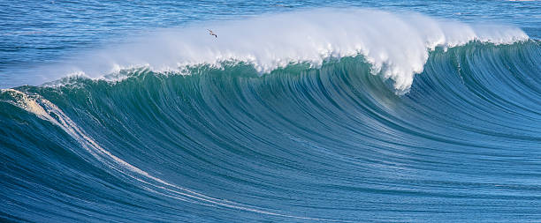

Principles of Marine Biology (BSC 3312)

Fall 2020
Tuesday/Thursday 9:00-10:20 AM

Instructor: Dr. Christa Diercksen
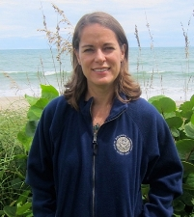

Communication:
- Email: christa.diercksen@ucf.edu
- Virtual Office Hours: Tuesday: 2:00-3:00 PM in Webcourses Chat or by individual appointments via Zoom

Official Class Group Me:
- Use this link: https://groupme.com/join_group/59706845/zhcdXDsq or scan the QR code below to join

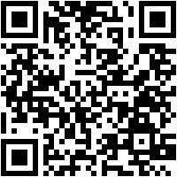

- Use this GroupMe to talk to other students in the class, ask questions about course content, set up study sessions or anything else you want to talk about! It should NOT be used to share any information pertaining to assessments or anything related to academic dishonesty and violations will be reported to the Office of Student Conduct.
- When posting in the GroupMe, students are expected to treat others with respect in accordance to the Inclusion, Safety and Disability Accommodation at UCF statement found below. Violators of this policy will be removed from the GroupMe and face potential disciplinary action.

Course Description:
- Credit hours: 3
- Course Prerequisites: Biology 1 (BSC 2010) and Biology 2 (BSC 2011)
- Purpose of the course: BSC 3312 is an introductory exploration of the marine environment that will provide students with an initial understanding of the different marine ecosystems and the organisms that occupy those ecosystems. This course can provide the foundation for more advanced classes in topics of marine science as well as giving students the knowledge and skills to understand the connections between the marine environment and human society.

Course Objectives:
- Learn basic oceanography and the physical marine environment as it relates to the organisms that live in the ocean
- Learn about the different types of marine ecosystems and their specific characteristics that shape those environments and the organisms that live there.
- Explore the major classes of organisms that live in the marine environment with focus on their unique adaptations that allow them to live in their different habits
- Investigate and question the impact of humans on the world’s oceans

General Course Topics:
- Basic salt water chemistry and oceanography
- Basic concepts in marine ecology
- Community structure of the different ocean ecosystems (deep sea, coral reefs, intertidal, etc.)
- Major animal and plant groups that live in marine environments (algae, phytoplankton, marine invertebrates, marine mammals, etc.)
- Human impact on oceans

Required book/materials:
- “Marine Biology, A Very Short Introduction, 2nd edition” by Philip V. Mladenov, ISBN 978-0-19-884171-5 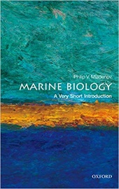
- The first edition of “Marine Biology, A Very Short Introduction” would be ok as well but note that pages numbers are different between the editions.
- Other readings or background information and/or links will be provided on Webcourses.
- Only the content on oceanography, marine ecosystems and human impact on oceans is covered in “Marine Biology, A Very Short Introduction”. Necessary information on the marine organisms will be given in the lecture slides and slide notes.

Academic Activity Assignment: 3 Words Reflection: Due date: Friday, August 28, 2020 at 5:00 PM

Faculty members are required to document students' academic activity at the beginning of each course in order for proper distribution of financial aid.

In order to document that you began this course, please complete the “3 Words Reflection” in Webcourses by the end of the first week of classes, or as soon as possible after adding the course. Failure to do so could result in a delay in the disbursement of your financial aid.

Non-financial aid students are encouraged to also complete this reflection as it will be an opportunity for you to introduce yourself to me and provide some information about your academic and life goals.

There is NO point value assigned to this assignment and will be scored for completion only after you have submitted it.
Primers on background material:
- Biology 1 and Biology 2 are pre-requisites for this class and knowledge of the content covered in those courses is expected.
- If you wish to refresh your Bio 1 & 2 information, view the “Primer of Biological Principles and Ecology” and “Primer of the Properties of Water” Powerpoints (in the Course Information Module) which contain a basic review of background concepts and important vocabulary necessary for BSC 3312.
- Additionally, there is a link in our Webcourses to a free Khan Academy crash course for Bio 1 & 2 and Ecology that students can use to review this basic content if needed.

Course Grade Breakdown: Total of 500 points
- Lecture Exams (2) 200 pts. (100 pts. each)
- Lecture Quizzes (13, lowest dropped) 120 pts. (10 pts. each)
- Final Exam (1) 50 pts.
- Case Studies (4) 100 pts. (25 pts. each)
- Marine Biology in the News (1) 15 pts.
- Speed Date Organism (1) 15 pts.

The final course grade will be awarded using the following scale by calculating the percentage of your total earned points during the semester out of 500 possible points:
- Grade Scale:
A =90-100%
B+ =87-89%
B =80-86%
C+ =77-79%
C =70-76%
D+ = 67-69%
D =60-66%
F <60%
Note: No minus grades, e.g. “A-“ or NC grades.
- Final grade percentages will be rounded up from 0.5 to the next highest whole number, e.g. An 89.6% would round to 90% and the letter grade would be an “A”. An 89.4% would round to an 89%, and the letter grade will be a “B+”. There are NO exceptions to this rounding scheme.
- Withdrawal Date: Friday, October 30, 2020 at 11:59 PM
  - Please refer to the Undergraduate Catalog for detailed information about the implications of the withdrawal date.
  - Students must initiate withdrawal themselves. Dr. Diercksen will NOT automatically withdraw any student from the course.
  - Late and medical withdrawals and Incompletes are granted for only very compelling and documented reasons.
- Grade Forgiveness Date: Friday, December 4, 2020 at 11:59 PM.
  - Please refer to the Undergraduate Catalog for detailed information about the Grade Forgiveness process.
  - Students must apply for grade forgiveness if they are taking the course the 2nd time. The 2nd grade will NOT be awarded automatically without applying for Grade Forgiveness.
- Grades will be posted in Webcourses as available but are NOT to be considered official grades at any one given moment.
- No grades will be given over the phone or by email according to Federal law (FERPA regulations).
- Grades will not be routinely curved unless warranted by Dr. Diercksen’s discretion.
- Extra Credit: Extra credit is NOT routinely available although opportunities may arise throughout the semester.
- Make-up work: Make-ups for missed exams, quizzes or other due dates must be approved at the discretion of Dr. Diercksen and will require documentation.

Grade Details:
Short Answer Exams (200 pts. total)
- Two (2) lecture exams (each worth 100 pts.) with short answer, free response, critical thinking style questions
- These exams are considered OPEN notes and will NOT require the LockDown Browser.
- Lecture exams will be available for a 24-hour period beginning at 12:01 AM and closing at 11:59 PM on the exam days (see course schedule for dates) but will be open for only 2 hours (120 minutes) once a student begins the exam.

Multiple Choice Quizzes (120 pts. total)
- Thirteen (13) multiple choice, 10 question quizzes (10 pts. each).
- The lowest quiz grade will be dropped (including any missed quiz which will receive a grade of zero) therefore only 12 quiz grades will count towards the final grade.
- Quizzes will be open beginning at 12:01 AM on Friday mornings and will be available until the following Sunday at 11:59 PM (i.e. Open for 72 hours). Please check the course schedule and Webcourses' Calendar for due dates.
- Quizzes will have a 15-minute time limit once a student begins.
- These quizzes are considered CLOSED notes and will require the Respondus Lock Down browser (more information below) but will NOT require a Webcam or other monitoring.
- NO late quizzes will be allowed unless approved by Dr. Diercksen.

Final Exam (50 pts.)
- This is not a classic cumulative exam but will still address major concepts from the whole semester. More information will be given as the Final Exam period approaches.
- The Final Exam will be available for a 24-hour period beginning at 12:01 AM and closing at 11:59 PM on Thursday, December 10 (per the UCF official Final Exam schedule) but open for only 2 hours (120 minutes) once a student begins the exam.
- The Final Exam is considered OPEN notes and will NOT require the LockDown Browser.

Case Studies (100 pts. total)
- There will be four (4) case studies each worth 25 pts.
- Late submissions will be accepted but will lose 20% of the point value for each day late.
- We will use some class time to discuss and work through the case studies, but students will be assessed based on their own submissions to the case studies in Webcourses.

- Ocean Acidification: Due Sunday, 9/6 at 11:59 PM
- Crown of Thorns (COTs): Due Sunday, 10/4 at 11:59 PM
- Missing Sea Otters: Due Sunday, 11/15 at 11:59 PM
- Dead Zone: Due Sunday, 12/6 at 11:59 PM

Marine Organism (15 pts.)
- Due: Tuesday, November 24 at 11:59 PM
- Late submissions will be accepted but will lose 20% of the point value for each day late.
- Students will be randomly assigned an interesting marine organism to research.

Marine Biology in the News (15 pts.)
- Due date: Thursday, December 3 at 11:59 PM
- Late submissions will be accepted but will lose 20% of the point value for each day late.
- You can submit this assignment at any time during the semester.
- Each student will summarize an article of their choice concerning the marine environment in the current news.

Other Important Information
- Students will need reliable access to at the very least, a smart phone or tablet although a computer (PC running Windows or Mac) is preferred.
- For the online quizzes, students will need to use a PC, Mac or iPad in order to use the Lockdown Browser. More information concerning the Lockdown Browser can be found below.
- It is highly recommended you access Webcourses through the Google Chrome browser when not needing the Lockdown Browser for online testing.
- Students will need the ability to access the internet on a regular and reliable manner.
- Student do NOT need a Webcam for Zoom classes or exams or quizzes.

Respondus Lockdown Browser
- Quizzes will require the use of the Respondus Lockdown Browser which locks down the testing environment within Webcourses to help maintain exam integrity and to prevent academic dishonesty.
- How the Lockdown Browser works:
  - Assessments are displayed full-screen and cannot be minimized.
  - Browser menu and toolbar options are removed, except for Back, Forward, Refresh and Stop
  - Prevents access to other applications including messaging, screen-sharing, virtual machines, and remote desktops
  - Printing and screen capture functions are disabled.
  - Copying and pasting anything to or from an assessment is prevented.
  - Right-click menu options, function keys, keyboard shortcuts and task switching are disabled.
  - An assessment cannot be exited until the student submits it for grading.
  - Assessments that are set up for use with Lockdown Browser cannot be accessed with other browsers.
  - Students will be required to download the UCF specific Lockdown Browser which can be found at this site.
  - If you are choosing to use the iPad for your Lockdown Browser, you will need to download it from the Apple App Store for iPad (Lockdown Browser, Respondus, Inc.).
  - Operating Systems that support the Lockdown Browser
    - Windows: 10, 8, 7 (recommended)
    - Mac: MacOS 10.12 or higher (recommended)
    - iOS: 11.0+ (iPad only) Note: You can NOT take an exam or quiz with the Lockdown Browser on an iPhone.
  - To take an online quiz, open the Lockdown Browser and navigate to the quiz inside our Webcourses. You will NOT be able to access the the quizzes with a standard web browser.
  - You will NOT need a Webcam (Respondus Monitor) to take quizzes for our course.
  - For additional details on using LockDown Browser, review the Student Quick Start Guide (PDF) found in our Webcourses Course Information Module.

General tips for online exams
- Select a location where you won't be interrupted
- Clear your area of all external materials — books, papers, other computers, or devices
- Before starting the test, know how much time is available for it, and that you've allotted sufficient time to complete it
- Remain at your desk or workstation for the duration of the test
- Turn off all mobile devices, phones, etc. and don't have them within reach
- Clear your area of all external materials — books, papers, other computers, or devices

Sample Quiz using the Lockdown Browser
- To familiarize yourself with the Lockdown Browser environment, please take the Sample Quiz found in our Webcourses Course Information Module for practice.
- There is only 1 question on this ungraded practice quiz.
- The practice quiz will remain available for the whole semester with unlimited attempts.
- It is highly recommended students practice using the Lockdown Browser before attempting any quiz.
- If you change the device you are taking quizzes or exams on during the semester, you will need to re-download the software to the new device. It is strongly encouraged to repeat the Sample Quiz to ensure you are still able to access the quizzes on the new device.

Course Submissions
- Assignments and assessments will be conducted within Webcourses.
- Details for submission is given for each assessment in the assignment or exam/quiz introduction.

Attendance/Participation
- The Zoom lectures do NOT have mandatory in "real time" attendance and participation however all students are strongly encouraged to attend for the highest level of success in the class.
- Zoom sessions will be recorded and can be viewed later if desired. These recorded videos will be uploaded to the Zoom Cloud and links will be available within our Webcourses.
- While some class information and reminders will be given in Announcements, the majority of communication will take place during the Zoom lectures.
- If a student misses a lecture, it is their responsibility to view the recorded sessions when available or communicate with other students who did attend.

General Zoom Information:
- Because of the continued remote instruction requirement due to the COVID-19 pandemic, this course will use Zoom for synchronous (“real time”) class meetings.
- Class meeting dates and times will be scheduled through Webcourses@UCF and should appear on your calendar with the meeting invite link. You will also receive an email for each class meeting invite.
- Please take the time to familiarize yourself with Zoom by visiting the UCF Zoom Guides at <https://cdl.ucf.edu/support/webcourses/zoom/>. You may choose to use Zoom on your mobile device (phone or tablet).

Things to Know About Zoom:
- You must sign in to the Zoom sessions using your UCF NID and password.
- The Zoom sessions are recorded and closed captioned.
- Due to the class size, student videos will NOT be enabled in the Zoom sessions.
- Students will also be muted by the instructor during the class sessions due to the large class size. Students are encouraged to use the Chat feature within Zoom to ask questions or participate in discussions.
- Improper classroom behavior is not tolerated within Zoom sessions and may result in a referral to the Office of Student Conduct.
- You can contact Webcourses@UCF Support at <https://cdl.ucf.edu/support/webcourses/> if you have any technical issues accessing Zoom.

Make-up Exams & Assignments
- Per university policy, students are allowed to submit make-up work (or an equivalent, alternate assignment) for authorized university-sponsored activities, religious observances, or legal obligations (such as jury duty).
- All potential make-up work (assignments or assessments such as quizzes or exams) will be handled on a case-by-case basis. Please contact Dr. Diercksen ASAP if you are unable to complete an assignment or assessment for any reason.

Course Schedule
- Please use the tentative course schedule in addition to Webcourses' Calendar to know the important due dates and which course topics are covered each week.
- Dr. Diercksen reserves the right to make changes if necessary to the course schedule, updating when needed and will notify students of any changes.

University Services and Resources
- Academic Services and Resources
  - A list of available academic support and learning services is available at UCF Student Services. Click on "Academic Support and Learning Services" on the right-hand side to filter.
- Non-Academic Services and Resources
  - During your UCF career, you may experience challenges including struggles with academics, finances, or your personal well-being. UCF has a multitude of resources available to all students.
  - Please visit UCFCares.com if you are seeking resources and support, or if you are worried about a friend or classmate. Free services and information are included for a variety of student concerns, including but not limited to alcohol use, bias incidents, mental health concerns, and financial challenges.
  - You can also e-mail ucfcares@ucf.edu with questions or for additional assistance.
  - You can reach a UCF Cares staff member between 8 a.m. and 5 p.m. by calling 407-823-5607. If you are in immediate distress, please call Counseling and Psychological Services to speak directly with a counselor 24/7 at 407-823-2811, or please call 911.
  - A list of non-academic support and services is also available at UCF Student Services. Click on "Support" on the right-hand side to filter.
  - If you are a UCF Online student, please consult the UCF Online Student Guidelines for more information about your access to non-academic services.
- Policy Statements
  - Students should familiarize themselves with UCF’s Rules of Conduct. According to Section 1, "Academic Misconduct," students are prohibited from engaging in:
    - Unauthorized assistance: Using or attempting to use unauthorized materials, information or study aids in any academic exercise unless specifically authorized by the instructor of record. The unauthorized possession of examination or course-related material also constitutes cheating.
    - Communication to another through written, visual, electronic, or oral means: The presentation of material which has not been studied or learned, but rather was obtained through someone else’s efforts and used as part of an examination, course assignment, or project.
    - Commercial Use of Academic Material: Selling of course material to another person, student, and/or uploading course material to a third-party vendor without authorization or without the express written permission of the university and the instructor. Course materials include but are not limited to class notes, Instructor’s PowerPoints, course syllabi, tests, quizzes, labs, instruction sheets, homework, study guides, handouts, etc.
    - Falsifying or misrepresenting the student’s own academic work.
    - Plagiarism: Using or appropriating another’s work without any indication of the source, thereby attempting to convey the impression that such work is the student’s own.
    - Multiple Submissions: Submitting the same academic work for credit more than once without the express written permission of the instructor.
    - Helping another violate academic behavior standards.
  - For more information about Academic Integrity, students may consult The Center for Academic Integrity.
  - For more information about plagiarism and misuse of sources, see “Defining and Avoiding Plagiarism: The WPA Statement on Best Practices”.

- Responses to Academic Dishonesty, Plagiarism, or Cheating
  - Students should also familiarize themselves with the procedures for academic misconduct in UCF’s student handbook, The Golden Rule. UCF faculty members have a responsibility for students’ education and the value of a UCF degree, and so seek to prevent unethical behavior and when necessary respond to academic misconduct. Penalties can include a failing grade in an assignment or in the course, suspension or expulsion from the university, and/or a "Z Designation" on a student’s official transcript indicating academic dishonesty, where the final grade for this course will be preceded by the letter Z. For more information about the Z Designation, see http://goldenrule.sdes.ucf.edu/zgrade.

Inclusion, Safety, and Disability Accommodation at UCF
- The University of Central Florida considers the diversity of its students, faculty, and staff to be a strength and critical to its educational mission. UCF expects every member of the university community to contribute to an inclusive and respectful culture for all in its classrooms, work environments, and at campus events. Dimensions of diversity can include sex, race, age, national origin, ethnicity, gender identity and expression, intellectual and physical ability, sexual orientation, income, faith and non-faith perspectives, socio-economic class, political ideology, education, primary language, family status, military experience, cognitive style, and communication style. The individual intersection of these experiences and characteristics must be valued in our community.
- Title IX prohibits sex discrimination, including sexual misconduct, sexual violence, sexual harassment, and retaliation. If you or someone you know has been harassed or assaulted, you can find resources available to support the victim, including confidential resources and information concerning reporting options at www.shield.ucf.edu and http://cares.sdes.ucf.edu/.
- If there are aspects of the design, instruction, and/or experiences within this course that result in barriers to your inclusion or accurate assessment of achievement, please notify the instructor as soon as possible and/or contact Student Accessibility Services.
- For more information on diversity and inclusion, Title IX, accessibility, or UCF’s complaint processes contact:
- Title IX – EO/AA - http://www.eeo.ucf.edu/ & askanadvocate@ucf.edu
Disability Accommodation – Student Accessibility Services - http://sas.sdes.ucf.edu/ & sas@ucf.edu
- Diversity and Inclusion Training and Events – www.diversity.ucf.edu
- Student Bias Grievances – Just Knights response team - http://jkrt.sdes.ucf.edu/
UCF Compliance and Ethics Office - http://compliance.ucf.edu/ & complianceandethics@ucf.edu
- Ombuds Office - http://www.ombuds.ucf.edu

Fully online course sections (W, V)
- Though most emergency situations are primarily relevant to courses that meet in person, such incidents can also impact online students, either when they are on or near campus to participate in other courses or activities or when their course work is affected by off-campus emergencies. The following policies apply to courses in online modalities.
- To stay informed about emergency situations, students can sign up to receive UCF text alerts by going to https://my.ucf.eduLinks to an external site. and logging in. Click on “Student Self Service” located on the left side of the screen in the toolbar, scroll down to the blue “Personal Information” heading on the Student Center screen, click on “UCF Alert”, fill out the information, including e-mail address, cell phone number, and cell phone provider, click “Apply” to save the changes, and then click “OK.”
- Students with special needs related to emergency situations should speak with their instructors.
- To stay informed about emergency situations, students can sign up to receive UCF text alerts by going to https://my.ucf.eduLinks to an external site. and logging in. Click on “Student Self Service” located on the left side of the screen in the toolbar, scroll down to the blue “Personal Information” heading on the Student Center screen, click on “UCF Alert”, fill out the information, including e-mail address, cell phone number, and cell phone provider, click “Apply” to save the changes, and then click “OK.”
- Students who are deployed active duty military and/or National Guard personnel and require accommodation should contact their instructors as soon as possible after the semester begins and/or after they receive notification of deployment to make related arrangements.
- This course may contain copyright protected materials such as audio or video clips, images, text materials, etc. These items are being used with regard to the Fair Use doctrine in order to enhance the learning environment. Please do not copy, duplicate, download or distribute these items. The use of these materials is strictly reserved for this online classroom environment and your use only. All copyright materials are credited to the copyright holder.
- During this course you might have the opportunity to use public online services and/or software applications sometimes called third-party software such as a blog or wiki. While some of these could be required assignments, you need not make any personally identifying information on a public site. Do not post or provide any private information about yourself or your classmates. Where appropriate you may use a pseudonym or nickname. Some written assignments posted publicly may require personal reflection/comments, but the assignments will not require you to disclose any personally identity-sensitive information. If you have any concerns about this, please contact your instructor.

Required UCF Statement Regarding COVID-19
University-Wide Face Covering Policy for Common Spaces and Face-to-Face Classes
- To protect members of our community, everyone is required to wear a facial covering inside all common spaces including classrooms (https://policies.ucf.edu/documents/PolicyEmergencyCOVIDReturnPolicy.pdf. Students who choose not to wear facial coverings will be asked to leave the classroom by the instructor. If they refuse to leave the classroom or put on a facial covering, they may be considered disruptive (please see the Golden Rule for student behavior expectations). Faculty have the right to cancel class if the safety and well-being of class members are in jeopardy. Students will be responsible for the material that would have been covered in class as provided by the instructor.
Notifications in Case of Changes to Course Modality
- Depending on the course of the pandemic during the semester, the university may make changes to the way classes are offered. If that happens, please look for announcements or messages in Webcourses@UCF or Knights email about changes specific to this course.
COVID-19 and Illness Notification
- Students who believe they may have a COVID-19 diagnosis should contact UCF Student Health Services (407-823-2509) so proper contact tracing procedures can take place.
- Students should not come to campus if they are ill, are experiencing any symptoms of COVID-19, have tested positive for COVID, or if anyone living in their residence has tested positive or is sick with COVID-19 symptoms. CDC guidance for COVID-19 symptoms is located here: (https://www.cdc.gov/coronavirus/2019-ncov/symptoms-testing/symptoms.html)
- Students should contact their instructor(s) as soon as possible if they miss class for any illness reason to discuss reasonable adjustments that might need to be made. When possible, students should contact their instructor(s) before missing class.
In Case of Faculty Illness
- If the instructor falls ill during the semester, there may be changes to this course, including having a backup instructor take over the course. Please look for announcements or mail in Webcourses@UCF or Knights email for any alterations to this course.
Course Accessibility and Disability COVID-19 Supplemental Statement
- Accommodations may need to be added or adjusted should this course shift from an on-campus to a remote format. Students with disabilities should speak with their instructor and should contact sas@ucf.edu to discuss specific accommodations for this or other courses.

Fall 2020 Schedule (subject to change)

Note: All due date times are 11:59 PM unless otherwise noted.
____________________________________________________________________________________________________________________________________
Week 1: August 25 & 27
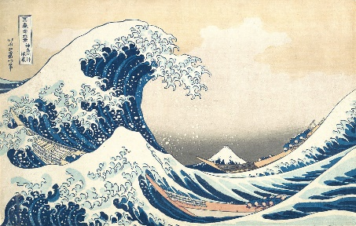
Reading: Chapter 1: Ocean Environment; Chapter 7: Intertidal Life (pages 135-136)
Lecture Topic: Introductory Oceanography
Due: “3 Words Reflection” on Friday, 8/28 at 5:00 PM (Academic Activity)
____________________________________________________________________________________________________________________________________
Week 2: September 1 & 3
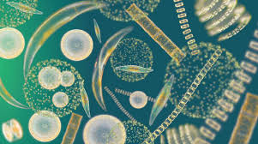
Reading: Chapter 2: Marine Biological Processes
Lecture Topics: Marine Primary Production; Ocean Acidification Case Study
Due: Ocean Acidification Case Study on Sunday, 9/6
Quiz #1 on Sunday, 9/6
____________________________________________________________________________________________________________________________________
Week 3: September 8 & 10
Reading: Chapter 3: Life in the Coastal Ocean (pgs 38-50); Chapter 7: Intertidal Life (pgs 136-146)
Lecture Topic: Coastal Communities (kelp forests, sea grass meadows, soft & rocky bottom, estuaries)
Due: Quiz #2 on Sunday, 9/13
______________________________________________________________________________________________________________________________
Week 4: September 15 & 17
Reading: Chapter 4: Polar Marine Biology
Lecture Topic: Polar Communities
Due: Quiz #3 on Sunday, 9/20
__________________________________________________________________________________________________________________________________

Week 5: September 22 & 24
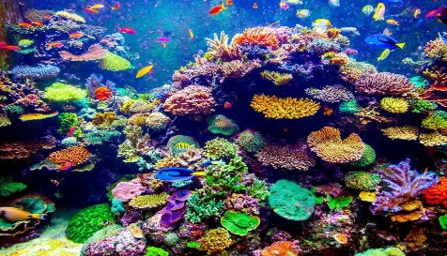
Reading: Chapter 5: Marine Life in the Tropics
Lecture Topic: Coral Reefs & Mangroves
Due: Quiz #4 on Sunday, 9/27
____________________________________________________________________________________________________________________________________
Week 6: September 29 & October 1
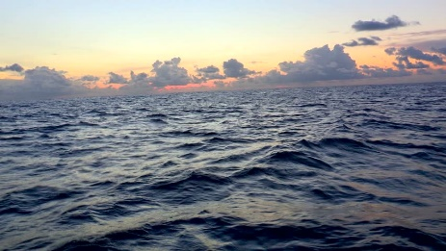
Reading: Note: There is not an associated chapter in the book for this content.
Lecture Topic: Crown of Thorns (COTs) Case Study; Open Ocean
Due: COTs Case Study on Sunday, 10/4
Quiz #5 on Sunday, 10/4
___________________________________________________________________________________________________________________________________
Week 7: October 6 & 8
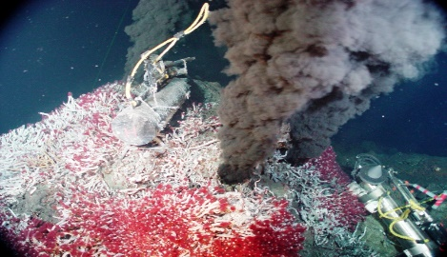
Reading: Chapter 6: Deep Ocean Biology
Lecture Topic: Deep Ocean Environment
Due: Quiz #6 on Sunday, 10/11
___________________________________________________________________________________________________________________________________

Week 8: October 13 & 15
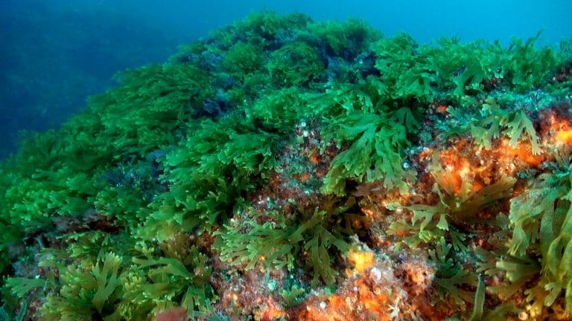
Lecture Topic: Marine Macroalgae & Plants
Due: Exam 1 on Thursday, 10/15 (available from 12:01 AM until 11:59 PM)
Due: Quiz #7 on Sunday, 10/18
___________________________________________________________________________________________________________________________________

Week 9: October 20 & 22
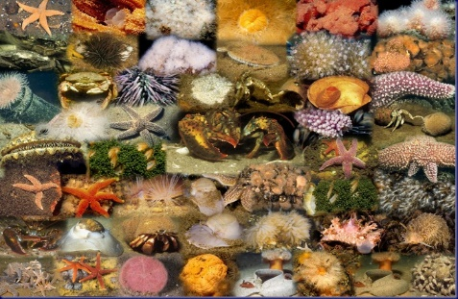
Lecture Topic: Marine Invertebrates
Due: Quiz #8 on Sunday, 10/25
____________________________________________________________________________________________________________________________________
Week 10: October 27 & 29
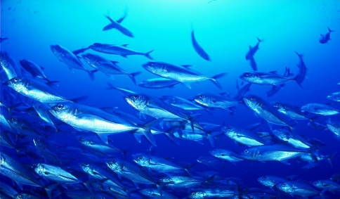
Lecture Topic: Marine Fishes
Due: Quiz #9 on Sunday, 11/1
____________________________________________________________________________________________________________________________________
Week 11: November 3 & 5
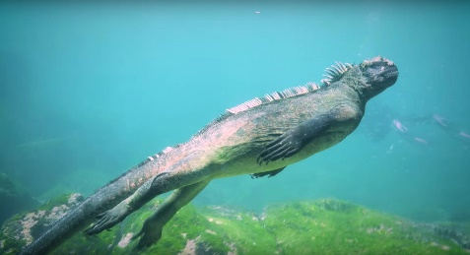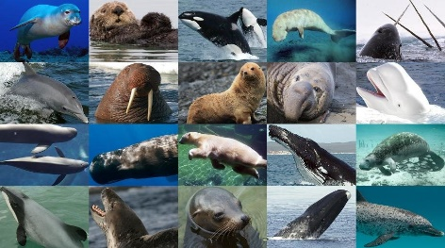
Lecture Topic: Marine Reptiles, Birds & Mammals
Due: Quiz #10 on Sunday, 11/8
____________________________________________________________________________________________________________________________________
Week 12: November 10 & 12
Lecture Topic: Marine Reptiles, Birds & Mammals (continued); Missing Sea Otter Case Study
Due: Missing Sea Otter Case Study due Sunday, 11/15
Quiz #11 on Sunday, 11/15
____________________________________________________________________________________________________________________________________
Week 13: November 17 & 19
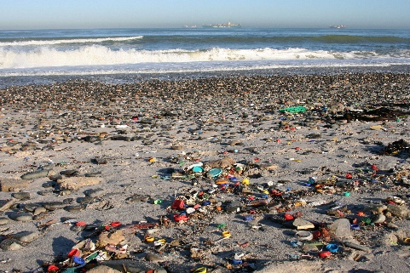
Reading: Chapter 3: Pgs. 61-70; Chapter 4: Pgs. 84-86; Chapter 5: Pgs. 102-110 & 113-114; Chapter 6: Pgs. 132-134; Chapter 7: Pgs. 143-146
Lecture Topics: Human Impacts on Ocean
Due: Quiz #12 on Sunday, 11/22
____________________________________________________________________________________________________________________________________

Week 14: November 24 (No class Thursday, November 26)
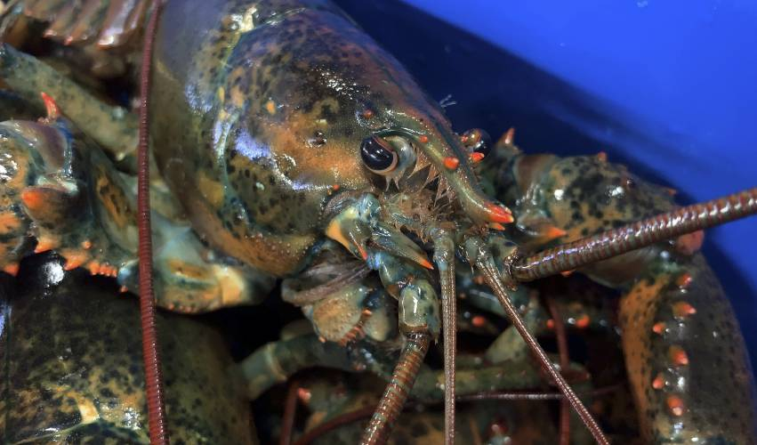
Lecture topic: Lobsters!
Due: Marine Organism Assignment on Tuesday, 11/24
Due: Quiz #13 on Sunday, 11/29
___________________________________________________________________________________________________________________________________
Week 15: December 1 & December 3
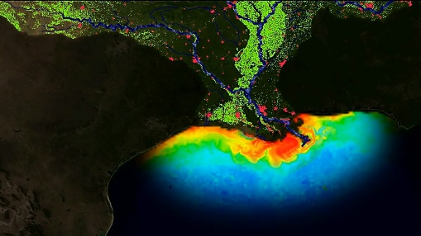
Lecture Topics: Wrap up semester, Dead Zone Case Study
Due: Exam 2 on Thursday, 12/3 (available from 12:01 AM until 11:59 PM)
Due: Dead Zone Case Study on Sunday, 12/6
__________________________________________________________________________________________________________________________________
Final Exam Thursday, 12/10 (available from 12:01 AM until 11:59 PM)

