MAC 1105C – 0001 College Algebra
Department of Mathematics, College of Sciences
3 Credit Hours
Modality P Face to Face (P) or In Person

Course Syllabus
Instructor: | William Plemmons | Term: | Spring 2024
Office Location: | MSB402 | Class Meeting Days: | T/T
Office Hours: | MW 0750-0850 1025-1125 TT 0900-0930  Via zoom check web course announcements for link | Class Meeting Time: | 1000-1120
Phone: | 407-823-6284 | Class Location: | MSB241/240/242/153
Email: | william.plemmons@ucf.edu | Course Modality: | Modality P Face to Face
Note the 24-hour clock is used in this syllabus.

Attendance/Participation
Attendance is required in person. See more details in the grading section.

Course Description
GEP courses in mathematics are designed to develop critical thinking as well as quantitative decision making skills. College Algebra (MAC1105), a foundation course, is designed to familiarize a student with fundamental mathematical concepts so that the student can think logically and will be able to apply different strategies to solve a variety of real life problems through algebraic tools. This mission supports the university goal to offer the best undergraduate education available in Florida.PR: Appropriate score on the UCF Math Placement exam, or MAT 1033C with a “C” (2.0) or better, or C.I. Inequalities. High degree polynomials. Graphs, rational, logarithmic, and exponential functions. Systems of equations.

Course Goals
This course is designed to familiarize the student with such fundamental mathematical concepts as polynomials, linear and quadratic equations, exponential functions, and logarithmic functions.

General Education Program – Mathematics Foundation
Students will prepare to be well-informed citizens who can reason and can apply analytical, statistical, and computational methods to the challenges of a globally diverse and technologically rich environment. This part of the GEP is designed to familiarize students with fundamental problem-solving concepts, frameworks, and paradigms that will equip them to logically solve a variety of real-world problems. Courses which utilize problem solving stress the development of critical thinking skills as well as students’ decision-making skills.
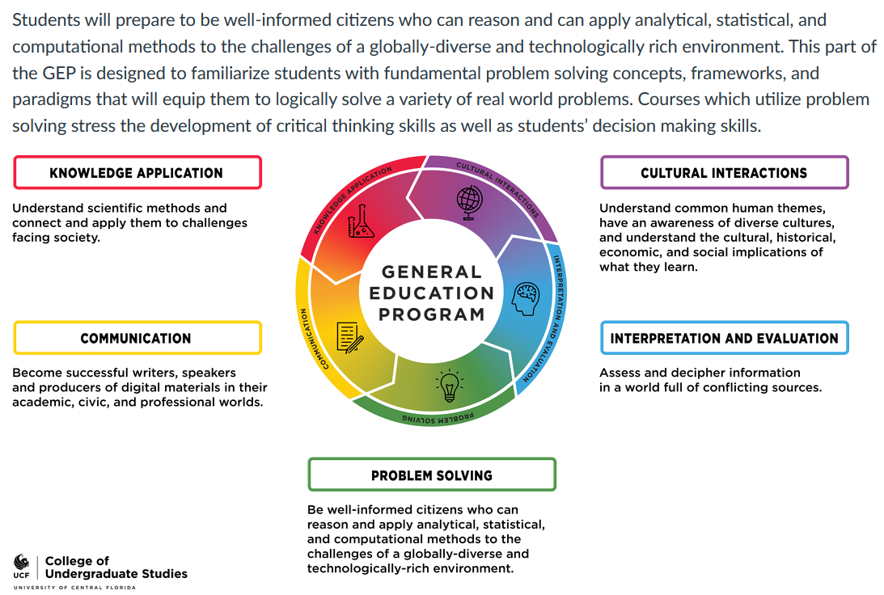

Learning Outcomes
- Apply Algebra techniques (evaluate, simplify, solve, transform, verify)
- Solve various types of equations and inequalities (linear, quadratic, rational, irrational, logarithmic, exponential)
- Understand the concepts of a function (apply definition, identify domain and range, use function notation)
- Build new functions from existing functions (understand relationship between a function equation, table and a graph. Identify sketch key points)
- Develop problem solving strategies.
- Model and solve real world problems.
- Acquire general education understanding and its connection to math.

Course Materials and Resources
- ALEKS 360 Online Access (18 weeks) for College Algebra by Miller, Julie. Edition: 3RD 23, Publisher: MCG COURSE. ISBN 13: 8220128059298. This product is available through the First Day® program. Please Opt-In through the Course Material link in Webcourses@UCF during the first week of class.
- UCF ID
- TI-30XA calculator. This type of calculator will be loaned on tests so it’s best if you have one and practice with it. Proctors will not help with questions on how to use a calculator during the tests.
- Notebook to write your math work. You can use these notes to review and when taking comprehensive assessment.
- Use of a graphing calculator in class will result in a zero for that day’s assignment.

Required Academic Activity:
As of Fall 2014, all faculty members are required to document students' academic activity at the beginning of each course. To document that you began this course, please complete the following academic activity by the due date as syllabus quiz in Webcourses no later Friday, 01/12/2024 17:00. Failure to do so may result in a delay in the disbursement of your financial aid.

Course Activities & Submissions
To accomplish the student learning outcomes, the following assignments are required. Weekly objectives, ALEKS pie progress, Weekly Quizzes, Comprehensive Assessment, Three Tests, and a Final Test. UCF ID is required for admission to all tests in this course.

Assessment and Grading Procedures
Assignments | Percentage
Objectives which are adaptive homework are due on Sundays. They can be completed before the due dates. Don’t wait until Sunday evening to start them. In ALEKS. Must complete them prior to due dates, know that incomplete topics which means the topics you don't do remain in ALEKS pie and won’t earn credit for the objective, and still must do for the pie. No extensions. Objectives can be done from anywhere. | 15%  We have 14 objectives and one lowest score of an objective is dropped. For success, log in to your course at least two more times outside class meetings to stay on track.
ALEKS Pie Progress due 4/22/2024 23:59  In ALEKS. As you work on objectives and learning path you build the pie. After the last objective is past due and if you have topics remaining in the ALEKS Pie you need to learn them, relearn them, or master them.  Be proactive by taking advantage of class time and stay the whole time after you finish the class activity and work on objective or pie progress. | 5%  90% Pie is required to earn full 5% credit. To see progress, when you log in to ALEKS and see the ALEKS pie, click the middle of the pie. It needs to be 90% or more to earn 100% grade for the pie in ALEKS assignments, which matches the 5% of the overall weight. You must see a 100% in one of the two places for the pie progress to know that you earned full pie credit.  Partial credit by percentage is earned if less than 90% pie is completed.
Class Activities (in person in the MALL)  In ALEKS. You may receive extra up to 7 quick attempts, but they must be completed in the classroom during class meetings. If you arrive late, you will not get an extension. Also, please log in a day before each class to see if you need to complete a knowledge check and complete it. No extension due to having to do knowledge check. See calendar for details. | 10%  We have 20 class activities, and 6 class activities are excused or dropped for everyone to help with absence due to late add, personal reasons or clinic visits. Don't use them until you must or use them wisely. No other exceptions.  Your own notes are allowed to use while working on activities. Apps or other unfair means are not allowed.
Comprehensive Assessment. Due 4/18/2024 in class. Start it from Assignments in ALEKS. In ALEKS. It must be completed in the classroom. It’ll be available after test 3, and two days are designated for it, 4/16/2024 and 4/18/2024. It is not timed but it may need the whole class time. My suggestion is to start on 4/16 so if you need more time to complete it by 4/18 in class. You can start it before 4/16 if 90% of the pie is completed. No extension. I encourage you to use your own notes and a TI-30xa. You should not use any other help. Note you must submit this assignment. While this assignment is open you cannot access any other thing in ALEKS | 4%  Own notes are allowed.  Apps or other unfair means are not allowed.
Syllabus Quiz in Webcourses. It's the same as required academic activity. Three attempts. Due on 1/12/2024 at 17:00. Stays available until next following Friday.  GEP Activity as Quiz in Webcourses. It’ll be posted under quizzes. It’s done in class and will be due on 3/12/24 in class. One attempt. | 2%  Do on your own. This activity is found in web courses.
Test 1 (Objectives 1, 2, 3) (in person proctored in the MALL) 2/1/2024, duration 60 minutes.  In ALEKS, proctored, closed notes, and restricted to designated computers. Taken when a student meets early testing criteria or during scheduled test 1 date. One attempt. Check UCF mall for testing policy https://sciences.ucf.edu/math/mall/  Test 2 (Objectives 4, 5, 6, 7) (in person proctored in the MALL) 2/29/2024, duration 60 minutes.  In ALEKS, proctored, closed notes, and restricted to designated computers. Taken when student meets early testing criteria or during scheduled test 2 date. One attempt.  Test 3 (Objectives 8, 9, 10, 11, 12) (in person proctored in the MALL) 4/11/2024, duration 60 minutes.  In ALEKS, proctored, closed notes, and restricted to designated computers. Taken when student meets early testing or during scheduled test 3 date. One attempt. | Best 2 are 42%  PROCTORED.  We have 3 tests before final exam. Among the three tests one lowest score test is dropped.  In case anyone is found adopting unfair means (cheating), the student will earn zero for the test(s), and all three tests will count, and no score is dropped.
Final Exam (All Objectives) (in person proctored in the MALL) 4/30/2024 1000-1250 duration 120 minutes.  In ALEKS, proctored, closed notes, and restricted to designated computers. Taken when student meets early testing criteria or during scheduled final exam date. No student should make travel plans prior to this day (unless successfully completed the course early). One attempt. You must appear in final examination to complete the course. | 22%  PROCTORED.  We have 1 final exam that is required. It can't be dropped and doesn't replace previous tests. If a student fails to appear will be awarded an F regardless of the average. In case of anyone is found adopting unfair means (cheating), the student will earn zero for the test.
Besides the dropped assignments mentioned above no extra credit is granted in this course. Note that the drops listed above will posted after test 3.

Final Grades
Letter Grade | Points
A | 90 – 100
B | 80 – 89
C | 70 – 79
NC | 40 – 69
F | 39 or below

Make-up Exams and Assignments: There are no make-up tests except for those involved in an Authorized University Events or Co-curricular Activities. Those students must show official documentation prior to absence. No make-up will be given 7 days after its initial due date. In the event of a make-up test is given, the test will not be same as the one that is given and released. Personal or family Emergencies are not considered excused reasons. We grant several excused assignments as dropped scores for everyone. See the grading section.

Progressing, Taking Tests Early or Completing the Course Early
Taking Test Early | Criteria | Early tests are given after week 1 during class meetings.  Must meet criteria to take a test early.
Test 1 | Completed Objectives 1, 2, 3 to over 90% each and taken practice test 1 more than once and received at least 85%.
Test 2 | Completed Objectives 1 to 7 to over 90% each and taken practice test 2 more than once and received at least 85%.
Test 3 | Completed Objectives 1 to 12 to over 90% each and taken practice test 3 more than once and received at least 85%.
Final Exam | Have good passing scores on at least two previous exams, and completed at least 90% Pie, and taken proctored comprehensive assessment, and scored at least 85% on a practice final test.
The criteria is only a guide and only the instructor can decide if you are eligible to complete the course early. Your instructor will also make recommendations based on your performance and major.

Email Policy
You are asked to read this entire document and be knowledgeable.
1. Please contact technical support when you have issues with ALEKS. Your instructor will not conduct technical support via email.
2. If you contact your instructor via Webcourses. It will link you to your Math class and section.
3. It is best if you use Knights email to contact your instructor you must include your full name and class meeting days and times.
4. Your instructor will not reply to communications from non-UCF addresses.
5. Emails about excused absences must FIRST have acceptable documentation attached. Keep in mind that some assignments include some drops/excused and you'll use that option in many cases. Also, activities include some extensions as stated above.
6. Emails will be answered the next business day in the order in which they were received.

Academic Integrity Statement
Students should familiarize themselves with UCF’s Rules of Conduct at https://scai.sdes.ucf.edu/student-rules-of-conduct. According to Section 1, “Academic Misconduct,” students are prohibited from engaging in:
- Unauthorized assistance: Using or attempting to use unauthorized materials, information or study aids in any academic exercise unless specifically authorized by the instructor of record. The use of any app is cheating. The unauthorized possession of examination or course-related material also constitutes cheating.
- Communication to another through written, visual, electronic, or oral means: The presentation of material which has not been studied or learned, but rather obtained through someone else’s efforts and used as part of an examination, course assignment, or project.
- Commercial Use of Academic Material: Selling of course material to another person, student, and/or uploading course material to a third-party vendor without authorization or without the express written permission of the university and the instructor. Course materials include but are not limited to class notes, Instructor’s PowerPoints, course syllabi, tests, quizzes, labs, instruction sheets, homework, study guides, handouts, etc.
- Falsifying or misrepresenting the student’s own academic work.
- Plagiarism: Using or appropriating another’s work without any indication of the source, thereby attempting to convey the impression that such work is the student’s own.
- Multiple Submissions: Submitting the same academic work for credit more than once without the express written permission of the instructor.
- Helping another violate academic behavior standards.
- Soliciting assistance with academic coursework and/or degree requirements.
- Use of a graphing calculator will result in a zero on that day’s assignment.

Responses to Academic Dishonesty, Plagiarism, or Cheating
Students should also familiarize themselves with the procedures for academic misconduct in UCF’s student handbook, The Golden Rule. UCF faculty members have a responsibility for students’ education and the value of a UCF degree, and so seek to prevent unethical behavior and respond to academic misconduct when necessary. Penalties for violating rules, policies, and instructions within this course can range from a zero on the exercise to an “F” letter grade in the course. In addition, an Academic Misconduct report could be filed with the Office of Student Conduct, which could lead to disciplinary warning, disciplinary probation, or deferred suspension or separation from the University through suspension, dismissal, or expulsion with the addition of a “Z” designation on one’s transcript.
Being found in violation of academic conduct standards could result in a student having to disclose such behavior on a graduate school application, being removed from a leadership position within a student organization, the recipient of scholarships, participation in university activities such as study abroad, internships, etc.
Let’s avoid all of this by demonstrating values of honesty, trust, and integrity. No grade is worth compromising your integrity and moving your moral compass. Stay true to doing the right thing: take the zero, not a shortcut.

Course Accessibility Statement
The University of Central Florida is committed to providing access and inclusion for all persons with disabilities. Students with disabilities who need access to course content due to course design limitations should contact the professor as soon as possible. Students should also connect with Student Accessibility Services (SAS). For students connected with SAS, a Course Accessibility Letter may be created and sent to professors, which informs faculty of potential course access and accommodations that might be necessary and reasonable. Determining reasonable access and accommodations requires consideration of the course design, course learning objectives and the individual academic and course barriers experienced by the student. Further conversations with SAS, faculty and the student may be warranted to ensure an accessible course experience.

Campus Safety Statement
Emergencies on campus are rare, but if one should arise during class, everyone needs to work together. Students should be aware of their surroundings and familiar with some basic safety and security concepts.
- In case of an emergency, dial 911 for assistance.
- Every UCF classroom contains an emergency procedure guide posted on a wall near the door. Students should make a note of the guide’s physical location and review the online version at https://centralflorida-prod.modolabs.net/student/safety/index.
- Students should know the evacuation routes from each of their classrooms and have a plan for finding safety in case of an emergency.
- If there is a medical emergency during class, students may need to access a first-aid kit or AED (Automated External Defibrillator). To learn where those are located, see https://ehs.ucf.edu/automated-external-defibrillator-aed-locations.
- To stay informed about emergency situations, students can sign up to receive UCF text alerts by going to https://my.ucf.edu and logging in. Click on “Student Self Service” located on the left side of the screen in the toolbar, scroll down to the blue “Personal Information” heading on the Student Center screen, click on “UCF Alert,” and fill out the information, including e-mail address, cell phone number, cell phone provider, click “Apply” to save the changes, and then click “Ok.”
- Students with special needs related to emergency situations should speak with their instructors outside of class.
- To learn about how to manage an active shooter situation on campus or elsewhere, consider viewing this video: https://youtu.be/NIKYajEx4pk.

Campus Safety Statement for Students in Online-Only Courses
Though most emergency situations are primarily relevant to courses that meet in person, such incidents can also impact online students, either when they are on or near campus to participate in other courses or activities or when their course work is affected by off-campus emergencies. The following policies apply to courses in online modalities.
- To stay informed about emergency situations, students can sign up to receive UCF text alerts by going to https://my.ucf.edu and logging in. Click on “Student Self Service” located on the left side of the screen in the toolbar, scroll down to the blue “Personal Information” heading on the Student Center screen, click on “UCF Alert,” and fill out the information, including e-mail address, cell phone number, cell phone provider, click “Apply” to save the changes, and then click “Ok.”
- Students with special needs related to emergency situations should speak with their instructors outside of class.

Deployed Active Duty Military Students
Students who are deployed active duty military and/or National Guard personnel and require accommodation should contact their instructors as soon as possible after the semester begins and/or after they receive notification of deployment to make related arrangements. Please provide a copy of your orders.
Religious Observances
Students must notify their instructor in the first 10 business days of the semester if they intend to miss class for a religious observance. For more information, see the UCF policy at <http://regulations.ucf.edu/chapter5/documents/5.020ReligiousObservancesFINALJan19.pdf>.
Title IX Policy
Title IX prohibits sex discrimination, including sexual misconduct, sexual violence, sexual harassment, and retaliation. If you or someone you know has been harassed or assaulted, you can find resources available to support the victim, including confidential resources and information concerning reporting options at https://letsbeclear.ucf.edu and http://cares.sdes.ucf.edu/.
Important Days
Classes begin January 8
Drop/Swap deadline January 12
MLK day January 15 (no classes)
Spring Break March 18-23 (no classes)
Classes end April 22
Study day April 23
Final Exam April 30__ 1000-1250
Test 1 February 1 during class
Test 2 February 29 during class
Test 3 April 11 during class

The instructor reserves the right to modify this syllabus at their discretion. Any changes will be announced in class and web course announcements. Student is responsible for all in class announcements whether student hears or not.

